
CORAL REEF HEALTH ASSESSMENT VIA CONVOLUTIONAL NEURAL NETWORK-BASED IMAGE ANALYSIS

by

MUHAMMAD LUQMAN HAZIQ BIN MOHAMAD LOFI
(221022249)

A thesis submitted in partial fulfillment of the requirements for the degree of
Bachelor of Engineering (Computer Engineering) with Honors

Faculty of Intelligent Computing
UNIVERSITI MALAYSIA PERLIS

2026

UNIVERSITI MALAYSIA PERLIS

DECLARATION OF THESIS
Author’s Full Name | : | MUHAMMAD LUQMAN HAZIQ BIN MOHAMAD LOFI
Title | : | CORAL REEF HEALTH ASSESSMENT VIA CONVOLUTIONAL NEURAL NETWORK-BASED IMAGE ANALYSIS
Date of Birth | : | 3 JUNE 2001
Date of Registration | : | 20 JANUARY 2019
Academic Session of Thesis Submission | : | 2025/2026

I hereby declare that this thesis becomes the property of Universiti Malaysia Perlis (UniMAP) and to be placed at the library of UniMAP. This report is classified as:
 |  | CONFIDENTIAL |  | (Contains confidential information under the Official Secret Act 1997)*
 |  | RESTRICTED | (Contains restricted information as specified by the organization where research was done)*
 |  | OPEN ACCESS | I agree that my report to be published as online open access (Full Text)
I, the author, give permission to reproduce this report in whole or in part for the purpose of research or academic exchange only.
 |  |  | Certified and approved by:
 |  |  | 
 | SIGNATURE |  | SIGNATURE OF SUPERVISOR
 | 010603-07-0147 |  | Assoc. Prof. Ts. Dr. Yasmin Yacob
 | (NEW IC NO. /PASSPORT NO.) |  | NAME OF SUPERVISOR
 | Date: 17 January 2026 |  | Date: 17 January 2026

NOTES : * If the thesis is CONFIDENTIAL or RESTRICTED, please attach with the letter from the organization with the period and reasons for confidentiality or restriction.

ACKNOWLEDGEMENT
This Final Year Project successfully completed all its requirements, and finishing this report was a deeply rewarding experience. This accomplishment met all the academic standards set by Universiti Malaysia Perlis (UniMAP) and represents the application of the technical knowledge gained during my Bachelor of Computer Engineering program.
First, I would like to express my sincere gratitude to the university and the Faculty of Intelligent Computing (FIC). The FIC provided the essential resources, including access to computing platforms and academic support, necessary for a project that relied on deep learning. I am especially grateful for the opportunity to apply theoretical knowledge to a real-world problem, such as coral health assessment. This practical experience, which transitioned from classroom concepts to a finished scientific tool, was the most critical part of my final year study.
I owe great thanks to my supervisor, Assoc. Prof. Ts. Dr. Yasmin Yacob. Her guidance was essential. She provided clear direction for the methodology, including critical advice on model selection and parameter testing. Her constant supervision and steady support ensured the project stayed on track and met its high technical standards, even when facing complex problems. Her expertise was the driving force behind the successful completion of this work. I also thank the Final Year Project committee for their helpful advice and insightful feedback during my presentations.
Finally, I would like to thank my family and friends for their ongoing support and understanding. Their encouragement and belief in my work were the foundation that allowed me to complete this project, especially during the periods of intensive model training and technical writing. Any omissions in this acknowledgement are unintentional and do not lessen my appreciation for their contributions.

TABLE OF CONTENTS
PAGE

DECLARATION OF THESIS i
ACKNOWLEDGEMENT ii
TABLE OF CONTENTS iii
LIST OF TABLES viii
LIST OF FIGURES xi
LIST OF ABBREVIATIONS xvi
LIST OF SYMBOLS xvii
ABSTRAK xviii
ABSTRACT xix
CHAPTER 1 : INTRODUCTION 1
1.1 Project Background 1
1.2 Problem Statements 2
1.3 Objectives 3
1.4 Scopes 4
1.5 Summary 5
CHAPTER 2 : LITERATURE REVIEW 7
2.1 Introduction 7
2.2 Coral Reef Health & Traditional Monitoring Methods 7
2.3 Image-Based Coral Reef Monitoring Using Computer Vision 10
2.4 Image Pre-processing in Coral Reef Image Analysis 11
2.5 Deep Learning Models for Coral Reef Health Classification 13
2.5.1 Convolutional Neural Networks for Image Classification 13
2.5.2 Transfer Learning in Environmental Image Analysis 14
2.5.3 CNN Architectures Used in Related Studies 14
2.6 EfficientNet Architecture and Scaling Strategy 15
2.6.1 Justification for EfficientNet in Coral Reef Health Assessment 17
2.6.2 Stochastic Weight Averaging as an Ensemble Optimisation Strategy 18
2.7 Interpretability Analysis Using Grad-CAM 18
2.7.1 Need for Model Interpretability in Coral Health Assessment 19
2.7.2 Working Principle of Grad-CAM 20
2.7.3 Evidence of Grad-CAM Effectiveness in Coral and Environmental Imaging 21
2.7.4 Compatibility of Grad-CAM with EfficientNet Architecture 22
2.7.5 Role of Grad-CAM in Supporting Scientific Trust 23
2.8 Performance Evaluation Metrics 24
2.9 Related Works 26
2.9.1 Deep Learning for Coral Reef Health Classification 26
2.9.2 EfficientNetB0 with Grad-CAM for Explainable Biological Image Classification 31
2.9.3 Ensemble Methods with EfficientNetB0 for Classification Robustness 36
2.9.4 Test-Time Augmentation (TTA) for CNN Classification 46
2.9.5 EfficientNetB0 with Grad-CAM for Multi-Class Classification and Deployment 52
2.9.6 Summary of related works 61
CHAPTER 3 : METHODOLOGY 64
3.1 Introduction 64
3.2 Design Framework 65
3.3 Dataset 66
3.3.1 BHD Coral Kaggle 66
3.4 Performance Evaluation Metrics 68
3.4.1 Classification Accuracy 69
3.4.2 Precision 69
3.4.3 Recall 70
3.4.4 F1-Score 70
3.4.5 Macro Average and Weighted Average 71
3.4.6 Confusion Matrix 71
3.5 Data Preparation 72
3.5.1 Data acquisition 74
3.5.2 Data pre-processing 75
3.5.3 Data Augmentation 76
3.6 Model Development and Optimisation 80
3.6.1 Model Training – EfficientNetB0 Architecture and Five-Seed SWA Ensemble Training 81
3.6.2 Hyperparameter Tuning 84
3.6.3 Model Export 86
3.7 Model Analysis and Output 87
3.7.1 Model Evaluation with Multi-Scale TTA 87
3.7.2 Model Interpretability - Grad-CAM 88
3.7.3 Output Results 91
3.8 Development Environment 92
3.8.1 Python Programming Language 92
3.8.2 TensorFlow & Keras Framework 93
3.8.3 OpenCV Library 94
3.8.4 Supporting Libraries 95
3.8.5 Hardware - NVIDIA RTX 3070 GPU 96
3.9 Summary 97
CHAPTER 4 : RESULT AND DISCUSSION 98
4.1 Introduction 98
4.1.1 Dataset Split and Class Distribution 98
4.1.2 Training and Validation Learning Curves 100
4.1.3 Hyperparameter Tuning and Final Model Selection 102
4.1.4 Final Classification Performance on the Test Set 103
4.1.5 Baseline vs Final Model Comparison 105
4.1.6 Ensemble Size and Multi-Scale TTA 107
4.1.7 Grad-CAM Explainability Results 111
4.2 Discussion 114
4.2.1 Data Split Reliability and Class Sensitivity 115
4.2.2 Training Convergence and Overfitting Analysis 116
4.2.3 Classification Performance and Error Profile 116
4.2.4 Baseline to Final Model Improvement 118
4.2.5 Ablation Study Interpretation 118
4.2.6 Grad-CAM Explainability Interpretation 120
4.3 Summary 122
CHAPTER 5 : CONCLUSION 123
5.1 Introduction 123
5.1.1 Conclusion 123
5.1.2 Research Limitations 124
5.2 Recommendations for Future Work 125
5.3 Chapter Summary 126
GANTT CHART 128
REFERENCES 129
APPENDIX A – TURNITIN RESULT 136

LIST OF TABLES
PAGE

Table 2.1 High-level comparison of CNN architectures (Tan & Le, 2019) . 17
Table 2.2 Performance comparison of EfficientNetB0-TRVFL against baseline CNN models across three underwater datasets (Zhou et al., 2024). 28
Table 2.3 Classification performance of selected deep learning models for multi-label coral reef condition classification (Shao et al., 2024). 29
Table 2.4 Classification performance of ML-Net and baseline models on the coral bleaching dataset (Wang et al., 2024). 30
Table 2.5 Classification performance comparison of XSE-TomatoNet against baseline models for tomato leaf disease classification (Assaduzzaman et al., 2025). 32
Table 2.6 Classification performance of EfficientNetB0 and comparative models for Discomycetes species classification with Grad-CAM interpretability (Korkmaz et al., 2025). 34
Table 2.7 Classification accuracy of fine-tuned EfficientNetB0 and baseline models for malaria parasite detection with Grad-CAM interpretability (Montalbo & Alon, 2021). 35
Table 2.8 Epoch-wise accuracy comparison (all 3 models) Singh et al. (2024). 39
Table 2.9 Class-level precision, recall, F1 comparison Singh et al. (2024). 40
Table 2.10 Performance metrics for breast and colon cancer baseline architectures Kallipolitis et al. (2021). 43
Table 2.11 Performance metrics for breast and colon cancer ensemble architectures Kallipolitis et al. (2021). 44
Table 2.12 Accuracy, Precision, Recall at four magnification factors (binary and multiclass) Kallipolitis et al. (2021). 44
Table 2.13 Percentages of increase by TTA compared to original method Kandel & Castelli (2021). 47
Table 2.14 F1-score comparison across the three experimental conditions (Oza et al., 2024). 49
Table 2.15 Comparison of different uncertainty types (Singh et al., 2022). 51
Table 2.16 Comparative analysis between different explainability techniques (Singh et al., 2022). 51
Table 2.17 F1 Score on Test Set for Different Models and Configurations Pham-Ngoc et al. (2025). 53
Table 2.18 Confusion matrix of the ThyroidEffi Basic model on test set Ngoc et al. (2025). 53
Table 2.19 Performance evaluation of the ThyroidEffi Basic model on real-world application data Ngoc et al. (2025). 54
Table 2.20 Class distribution of dataset Alqhatani et al. (2025). 55
Table 2.21 Data split and preprocessing for lung cancer classification Alqhatani et al. (2025). 55
Table 2.22 Comparison of the proposed model with existing models Alqhatani et al. (2025). 58
Table 2.23 Model Performance Evaluation on the Validation and Test Set Long et al. (2025). 59
Table 2.24 Summary of Related Works. 62
Table 3.1 Distribution of BHD Coral Dataset 67
Table 3.2 Confusion Matrix Terms and Definitions. 72
Table 3.3 Class Distribution Before and After Augmentation. 77
Table 3.4 Augmentation Focus Strategy. 80
Table 3.5 Modified EfficientNet-B0 Architecture. 82
Table 3.6 Training Configuration. 83
Table 3.7 Hyperparameters Tuning Summary. 85
Table 3.8 Grad-CAM Setup Configuration. 90
Table 3.9 Expected Grad-CAM Attention Regions per Class. 91
Table 4.1 Distribution of Training, Validation, and Test Samples Across Coral Health Classes. 99
Table 4.2 Finalised hyperparameter configuration for the EfficientNetB0 5-seed SWA ensemble. 102
Table 4.3 Per-class classification report metrics. 105
Table 4.4 Comparison table of accuracy, macro F1-score, and total errors between the baseline EfficientNetB0 single model and the final 5-seed SWA ensemble. 106
Table 4.5 Ablation study results across eight configurations — single- to five-seed ensembles evaluated with and without Multi-Scale TTA. 108

LIST OF FIGURES
PAGE
Figure 2.1 Diagram of thermal coral bleaching Marshall and Schuttenberg (2006). 8
Figure 2.2 Architecture of Convolutional Neural Network (CNN) (Babaeipour et al., 2023). 13
Figure 2.3 Overview of CNN architectures evaluated in coral reef and marine image classification studies. 15
Figure 2.4 EfficientNet architecture diagram (Tan & Le, 2019). 16
Figure 2.5 Compound scaling principle.(Tan & Le, 2019). 17
Figure 2.6 Conceptual illustration of the Grad-CAM process (adapted from Selvaraju et al., 2020). 20
Figure 2.7 Grad-CAM visualizations highlighting image regions contributing to the classification of Healthy, Bleached Coral, and Dead Coral (Ghaffar & Choi, 2025). 21
Figure 2.8 Grad-CAM heatmap results from an EfficientNet-based classification model showing localized activations corresponding to diseased leaf regions(Shukla et al., 2020). 23
Figure 2.9 Architecture of the EfficientNetB0-TRVFL underwater image classification model (Zhou et al., 2024). 27
Figure 2.10 Representative patch samples from the coral reef condition dataset across eight ecological classes including healthy coral (HLC), dead coral (DDC), and compromised coral (CPC) (Shao et al., 2024). 29
Figure 2.11 Representative samples of (a) healthy coral and (b) bleached coral from the binary classification dataset (Wang et al., 2024). 30
Figure 2.12 Grad-CAM heatmaps generated by XSE-TomatoNet highlighting disease-relevant regions on tomato leaf images, confirming model attention on symptom areas (Assaduzzaman et al., 2025). 33
Figure 2.13 Grad-CAM and Score-CAM visualisations applied to EfficientNetB0 for Discomycetes species classification, highlighting activated regions corresponding to fungal morphological structures (Korkmaz et al., 2025). 34
Figure 2.14 Grad-CAM saliency maps generated by fine-tuned EfficientNetB0 for malaria parasite detection, showing precise localisation of infected regions within blood smear images (Montalbo & Alon, 2021). 36
Figure 2.15 Ensemble framework flowchart Singh et al. (2024). 38
Figure 2.16 Ensemble model architecture diagram Singh et al. (2024). 38
Figure 2.17 Confusion matrices for all 3 models Singh et al. (2024). 41
Figure 2.18 Parallel EfficientNet system architecture Kallipolitis et al. (2021). 43
Figure 2.19 Grad-CAM explainability results, adenosis benign sample (single vs. ensemble) Kallipolitis et al. (2021). 45
Figure 2.20 Grad-CAM explainability results, in situ malignant sample (single vs. ensemble) Kallipolitis et al. (2021). 46
Figure 2.21 Kappa score distributions across 50 repeated experiments for each CNN architecture on the Finger image subset, illustrating the consistent performance improvement produced by TTA over the baseline method without augmentation (Kandel & Castelli, 2021). 48
Figure 2.22 Schematic diagram of the proposed TTA workflow, illustrating the generation of multiple augmented test image variants, individual model predictions, and the aggregation process for final classification output (Oza et al., 2024). 49
Figure 2.23 Model’s region of interest depicted by XRAI and Guided Grad CAM (Singh et al., 2022). 51
Figure 2.24 Grad-CAM of a slide image (left) and 12 sub-images (right) after pass ThyroidEffi Basic Ngoc et al. (2025). 54
Figure 2.25 Classification report detailing the precision, recall, and F1-score across different lung cancer stages (benign, malignant, and normal cases) Alqhatani et al. (2025). 56
Figure 2.26 Various metrics including F2 Score, Matthews Correlation Coefficient (MCC), and Cohen’s Kappa for the classification model Alqhatani et al. (2025). 56
Figure 2.27 Confusion matrix summarizing the model’s classification performance Alqhatani et al. (2025). 57
Figure 2.28 Grad-CAM visualizations highlighting the regions within the CT images that most influence the model’s predictions Alqhatani et al. (2025). 57
Figure 2.29 ROC curve for grading of Diabetic Retinopathy (DR) Long et al. (2025). 59
Figure 2.30 Confusion matrix for grading of Diabetic Retinopathy (DR) Long et al. (2025). 60
Figure 2.31 Confusion matrix for diagnosis of Diabetic Macular Edema (DME), Class labels: 0 = Non-DME; 1 = DME Long et al. (2025). 60
Figure 2.32 Heatmap Visualization for Deep Learning Explainability Long et al. (2025). 60
Figure 3.1 Illustrates the methodological framework adopted in this study for coral reef health classification. 65
Figure 3.2 Sample Images from the BHD Coral Dataset Representing Healthy, Bleached, and Dead Classes (Jamil, 2021). 66
Figure 3.3 Coral Reef Assessment Flowchart. 73
Figure 3.4 Example of Image Resizing Process. 75
Figure 3.5 Random Rotation Augmentation. 77
Figure 3.6 Horizontal Flipping Augmentation. 78
Figure 3.7 Random Zoom Augmentation. 79
Figure 3.8 Python programming environment used for model development. 93
Figure 3.9 TensorFlow and Keras deep learning framework. 94
Figure 3.10 OpenCV image processing operations. 94
Figure 3.11 NumPy. 95
Figure 3.12 Matplotlib. 96
Figure 3.13 Scikit Learn. 96
Figure 3.14 Seaborn. 96
Figure 3.15 Flask. 96
Figure 4.1 Training and validation accuracy over 30 epochs for the EfficientNetB0 5-seed SWA ensemble. 101
Figure 4.2 Training and validation loss over 30 epochs for the EfficientNetB0 5-seed SWA ensemble. 101
Figure 4.3 Confusion matrix of the EfficientNetB0 5-seed SWA ensemble evaluated on 159 test images across three coral health classes. 104
Figure 4.4 Test accuracy versus ensemble size for configurations with and without Multi-Scale TTA. 109
Figure 4.5 Macro F1-score versus ensemble size for configurations with and without Multi-Scale TTA. 110
Figure 4.6 Misclassification count across the eight ablation configurations. 110
Figure 4.7 Grad-CAM attention heatmaps for three correctly classified samples per coral health class generated using the EfficientNetB0 5-seed SWA ensemble, with per-sample prediction confidence ranging from 97.3% to 99.4%. 112
Figure 4.8 Grad-CAM attention heatmaps generated by the baseline EfficientNetB0 single model for one representative sample per coral health class, with prediction confidence of 75.2% (Healthy), 45.5% (Bleached), and 52.5% (Dead). 113

LIST OF ABBREVIATIONS
AI | Artificial Intelligence
AUC | Area Under the Curve
AUV | Autonomous Underwater Vehicle
BCS | Body Condition Scoring
BHD | Benthic Habitat Dataset
CAM | Class Activation Mapping
CNN | Convolutional Neural Network
CPU | Central Processing Unit
DL | Deep Learning
FN | False Negative
FP | False Positive
F1 | F1-Score
GPU | Graphics Processing Unit
GradCAM | Gradient-weighted Class Activation Mapping
IDE | Integrated Development Environment
IoU | Intersection over Union
MBConv | Mobile Inverted Bottleneck Convolution
ML | Machine Learning
ReLU | Rectified Linear Unit
RGB | Red, Green, Blue
ROC | Receiver Operating Characteristic
SGD | Stochastic Gradient Descent
SoftMax | Soft Maximum Function
SWA | Stochastic Weight Averaging
TN | True Negative
TP | True Positive
TTA | Test-Time Augmentation
XAI | Explainable Artificial Intelligence
API | Application Programming Interface
LIME | Local Interpretable Model-agnostic Explanations
MCC | Matthews Correlation Coefficient
SHAP | SHapley Additive exPlanations

LIST OF SYMBOLS
α | Scaling coefficient controlling network depth in EfficientNet
β | Scaling coefficient controlling network width in EfficientNet
γ | Scaling coefficient controlling input image resolution in EfficientNet
Φ | Compound scaling factor in EfficientNet architecture
∂ | Partial derivative operator
Σ | Summation operator
× | Matrix or scalar multiplication
𝑦ᶜ | Score of target class c before SoftMax
𝐴ᵏ | Feature map from the k-th convolutional filter
𝐴ᵢⱼᵏ | Activation at spatial location (i, j) in feature map k
𝑍 | Total number of pixels in a feature map
αᵏᶜ | Importance weight of feature map k for class c
𝐿ᶜGrad-CAM | Grad-CAM heatmap for target class c
ReLU(·) | Rectified Linear Unit activation function
N | Number of classes in the classification task

PENILAIAN KESIHATAN TERUMBU KARANG MELALUI ANALISIS IMEJ BERASASKAN RANGKAIAN NEURAL KONVOLUSIONAL

ABSTRAK
Terumbu karang menyokong satu perempat daripada semua spesies marin yang diketahui, namun kejadian pelunturan yang semakin kerap mendorong ekosistem ini ke arah kemerosotan yang tidak dapat dipulihkan. Pemantauan manual kekal lambat, mahal, dan terhad dari segi liputan geografi, sekali gus mengekang tindak balas pemuliharaan. Kajian ini mengaplikasikan analisis imej berasaskan rangkaian neural konvolusi bagi mengklasifikasikan imej terumbu karang bawah air ke dalam tiga kategori kesihatan: Sihat, Terputih, dan Mati. EfficientNetB0, yang telah pra-latih menggunakan ImageNet, dilaras halus pada BHD Coral Dataset yang mengandungi 1,582 imej berlabel, dengan pensampelan berlebihan contoh sukar diterapkan bagi menangani ketidakseimbangan kelas, ensemble lima benih Purata Pemberat Stokastik digunakan untuk menstabilkan ramalan, dan Penambahan Masa Ujian Pelbagai Skala diaplikasikan semasa inferens pada dua resolusi bagi meningkatkan keteguhan klasifikasi. Pemetaan Pengaktifan Kelas Berwajaran Kecerunan (Grad-CAM) diintegrasikan bagi mengenal pasti kawasan imej yang mempengaruhi setiap keputusan klasifikasi. Pada 159 imej ujian terpencil, rangka kerja ini mencapai ketepatan 98.11% dan skor F1 makro 0.9769, mewakili peningkatan ketepatan sebanyak 13.20 mata peratusan berbanding model garis asas satu benih yang menghasilkan 24 salah klasifikasi berbanding tiga oleh ensemble. Grad-CAM mengesahkan bahawa perhatian model secara konsisten tertumpu pada tisu terumbu karang yang relevan secara biologi. Ensemble ini digunakan sebagai aplikasi web Flask yang menyokong inferens masa nyata dan visualisasi Grad-CAM. Keputusan ini menunjukkan bahawa pembelajaran pindah berasaskan ensemble dengan kebolehjelasan visual merupakan pendekatan yang boleh dipercayai bagi penilaian kesihatan terumbu karang secara automatik.

CORAL REEF HEALTH ASSESSMENT VIA CONVOLUTIONAL NEURAL NETWORK-BASED IMAGE ANALYSIS

ABSTRACT
Coral reefs support a quarter of all known marine species, yet accelerating bleaching events push these ecosystems toward irreversible decline. Manual monitoring remains slow, expensive, and geographically limited, constraining conservation response. This study applies convolutional neural network-based image analysis to classify underwater coral images into three health categories: Healthy, Bleached, and Dead. EfficientNetB0, pre-trained on ImageNet, was fine-tuned on the BHD Coral Dataset of 1,582 labelled images, with hard-example oversampling applied to address class imbalance, a five-seed Stochastic Weight Averaging ensemble used to stabilise predictions, and Multi-Scale Test-Time Augmentation applied at inference across two resolutions to improve classification robustness.Gradient-weighted Class Activation Mapping (Grad-CAM) was integrated to identify image regions driving each classification decision. On 159 held-out test images, the framework achieved 98.11% accuracy and a macro F1-score of 0.9769, representing a 13.20 percentage point accuracy improvement over a single-model baseline that produced 24 misclassifications against the ensemble's three. Grad-CAM confirmed that model attention consistently localised to biologically relevant coral tissue. The ensemble was deployed as a Flask web application supporting real-time inference and Grad-CAM visualisation. These results demonstrate that ensemble-based transfer learning with visual explainability constitutes a reliable approach for automated coral reef health assessment.

INTRODUCTION

Project Background
Coral reefs are among the most ecologically significant ecosystems on Earth. Although they occupy less than one percent of the ocean floor, they support approximately 25 percent of all known marine species and deliver essential services including coastal protection, fisheries habitat, and tourism revenue (Moberg & Folke, 1999). These functions sustain the livelihoods of hundreds of millions of people across tropical coastal regions, and the economic value attributed to reef services reaches hundreds of billions of dollars annually (Burke et al., 2011). The health of coral reef ecosystems is therefore fundamental to both marine biodiversity and the coastal communities that depend on them.
Coral reefs face accelerating threat from rising sea surface temperatures driven by climate change. The primary symptom of thermal stress is coral bleaching, a condition in which corals expel the symbiotic zooxanthellae algae residing within their tissues. These algae supply up to 90 percent of a coral's energy requirements through photosynthesis, and their loss causes the coral to lose its natural coloration and appear white or pale. If stressful conditions persist, bleached corals become increasingly energy-deficient and may eventually die, resulting in widespread reef mortality and the collapse of the biodiversity they support (Hughes et al., 2018). The progression from a healthy, pigmented reef to a bleached or dead state represents a visually detectable change in coral tissue condition that can be captured in underwater photography.
Monitoring this progression at scale remains a significant challenge. Traditional underwater surveys conducted by trained divers are time-consuming, expensive, and limited in spatial coverage (González-Rivero et al., 2020). The growing volume of reef imagery now exceeds the capacity of human analysts to review consistently. Convolutional neural network (CNN)-based image analysis offers a scalable alternative, enabling automated classification of coral health conditions from digital photographs and reducing dependence on manual ecological assessment.

Problem Statements
Manual analysis is insufficient for the volume of ecological imagery produced by modern underwater monitoring platforms. Cameras mounted on remotely operated vehicles and autonomous underwater vehicles generate data far exceeding human review capacity (González-Rivero et al., 2020). Manual examination is labour-intensive and susceptible to error from observer fatigue and inter-observer subjectivity (Mahmood et al., 2016), necessitating automated classification of coral health imagery at scale (Beijbom et al., 2012).
Deep learning models used in coral health classification frequently operate as black boxes, producing predictions without identifying the image regions that influenced the decision. In underwater imagery, this can cause a model to attend to irrelevant background elements, such as water colour or sediment, rather than biologically meaningful indicators like tissue discolouration or bleaching patterns (Borjali et al., 2020). High accuracy offers no guarantee that predictions reflect valid coral health features, making visual explanation methods essential for scientific credibility (Selvaraju et al., 2020).
Reliance on a single performance measure, typically overall accuracy, can produce misleading assessments of model reliability. In datasets with uneven class distribution, a model may achieve high accuracy by defaulting to majority classes while consistently misclassifying underrepresented categories such as dead coral (Borjali et al., 2020). Under these conditions, reported accuracy overstates true model effectiveness. Evaluation across multiple metrics, including precision, recall, and F1-score for each health class, is therefore necessary to provide a trustworthy assessment.

Objectives
The overall objective of the project is to design and test an automated AI system that can detect and categorize the health of coral reefs based on digital images.
This main aim will be met with three clear goals:

To create a deep learning model for coral reef health classification based on image data.

To apply a visual explanation method to support the interpretation and validation of the model's classification decisions.

To evaluate the model's classification performance using multiple standard metrics across all coral health categories.

Scopes
This study employs the BHD Coral Dataset, comprising 1,582 labelled underwater coral images sourced from Kaggle, to train and evaluate a three-class coral reef health classification system. The dataset spans three health categories Healthy, Bleached, and Dead and serves as the sole data source, with classification restricted to these categories without extension to species identification or disease diagnosis.
EfficientNetB0, pretrained on ImageNet, serves as the feature extraction backbone. To address class imbalance, Hard-Example Oversampling is applied during training, and five independently seeded model instances are combined through Stochastic Weight Averaging to stabilise predictions. Multi-Scale Test-Time Augmentation is applied at inference to further improve classification robustness.
Grad-CAM visualisations are integrated to identify image regions most influential to each classification decision, supporting model interpretability. The trained ensemble is deployed as a locally hosted Flask web application, enabling real-time classification with confidence scoring and heatmap overlays. The software stack comprises Python, TensorFlow, Keras, OpenCV, and Scikit-learn, with training conducted on an NVIDIA RTX 3070 GPU.
Several limitations bound the scope of this study. The BHD Coral Dataset originates from a constrained geographic and environmental context, and the model's capacity to generalise across imagery from ecologically distinct reef regions, varying water turbidity levels, or different imaging devices is not evaluated. Classification is restricted to three broad health categories, with no extension to species-level identification, sub-category staging of bleaching severity, or disease diagnosis. The framework processes individual static images and does not support temporal or sequential analysis of reef degradation trends over time. The web application is limited to local hosting on a single workstation and lacks the server infrastructure required for multi-user access or cloud-scale deployment. These constraints define the operational boundary of the current study and are addressed as directions for future work in Chapter 5.

Summary
This chapter introduced the background, motivation, and scope of the study. Coral reefs are ecologically and economically vital ecosystems that are increasingly threatened by bleaching and degradation. Monitoring their health condition at scale is difficult using conventional survey methods, which are costly, time-consuming, and difficult to apply broadly. This gap motivates the use of image-based automated approaches that can assess coral health conditions more efficiently and consistently.
The study aims to develop an automated image classification system capable of distinguishing between healthy, bleached, and dead coral reef conditions. Three research objectives were established: to build an image classification model, to incorporate a visual explanation method so that the model's decisions can be interpreted, and to assess the system's performance across all health categories using recognised evaluation measures. The scope of the study, including the dataset used and the boundaries of the analysis, was also defined to ensure a focused and manageable investigation. The subsequent chapters present the literature review, methodology, results, and conclusion that collectively address these objectives.

LITERATURE REVIEW

Introduction
This chapter reviewed the theoretical and empirical foundations underpinning the proposed coral reef health classification system. The biological progression of coral health conditions was established, followed by a survey of image-based monitoring approaches and preprocessing techniques relevant to underwater imagery. The EfficientNet architecture, Stochastic Weight Averaging, Test-Time Augmentation, and Grad-CAM explainability were reviewed and justified as the core components of the proposed pipeline. Fifteen related works spanning coral reef classification, explainable biological imaging, ensemble methods, and multi-class deployment were critically examined, with the research gap identified as the absence of any study combining EfficientNetB0 with multi-seed SWA, multi-scale TTA, and Grad-CAM for tri-class coral health classification. The methodology adopted to address this gap is presented in Chapter 3.

Coral Reef Health & Traditional Monitoring Methods
Coral bleaching follows a defined thermal stress progression. Zooxanthellae algae, which reside within coral tissue and supply the majority of its energy through photosynthesis, are expelled when sea surface temperatures exceed the coral's thermal tolerance threshold. This expulsion strips the tissue of pigmentation, revealing the pale calcareous skeleton beneath. Without recovery, prolonged stress leads to colony mortality, leaving exposed skeletal structures colonised by filamentous algae. These three states healthy symbiosis, bleaching, and death form the classification targets of this study (Hoegh-Guldberg et al., 2007).
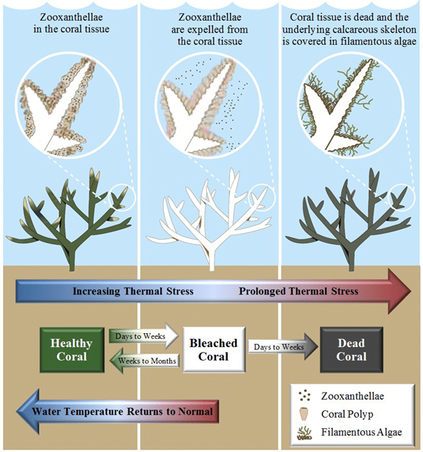
Figure 2.1 Diagram of thermal coral bleaching Marshall and Schuttenberg (2006).

Traditionally, coral reef monitoring has relied on survey-based methods conducted by trained divers. Common approaches include line transect surveys and quadrat sampling, where observers manually inspect reef sections and record coral conditions. While these methods provide detailed ecological observations, they suffer from critical limitations. Survey coverage is restricted by dive duration, environmental conditions, and operational cost. In addition, manual assessments are inherently subjective, leading to inconsistencies between observers and increasing the likelihood of classification errors, especially under fatigue or poor visibility conditions.
As coral reef degradation occurs rapidly and across large spatial scales, traditional surveys struggle to deliver timely and repeatable assessments. The growing volume of reef imagery collected using underwater cameras, remotely operated vehicles, and autonomous platforms has further widened the gap between data acquisition and human analysis capacity. This limitation has motivated a shift away from purely manual surveys toward automated analysis techniques.
To address these challenges, computer vision–based monitoring has emerged as an effective alternative. Computer vision enables the automated analysis of coral reef images by extracting visual patterns related to colour, texture, and structural features. This approach reduces dependence on human judgement, improves consistency, and allows large image datasets to be processed efficiently. As a result, image-based monitoring has become a practical solution for large-scale coral reef assessment.
Underwater imagery introduces a range of domain-specific challenges that differ from terrestrial image acquisition, including wavelength-dependent colour attenuation, reduced contrast, non-uniform lighting conditions, and image degradation caused by light absorption and scattering in water. These factors can mask ecologically meaningful visual cues and negatively affect classification performance. As a result, image pre-processing becomes a critical step before automated analysis. Common pre-processing operations include colour normalization and correction, contrast enhancement, spatial resizing, and intensity scaling to improve feature representation and ensure compatibility with learning algorithms. In addition, data augmentation techniques are widely adopted to mitigate data scarcity or class imbalance and to enhance the generalisation capability of deep learning models (Ancuti, Ancuti, Haber, & Bekaert, 2012; Akkaynak & Treibitz, 2019).
While traditional image processing methods can enhance image quality, they are insufficient for reliably distinguishing complex coral health patterns across diverse underwater conditions. This limitation has led to the adoption of deep learning approaches, which can automatically learn hierarchical feature representations directly from image data. Convolutional neural networks have demonstrated strong capability in capturing spatial and textural features relevant to coral health classification. Recent studies further indicate that efficient CNN architectures, such as EfficientNet, provide a favourable balance between classification accuracy and computational efficiency, making them suitable for large-scale coral reef monitoring systems.

Image-Based Coral Reef Monitoring Using Computer Vision
Following the transition from manual surveys to automated analysis, computer vision has become a central approach for large-scale coral reef monitoring. In this context, computer vision refers to the use of algorithms that enable machines to interpret and analyse visual information from coral reef images in a consistent and scalable manner. Rather than relying on human observers, these systems process pixel-level information to detect visual patterns associated with coral health conditions.
Recent advances in imaging technology have significantly increased the availability of underwater coral imagery. High-resolution cameras mounted on divers, remotely operated vehicles, and autonomous underwater vehicles allow extensive reef areas to be documented efficiently. However, the sheer volume of images produced makes manual analysis impractical. Computer vision addresses this challenge by enabling automated extraction of relevant visual cues such as colour variation, surface texture, and structural integrity, which are key indicators of coral health.
Early computer vision approaches in coral reef studies relied on handcrafted features and rule-based classifiers. While these methods demonstrated potential, their performance was limited by sensitivity to environmental variations such as lighting conditions, water turbidity, and background complexity. As a result, modern approaches increasingly integrate learning-based techniques that adapt to diverse underwater conditions. Empirical studies have shown that image-based computer vision systems can achieve higher consistency and repeatability than manual annotation, making them suitable for long-term reef monitoring and comparative analysis across sites (Beijbom et al., 2015; González-Rivero et al., 2020).
This progression establishes computer vision as a foundational component of automated coral reef health assessment systems. However, the effectiveness of such systems depends heavily on the quality and consistency of the input images, which necessitates systematic image preprocessing prior to model training and analysis.

Image Pre-processing in Coral Reef Image Analysis
Image preprocessing plays a critical role in ensuring reliable performance of computer vision and deep learning models applied to underwater coral imagery. Unlike terrestrial images, underwater images are affected by wavelength-dependent light absorption, scattering, and colour attenuation, which often result in low contrast, colour imbalance, and noise. These distortions can obscure biologically meaningful features if not addressed prior to analysis.
Common preprocessing operations include image resizing, normalisation, colour correction, and contrast enhancement. Resizing ensures uniform input dimensions required by convolutional neural networks, while normalisation stabilises numerical ranges and supports efficient model convergence during training. Colour correction and contrast enhancement are applied to mitigate the effects of blue or green colour dominance caused by water absorption, thereby improving the visibility of coral tissue and structural patterns.
In addition to basic preprocessing, data augmentation techniques are frequently employed to improve model robustness and generalisation. Operations such as random rotation, flipping, zooming, and scaling artificially increase dataset diversity and help reduce overfitting, particularly when class distributions are imbalanced. This is especially relevant in coral reef datasets, where healthy coral images often outnumber bleached or dead samples.
Prior studies consistently report that effective preprocessing enhances feature extraction and improves classification accuracy in coral reef image analysis (Beijbom et al., 2015; Mahmood et al., 2021). Rather than serving as an isolated step, preprocessing functions as an enabling stage that prepares underwater imagery for higher-level learning models. The specific preprocessing techniques adopted in this project are detailed in Chapter 3, where their implementation and parameter selection are described in relation to the chosen deep learning architecture.

Deep Learning Models for Coral Reef Health Classification

Convolutional Neural Networks for Image Classification
Convolutional neural networks (CNNs) have emerged as a powerful method in classifying images as they have the propensity to extract discriminative visual pictures out of raw image data. Instead of using the handcrafted features, CNNs use a series of layered convolutional operations to learn spatial patterns at different levels of abstraction. CNNs can model visual features, like coral texture, colour variation, and structural morphology, which characterize healthy, bleached and dead coral conditions in the context of coral reef health assessment. The lower network layers generally encode common visual features, such as edges and colour gradients, whilst higher levels specify features that are more high-level and class-specific and can be useful in classification. This hierarchical feature learning approach predetermines that CNNs are especially appropriate to underwater image processing, in which subtle visual distinctions play a crucial role in this domain of accurate discrimination of health conditions (LeCun, Bengio, and Hinton, 2015).
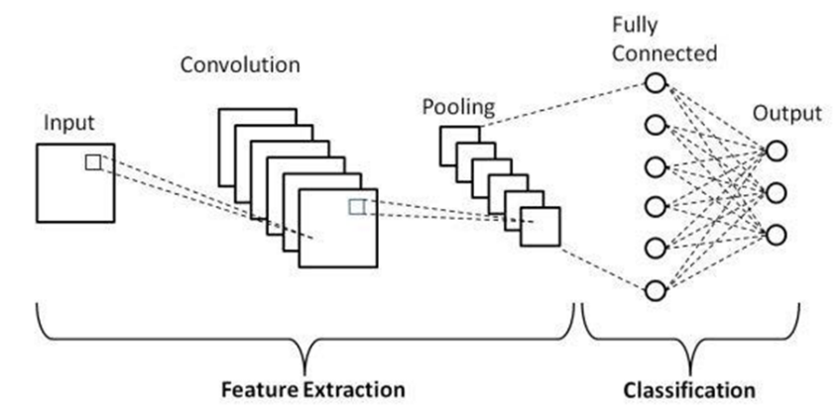
Figure 2.2 Architecture of Convolutional Neural Network (CNN) (Babaeipour et al., 2023).

Transfer Learning in Environmental Image Analysis
Most datasets on coral reefs are relatively small, impeding the use of deep learning algorithms that must be trained from the ground up. This issue can be mitigated by using transfer learning, which makes use of convolutional neural networks (CNNs) trained on other large collections of images. Researchers can avoid the issues of overfitting and excessive training time when refining pre-trained models on coral reef images and thus achieve better classification results. Due to these advantages, transfer learning has become a widely accepted approach in the analysis of images from marine and other environmental domains, enabling robust feature extraction even when domain-specific labelled data is limited (Pan & Yang, 2010).

CNN Architectures Used in Related Studies
At present, there is a compromise between accuracy and computational cost in various architectures of convolutional neural networks and the classification of images of coral reefs and associated environments. There are VGG-based models that are relatively simple, but they have a high parameter count which is costly in terms of computations. Some architectures of ResNets have solved one of the problems of deep networks with residual connections whereby greater accuracy is achieved, though at a greater cost to the complexity of the model. Other architectures of MobileNets emphasise less on computations and more on the design of lightweight models which are effective in situations where computational resources are limited, though at the cost of performance.
Recent studies consistently report a clear trade-off trend between classification accuracy and model size across these architectures. As model capacity increases, accuracy generally improves, but this is accompanied by higher parameter counts and computational demands. EfficientNet architectures are notable within this trend, as they achieve comparatively strong performance while maintaining lower computational cost through balanced scaling of network depth, width, and input resolution (Tan & Le, 2019). These reported trade-off trends in the literature highlight the importance of selecting architectures that balance performance and efficiency for practical coral reef health applications.
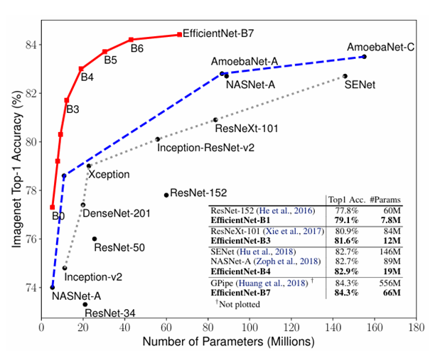
Figure 2.3 Overview of CNN architectures evaluated in coral reef and marine image classification studies.

EfficientNet Architecture and Scaling Strategy
EfficientNet performs a joint scaling of convolutional neural networks, which scales both network depth and network width as well as input resolution. This compound scaling strategy also assigns model capacity more efficiently in all dimensions, rather than adding capacity in a single dimensional architecture, and is likely to result in higher learning efficiency. With a combination of these scaling factors, EfficientNet can trade-off between accuracy and computational cost, which does not need to unnecessarily increase model complexity. As Tan and Le (2019) showed, EfficientNet models have continued to achieve superior performance over standard architectures on large-scale image classification tasks with much fewer parameters and less computational resources.
The EfficientNet family includes one baseline model, EfficientNet-B0, and seven variants, EfficientNet-B1 through EfficientNet-B7, each of which is progressively larger and incorporates increased model capacity through fixed scaling coefficients. This construction enables users to tailor model selection to specific computational and application needs. This flexibility is especially useful in environmental monitoring, where there are limitations in deployment and efficiency needs.
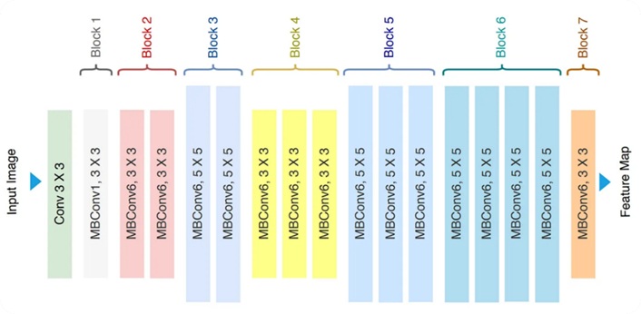
Figure 2.4 EfficientNet architecture diagram (Tan & Le, 2019).
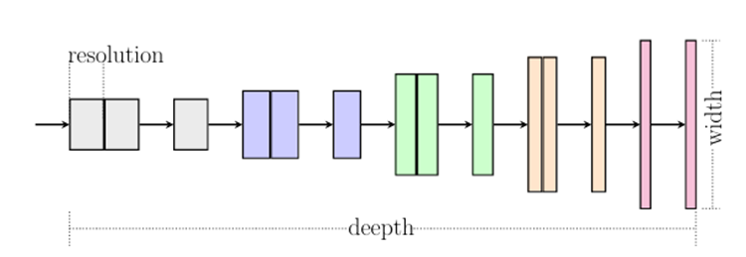
Figure 2.5 Compound scaling principle.(Tan & Le, 2019).

Table 2.1 High-level comparison of CNN architectures (Tan & Le, 2019) .
Architecture | Key characteristic | Computational cost | Reported performance trend
VGG | Uniform deep layers | High | Moderate accuracy
ResNet | Residual connections | High | High accuracy
MobileNet | Depth wise convolutions | Low | Lower accuracy
EfficientNet | Compound scaling | Low-moderate | High accuracy

Justification for EfficientNet in Coral Reef Health Assessment
Considering the balance between accuracy and model efficiency, EfficientNet is a good choice for classifying the health of coral reefs. EfficientNet works well since underwater images have many textures and hues and require strong feature representations. Monitoring systems, however, require a model that is efficient computationally. EfficientNet meets the criteria of strong feature representation and compact architecture for classification and deployment in resource-limited settings. Underwater images have many textures and hues that require strong representations. EfficientNet captures these patterns and features and is compact and efficient. The model completes training quickly, allowing for deployment in field or edge-based monitoring systems. EfficientNet is the primary choice for a convolutional neural network structure for this project.

Stochastic Weight Averaging as an Ensemble Optimisation Strategy
Stochastic Weight Averaging (SWA) is an optimisation technique that constructs an ensemble representation within a single model instance by averaging the weights visited across multiple training checkpoints rather than selecting a single final solution. Proposed by Izmailov et al. (2018), SWA exploits the observation that SGD trajectories traverse diverse regions of the loss landscape, many of which individually generalise well but are not fully exploited when training is terminated at a single point. By averaging these weight solutions, SWA converges to a wider, flatter loss region that correlates with improved generalisation on unseen data compared to conventional single-checkpoint models. This weight-space averaging approach reduces per-seed variance without the storage and inference overhead associated with independently deployed multi-model ensembles (Lakshminarayanan et al., 2017), making it particularly suitable for constrained training settings where class imbalance and limited sample availability amplify the risk of suboptimal single-checkpoint convergence.

Interpretability Analysis Using Grad-CAM
Explainable Artificial Intelligence (XAI) refers to a class of methods and frameworks designed to make the decision-making processes of machine learning models transparent and interpretable to human users. As deep learning systems are increasingly applied in high-stakes domains such as environmental monitoring, the inability to understand why a model produces a particular output represents a critical limitation for scientific trust and operational deployment. XAI techniques address this by providing post-hoc explanations that relate model predictions to specific input features. Among the available XAI methods, Gradient-weighted Class Activation Mapping (Grad-CAM) is particularly well-suited to convolutional neural network architectures, as it generates spatially resolved heatmaps that directly highlight the image regions most influential to the model's classification decision.

Need for Model Interpretability in Coral Health Assessment
Grad-CAM is integral to coral health classification since convolutional neural networks are often considered black-box models. In ecological monitoring, researchers require models to demonstrate reliable predictions coupled with the ability to pay attention to biologically relevant features of the coral. In coral reef images, relevant features are the images of the coral itself, such as the colour of the tissue, signs of bleaching, and the texture of the algae. A model without interpretability might focus on features of the background that are not relevant, such as lighting and colour of the water. Previous works have outlined the importance of explainable artificial intelligence in building trust and fostering informed decision-making and conservation action in marine ecology and environmental monitoring (González-Rivero et al., 2020; Samek et al., 2021). For Grad-CAM, this is because it produces class-discriminative visual explanations that show which spatial dimensions of the input image are most relevant to the predicted class of coral health.

Working Principle of Grad-CAM
Gradient-weighted Class Activation Mapping is an explainability technique designed to associate a convolutional neural network’s prediction with spatial regions in the input image. Instead of relying on the final classification layers, Grad-CAM analyses the responses of the final convolutional layer, where high-level semantic information and spatial structure are still preserved. The contribution of each feature map is estimated by examining how changes in that map influence the output score of a specific target class. These contributions are then combined to generate a class-dependent activation map that highlights image regions most relevant to the prediction.
To ensure interpretability, only positively contributing regions are retained through a rectification operation, resulting in a coarse but meaningful localization of discriminative visual patterns. Because the method operates directly on convolutional features, it maintains spatial awareness while remaining applicable to a wide range of CNN architectures. This characteristic makes Grad-CAM particularly suitable for complex visual environments, such as underwater imagery, where identifying biologically meaningful regions is essential for distinguishing healthy, bleached, and dead coral structures.
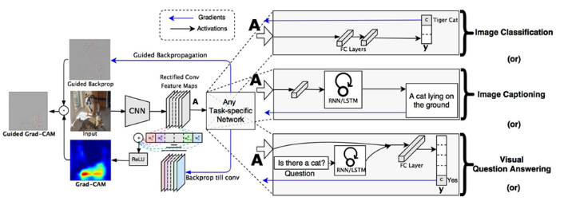
Figure 2.6 Conceptual illustration of the Grad-CAM process (adapted from Selvaraju et al., 2020).

Evidence of Grad-CAM Effectiveness in Coral and Environmental Imaging
Prior work in coral reef monitoring indicates that Grad-CAM can generate visual explanations that are consistent with biological interpretations of coral health. Ghaffar and Choi (2025) applied Grad-CAM within a two-stream deep learning framework to analyse coral reef images across three health conditions: healthy, bleached, and dead. Their results showed that model attention was predominantly directed toward ecologically meaningful coral regions rather than irrelevant background areas. Specifically, activation maps for healthy corals highlighted intact tissue and distinct colour patterns, while bleached corals exhibited reduced pigmentation associated with tissue degradation. In contrast, dead coral samples showed attention focused on regions affected by sediment deposition and algal overgrowth. These activation patterns correspond closely with visual cues commonly used by marine scientists during manual assessments, providing evidence that Grad-CAM supports biologically valid and interpretable coral health classification.
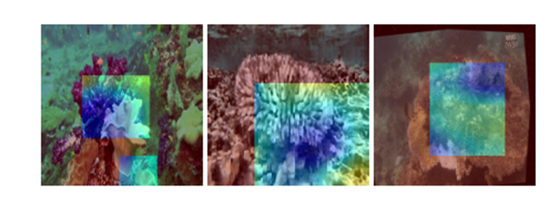
Figure 2.7 Grad-CAM visualizations highlighting image regions contributing to the classification of Healthy, Bleached Coral, and Dead Coral (Ghaffar & Choi, 2025).

The images produced by Grad-CAM presented by (Ghaffar & Choi, 2025) demonstrate that the outputs of convolutional neural networks can be interpreted within the context of the neural networks and coral reefs. The authors state that Grad-CAM heatmaps demonstrate bubble coral features, while open water and background sand remain suppressed. This evidence overcomes one of the main criticisms of previous studies on coral classification that relied on accuracy as a deciding metric, while not addressing the visual interpretations of the model's decisions. Predictive coral features observed by Grad-CAM lend credibility to the application of deep learning technology in ecological and environmental monitoring. Thus, Grad-CAM demonstrates the biological adequacy of the auto-classification of coral reef and mortality.

Compatibility of Grad-CAM with EfficientNet Architecture
Grad-CAM was able to work with EfficientNet since it generates class-discriminative localization heatmaps based on gradients of target classes responsible for each convolutional feature map. EfficientNet’s convolutional layers maintain sufficient spatial resolution so that meaningful localization maps can be created upon gradient backpropagation. In the plant disease detection study by (Shukla et al., 2020), the authors used Grad-CAM for leaf disease classification using both ResNet and EfficientNet, and localized disease symptoms on leaf images. The authors observed that, compared to the older CAM method, Grad-CAM, with EfficientNet, localized diseased areas on leaf images more clearly and more focused. This suggested that the final convolutional feature maps had enough spatial resolution for gradient-based explanations to be created.
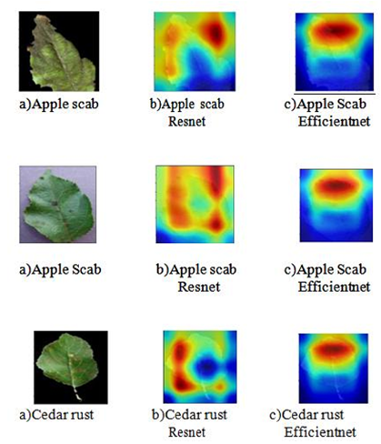
Figure 2.8 Grad-CAM heatmap results from an EfficientNet-based classification model showing localized activations corresponding to diseased leaf regions(Shukla et al., 2020).

The Grad-CAM heatmaps, generated using an EfficientNet-based model, show relevant affected leaf areas, while omitting background areas such as healthy tissue. This suggests that EfficientNet is good for feature extraction and appropriate for spatial representation and interpretability. The empirical evidence, though different from coral, supports the fine-grained texture and colour complexity, which justifies the use of Grad-CAM and EfficientNet for coral reef health classification. This is consistent with the literature on explainable AI and Grad-CAM, which can be used with any convolutional neural network, including the various versions of EfficientNet.

Role of Grad-CAM in Supporting Scientific Trust
Grad-CAM in the context of the assessment of the health of coral reefs combines the automated prediction with scientific reasoning. By linking classifications to specific areas of coral, researchers may evaluate whether the model focuses on the areas of the patchy bleaching, intact pigmentation, or algal dominance, which is in tune with ecological reasoning. This is supportive of the second goal of the project, which is to offer interpretable model outputs that scientists can trust. Thus, the use of Grad-CAM in conjunction with the proposed EfficientNet-based framework is, in this case, a technical improvement as well as a methodological necessity for incorporating deep learning into the tool kit for the conservation of endangered species.

Performance Evaluation Metrics
Evaluating a classification model requires metrics that reflect performance across all classes, not merely the aggregate result. This is particularly relevant when class distributions are unequal, as a model biased toward majority classes can report misleadingly high overall accuracy while consistently failing on minority categories.
Accuracy measures the proportion of correctly classified samples across all classes:
$$\text{Accuracy}=\frac{TP+TN}{TP+TN+FP+FN}$$ | (2.1)

For example, given TP = 50, TN = 35, FP = 8, and FN = 7, the accuracy is (50 + 35) / (50 + 35 + 8 + 7) = 85/100 = 0.85, indicating that 85% of all samples are correctly classified.

Precision quantifies the reliability of positive predictions:
$$\text{Precision}=\frac{TP}{TP+FP}$$ | (2.2)
For example, given TP = 50 and FP = 8, Precision = 50 / (50 + 8) = 50/58 ≈ 0.862, meaning 86.2% of positive predictions are correct.
Recall measures the model's ability to detect all actual positives:
$$\text{Recall}=\frac{TP}{TP+FN}$$ | (2.3)
For example, given TP = 50 and FN = 7, Recall = 50 / (50 + 7) = 50/57 ≈ 0.877, meaning 87.7% of all actual positives are correctly identified.

F1-Score harmonises precision and recall into a single value:
$$F_{1}=2×\frac{\text{Precision}×\text{Recall}}{\text{Precision}+\text{Recall}}$$ | (2.4)
For example, using Precision = 0.862 and Recall = 0.877, F1 = 2 × (0.862 × 0.877) / (0.862 + 0.877) = 1.512/1.739 ≈ 0.869, reflecting a balanced performance across both metrics.
Macro F1-Score averages class-level F1-scores with equal weight regardless of sample count, making it the most informative metric when one class such as Dead coral is underrepresented. These metrics are applied jointly in the related works reviewed in the following section and form the evaluation framework used in Chapter 4.

Related Works

Deep Learning for Coral Reef Health Classification
The application of convolutional neural networks to underwater image classification has expanded considerably in recent years, reflecting the broader demand for automated tools in marine ecosystem monitoring. Zhou et al. (2024) proposed a classification model combining EfficientNetB0, pretrained on ImageNet, with a two-hidden-layer random vector functional link (TRVFL) classifier for underwater image recognition. Evaluated across three benchmark datasets MLC2008, MLC2009, and Fish-gres the EfficientNetB0-TRVFL model achieved classification accuracies of 87.28%, 74.06%, and 99.59% respectively, consistently outperforming ResNet50, VGG16, AlexNet, and GoogLeNet across all six evaluation indicators. The architecture of the proposed model is illustrated in Figure 2.9, which presents the EfficientNetB0 feature extraction pipeline coupled with the TRVFL classification layer. The comparative results, summarised in Table 2.2, confirm that EfficientNetB0 delivers superior and more stable classification performance relative to conventional CNN architectures under challenging underwater imaging conditions, establishing its suitability as a backbone for marine visual classification tasks.
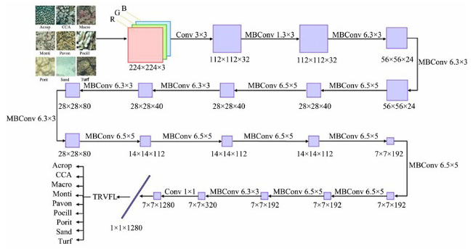
Figure 2.9 Architecture of the EfficientNetB0-TRVFL underwater image classification model (Zhou et al., 2024).

Table 2.2 Performance comparison of EfficientNetB0-TRVFL against baseline CNN models across three underwater datasets (Zhou et al., 2024).
Model | MLC2008  Accuracy (%) | MLC2008  F1 (%) | MLC2009  Accuracy (%) | Fish-gres  Accuracy (%) | Fish-gres  F1 (%)
AlexNet | 79.47 | 76.07 | 67.17 | 90.14 | 87.04
VGG16 | 81.78 | 80.43 | 68.46 | 92.61 | 91.09
ResNet50 | 79.97 | 77.95 | 69.45 | 94.87 | 93.94
EfficientNetB0 | 82.44 | 81.21 | 71.38 | 94.97 | 94.36
EfficientNetB0-TRVFL | 87.28 | 84.34 | 74.06 | 99.59 | 99.55

At the coral condition classification level, Shao et al. (2024) constructed a dataset of over 20,000 high-resolution underwater images collected through field surveys at Koh Tao, Thailand, annotated across eight ecological classes including healthy coral, compromised coral, and dead coral. As illustrated in Figure 2.10, the dataset captures both close-range and colony-scale photographs to reflect real-world monitoring conditions. Twenty-one deep learning architectures were systematically evaluated using the F1 metric and match ratio, with results presented in Table 2.3. EfficientNet models achieved an average micro F1-score of 82.31%, surpassing the VGG family average of 76.53% whilst employing substantially fewer parameters 39.75M on average compared to VGG's 138.40M. The study further demonstrated that an ensemble integrating Swin-Transformer-Small, Swin-Transformer-Base, and EfficientNet-B7 achieved the highest overall performance, recording a micro F1-score of 86.39% and a match ratio of 63.33%. These findings establish that EfficientNet architectures offer a computationally efficient and ecologically viable solution for coral condition monitoring, and that ensemble strategies consistently yield performance gains beyond what any individual model achieves in isolation.
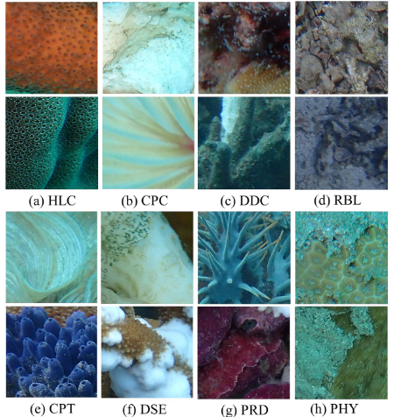
Figure 2.10 Representative patch samples from the coral reef condition dataset across eight ecological classes including healthy coral (HLC), dead coral (DDC), and compromised coral (CPC) (Shao et al., 2024).

Table 2.3 Classification performance of selected deep learning models for multi-label coral reef condition classification (Shao et al., 2024).
Model | Match Ratio (%) | Micro F1 (%) | Macro F1 (%) | Parameters
VGG-16 (BN) | 44.63 | 76.34 | 68.36 | 138.4M
ResNet-50 | 44.15 | 77.27 | 69.20 | 25.6M
EfficientNet-B7 | 54.92 | 82.99 | 77.54 | 66.3M
Swin-Transformer-Base | 58.49 | 84.00 | 78.87 | 87.8M
Swin-S + Swin-B + EfficientNet-B7 | 63.33 | 86.39 | 81.74 | 203.7M

The challenges of applying standard CNN models to coral health classification are also demonstrated by the work of Wang et al. (2024), who developed ML-Net, a multi-local perception network to specifically learn the colour and texture features that are essential for coral health classification. Figure 2.11 displays sample healthy and bleached coral images from the coral dataset, showcasing the visual features that the classification task needs to discriminate. As per the results in Table 2.4, EfficientNet achieved the lowest accuracy (54.25%) and F1-score (38.16%) among the models on the coral bleaching dataset, due to its compound scaling approach, which focuses on global feature extraction rather than localised visual features. ML-Net recorded an accuracy of 86.35% and F1-score of 86.34%, surpassing EfficientNet, ResNet, ViT and ConvNext on all six performance metrics. This result illustrates that the base EfficientNetB0 architecture, without architectural modifications and ensemble-based techniques to improve the model's robustness, is not suitable for coral health classification that involves subtle visual distinctions.
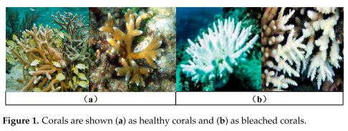
Figure 2.11 Representative samples of (a) healthy coral and (b) bleached coral from the binary classification dataset (Wang et al., 2024).

Table 2.4 Classification performance of ML-Net and baseline models on the coral bleaching dataset (Wang et al., 2024).
Model | ACC (%) | AUC (%) | F1 (%) | Precision (%) | Recall (%)
EfficientNet | 54.25 | 49.91 | 38.16 | 29.43 | 54.25
MobileNet | 78.64 | 82.21 | 78.50 | 78.71 | 78.64
ResNet | 81.99 | 86.59 | 81.92 | 82.03 | 81.99
ShuffleNet | 84.79 | 87.50 | 84.81 | 85.03 | 85.03
ML-Net | 86.35 | 90.78 | 86.34 | 86.34 | 86.35

Collectively, the three studies reviewed in this section confirm that EfficientNetB0 constitutes a validated and computationally efficient backbone for underwater and marine image classification. Zhou et al. (2024) demonstrate its superiority over conventional CNN architectures in underwater benchmark tasks, while Shao et al. (2024) establish the effectiveness of EfficientNet-based ensemble approaches for multi-label coral condition monitoring. Wang et al. (2024), however, reveal that standard EfficientNet applied without ensemble augmentation or architecture-level modification fails to achieve competitive accuracy for coral health classification. Taken together, these findings identify a clear gap: no existing study has combined EfficientNetB0 with multi-seed stochastic weight averaging, multi-scale test-time augmentation, and Grad-CAM interpretability for the specific task of tri-class coral health classification encompassing healthy, bleached, and dead coral conditions. This gap directly motivates the architecture proposed in the present study.

EfficientNetB0 with Grad-CAM for Explainable Biological Image Classification
Combining Gradient-weighted Class Activation Mapping (Grad-CAM) with EfficientNetB0 has already been confirmed as a successful way to produce interpretable classification decisions in biological image classification systems. Assaduzzaman et al. (2025) introduced XSE-TomatoNet, a modified EfficientNetB0 model with Squeeze-and-Excitation blocks and multi-scale feature fusion for the classification of tomato leaf diseases. The network was trained using 10-fold cross-validation with a training accuracy of 99.41% and validation accuracy of 98.88%, surpassing MobileNet (87.44%) and VGG-19 (95.50%) as shown in Table 2.5. Heatmaps were produced using Grad-CAM and Grad-CAM++ that visually showed model focus on diseased areas of the tomato leaf, shown in Figure 2.12. The researchers also employed LIME and SHAP explanations in conjunction with Grad-CAM to build a multi-level interpretability model. The authors deployed the model in a Flask-based web service for end-users (tomato farmers), which aligns with the deployment goals of this study.
Table 2.5 Classification performance comparison of XSE-TomatoNet against baseline models for tomato leaf disease classification (Assaduzzaman et al., 2025).
Model | Accuracy (%) | Precision (%) | Recall (%) | F1-Score (%)
MobileNet | 87.44 | — | — | —
VGG-19 | 95.50 | — | — | —
XSE-TomatoNet (EfficientNetB0) | 99.41 | 99.00 | 99.00 | 99.00

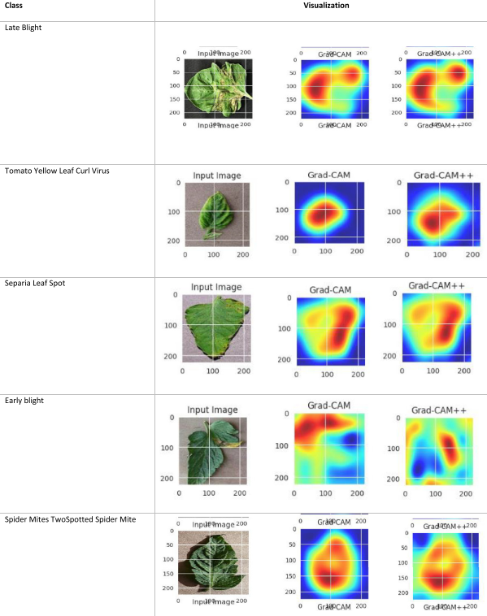
Figure 2.12 Grad-CAM heatmaps generated by XSE-TomatoNet highlighting disease-relevant regions on tomato leaf images, confirming model attention on symptom areas (Assaduzzaman et al., 2025).

At the level of species-level biological taxonomy, Korkmaz et al. (2025) applied multiple deep learning architectures including EfficientNetB0 for the classification of Discomycetes macrofungi species a visually complex multi-class biological task requiring discrimination between morphologically similar organisms. EfficientNetB0 achieved 97% accuracy and a 97% F1-score as presented in Table 2.6, demonstrating strong generalisation capability in a domain characterised by significant intraclass visual variation. Grad-CAM and Score-CAM were subsequently applied to examine which image regions activated the model's classification decisions, with results shown in Figure 2.13. The XAI analysis revealed that EfficientNetB0 attended to both core fungal morphological structures including cap shape, texture, and spore distribution and contextual background regions. This finding highlights the dual role of Grad-CAM as both a performance validation tool and a diagnostic instrument for identifying model attention patterns in biological classification tasks. The study confirms that Grad-CAM is not merely cited but actively implemented to verify the biological relevance of model decisions, a practice directly applicable to coral health assessment where distinguishing bleached from healthy tissue relies on analogous texture and colour features.
Table 2.6 Classification performance of EfficientNetB0 and comparative models for Discomycetes species classification with Grad-CAM interpretability (Korkmaz et al., 2025).
Model | Accuracy (%) | F1-Score (%) | XAI Method Applied
Comparative CNNs | Below 97 | Below 97 | —
EfficientNetB0 | 97 | 97 | Grad-CAM, Score-CAM

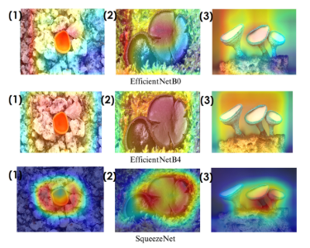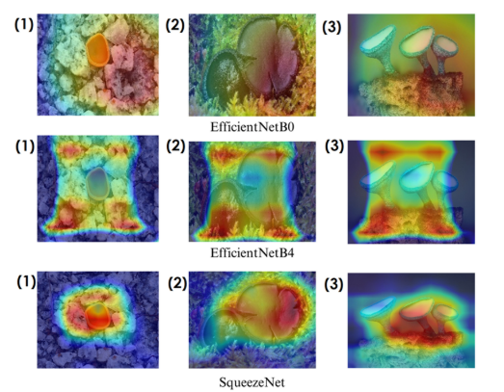
Figure 2.13 Grad-CAM and Score-CAM visualisations applied to EfficientNetB0 for Discomycetes species classification, highlighting activated regions corresponding to fungal morphological structures (Korkmaz et al., 2025).

The localization capability of Grad-CAM when paired with EfficientNetB0 is further supported in the medical imaging domain by Montalbo and Alon (2021), who applied a fine-tuned EfficientNetB0 for the classification and detection of malaria parasites from microscopic blood smear images. The model achieved a classification accuracy of 94.70% on the LHNCBC dataset, outperforming several deeper architectures including VGG and ResNet variants as shown in Table 2.7. Grad-CAM was applied to generate saliency maps that visualised the precise spatial regions corresponding to parasitic infections within blood cells, as depicted in Figure 2.14. The analysis demonstrated that EfficientNetB0 produced the most localised and biologically accurate attention maps among all evaluated models, focusing specifically on infected cell regions rather than surrounding tissue. This precision in region localisation is directly analogous to the interpretability objective of the present study, where Grad-CAM is used to confirm that the model attends to biologically meaningful coral features such as pigmentation loss in bleached coral and skeletal exposure in dead coral rather than background noise or imaging artefacts.
Table 2.7 Classification accuracy of fine-tuned EfficientNetB0 and baseline models for malaria parasite detection with Grad-CAM interpretability (Montalbo & Alon, 2021).
Model | Accuracy (%) | Grad-CAM Applied | Localisation Quality
VGG variants | Below 94 | No | Diffuse
ResNet variants | Below 94 | No | Diffuse
EfficientNetB0 (Fine-tuned) | 94.70 | Yes | Precise parasite localisation

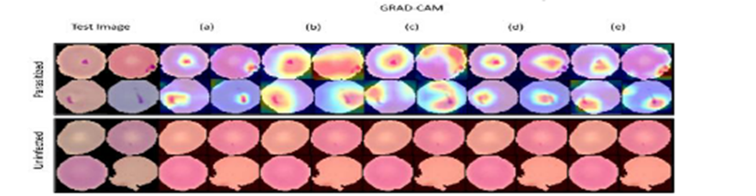
Figure 2.14 Grad-CAM saliency maps generated by fine-tuned EfficientNetB0 for malaria parasite detection, showing precise localisation of infected regions within blood smear images (Montalbo & Alon, 2021).

These studies collectively confirm that EfficientNetB0 paired with Grad-CAM is a peer-validated, cross-domain approach for explainable biological image classification, consistently achieving high accuracy whilst producing spatially meaningful activation maps across fungal taxonomy (Korkmaz et al., 2025), plant disease detection (Assaduzzaman et al., 2025), and medical microscopy (Montalbo & Alon, 2021). None of the reviewed studies applied EfficientNetB0 and Grad-CAM within an ensemble framework incorporating stochastic weight averaging, multi-scale test-time augmentation, and tri-class coral health classification, motivating the integrated pipeline adopted in the present study.

Ensemble Methods with EfficientNetB0 for Classification Robustness
Ensemble learning addresses a fundamental limitation of single-model deployment: the sensitivity of learned weight configurations to stochastic initialisation. By aggregating predictions or feature representations from multiple networks or training seeds, ensemble frameworks suppress individual model variance and produce more stable decision boundaries. Three peer-reviewed studies are examined in this subsection, each demonstrating that EfficientNet-based ensemble strategies yield consistent classification gains over standalone configurations across diverse medical imaging domains.
Singh et al. (2024) developed a weighted probability-averaging ensemble of ResNet50 and EfficientNet-B7 to classify four classes of brain tumours using Crystal Clean Brain Tumour MRI Dataset, which contains about 22,000 high-resolution images of no tumour, glioma, meningioma, and pituitary tumour. Figure 2.15 and Figure 2.16 of Singh et al. (2024) present the ensemble architecture, which uses a weight of 30 percent on ResNet50 and 70 percent on EfficientNet-B7, combining the results of the softmax into a weighted average to form the final prediction. Table 2.8 of Singh et al. (2024) records training and validation performance in all ten epochs with the ensemble model achieving a final validation accuracy of 99.68 per cent compared to 98.20 per cent with EfficientNet-B7 and 97.65 per cent with ResNet50 respectively. The ensemble achieved 99.53 on the held-out test set, with the values of class-level precision, recall and F1-scores in Table 2.9 of Singh et al. (2024) indicating values of at least 0.99 across most tumour types. Figure 2.17 of Singh et al. (2024) further confirm that the ensemble significantly decreased the inter-class confusion between glioma and meningioma, which was still the main source of error in both the single models. It is only necessary to selectively weigh a stronger model with complementary predictions of a secondary architecture to suppress classification errors that cannot be resolved with either of them individually.
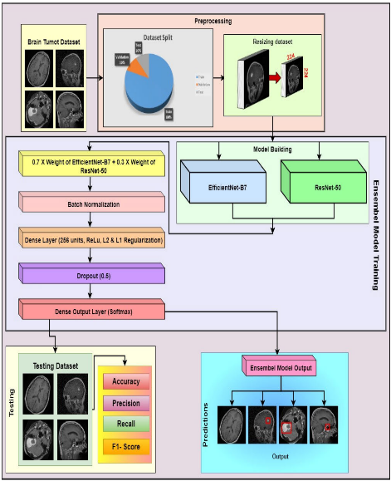
Figure 2.15 Ensemble framework flowchart Singh et al. (2024).
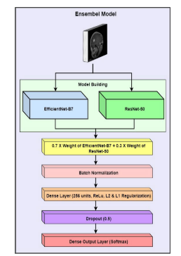
Figure 2.16 Ensemble model architecture diagram Singh et al. (2024).
Table 2.8 Epoch-wise accuracy comparison (all 3 models) Singh et al. (2024).
Epoch | Model | Training Accuracy | Validation Accuracy | Validation F1-Score
1 | ResNet50 | 83.15 | 92.62 | 0.929
 | EfficientNet-B7 | 91.12 | 93.45 | 0.9406
 | Ensemble Model | 88.55 | 96.54 | 0.9671
2 | ResNet50 | 93 | 95.39 | 0.9568
 | EfficientNet-B7 | 96.58 | 95.85 | 0.9595
 | Ensemble Model | 97.02 | 96.77 | 0.9712
3 | ResNet50 | 95.79 | 95.52 | 0.9567
 | EfficientNet-B7 | 97.47 | 97.88 | 0.9791
 | Ensemble Model | 98.28 | 98.48 | 0.9863
4 | ResNet50 | 96.95 | 95.71 | 0.96
 | EfficientNet-B7 | 97.99 | 98.2 | 0.984
 | Ensemble Model | 98.89 | 99.03 | 0.9906
5 | ResNet50 | 97.81 | 96.31 | 0.9654
 | EfficientNet-B7 | 98.48 | 97.65 | 0.974
 | Ensemble Model | 98.96 | 98.34 | 0.985
6 | ResNet50 | 98.38 | 96.95 | 0.9709
 | EfficientNet-B7 | 98.67 | 98.02 | 0.9781
 | Ensemble Model | 99.22 | 99.58 | 0.9962
7 | ResNet50 | 98.78 | 97.46 | 0.9754
 | EfficientNet-B7 | 98.84 | 98.8 | 0.9884
 | Ensemble Model | 99.41 | 99.68 | 0.997
8 | ResNet50 | 98.93 | 97.65 | 0.9776
 | EfficientNet-B7 | 98.94 | 97.09 | 0.9719
 | Ensemble Model | 99.5 | 99.58 | 0.9964
9 | ResNet50 | 99.04 | 97.32 | 0.9743
 | EfficientNet-B7 | 98.94 | 98.02 | 0.9802
 | Ensemble Model | 99.49 | 99.22 | 0.9924
10 | ResNet50 | 99.3 | 96.82 | 0.9693
 | EfficientNet-B7 | 98.86 | 98.11 | 0.9794
 | Ensemble Model | 99.57 | 99.31 | 0.9939

Table 2.9 Class-level precision, recall, F1 comparison Singh et al. (2024).
Class | Model | Precision | Recall | F1-Score | Support
Normal | Ensemble Model | 1 | 0.99 | 1 | 307
Glioma Tumor |  | 0.99 | 0.99 | 0.99 | 631
Meningioma Tumor |  | 0.99 | 1 | 0.99 | 639
Pituitary Tumor |  | 0.99 | 1 | 1 | 591
Normal | ResNet50 | 0.98 | 0.99 | 0.98 | 307
Glioma Tumor |  | 0.97 | 0.97 | 0.97 | 631
Meningioma Tumor |  | 0.97 | 0.96 | 0.97 | 639
Pituitary Tumor |  | 0.98 | 0.99 | 0.99 | 591
Normal | EfficientNet-B7 | 0.95 | 1 | 0.97 | 307
Glioma Tumor |  | 0.99 | 0.98 | 0.98 | 631
Meningioma Tumor |  | 0.97 | 0.99 | 0.98 | 639
Pituitary Tumor |  | 1 | 0.97 | 0.99 | 591
Overall Accuracy | Ensemble Model | 0.99 | 0.99 | 0.99 | 2168
 | ResNet50 | 0.98 | 0.98 | 0.98 | 2168
 | EfficientNet-B7 | 0.98 | 0.98 | 0.98 | 2168

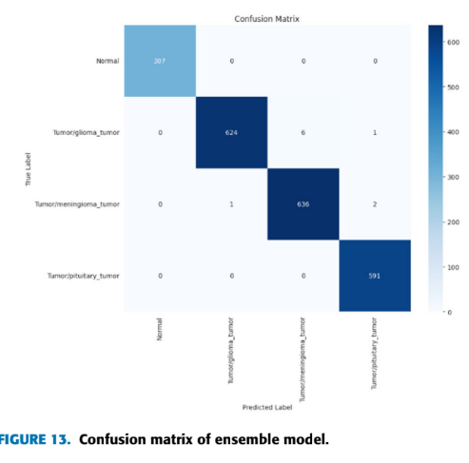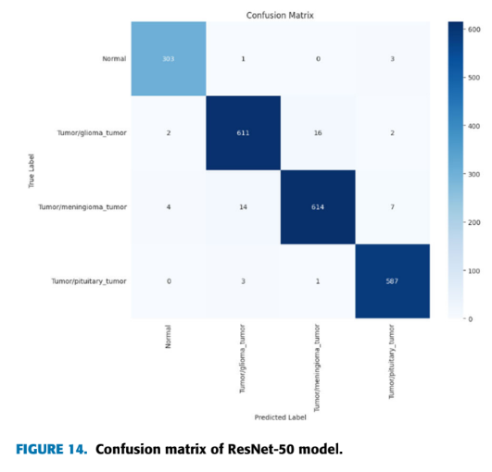
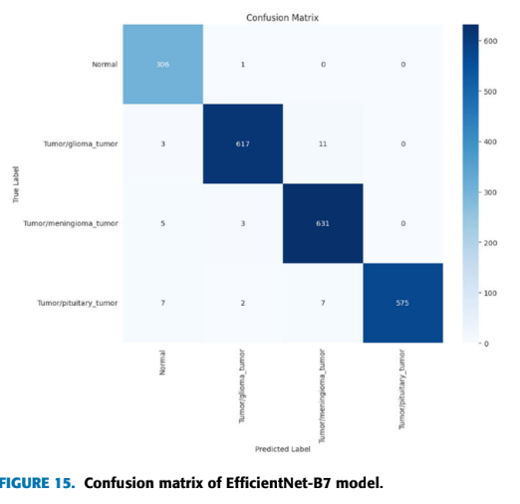
Figure 2.17 Confusion matrices for all 3 models Singh et al. (2024).

Ravi et al. (2022) suggested a multichannel stacking ensemble with the use of EfficientNet-B0, B1 and B2 as parallel feature extractors to classify lung diseases in three chest X-ray datasets comprising of paediatric pneumonia, tuberculosis and COVID-19. The representations of features obtained by each variant were then merged and fed into a two level stacking classifier which has the Random Forest, support vector machine and logistic regression modules. The ensemble scored 98, 99 and 98 percent classification on the three tasks, which is about 1-4 percentage points higher than EfficientNet variants alone on the same three tasks. The fact that EfficientNet-B0 is included in the multi-variant stack, and is in fact the most computationally efficient member of the EfficientNet family, is a good lesson in itself, that even when combined with architecturally complementary members scaled with larger compound coefficients, EfficientNet-B0 can contribute to overall performance.
Kallipolitis et al. (2021) explored a parallel ensemble system, where pretrained EfficientNet-B1, B2, and B3 models were run in parallel, with their feature maps concatenated and fed to a common fully connected classification head, as shown in Figure 2.18. Trained on breast and colon cancer histopathology datasets using the BreakHis and colorectal cancer benchmarks, the ensemble achieved 99.25% accuracy on the breast cancer binary task under the standard 70–30% split. Baseline performance metrics across binary and multiclass tasks are reported in Table 2.10, where individual EfficientNet variants and other architectures are evaluated on both breast and colon cancer datasets. Ensemble performance metrics across binary tasks at two training-to-validation splits (40–60% and 30–70%) are documented in Table 2.11, where the EfficientNet B0–B2 ensemble consistently matched or exceeded all individual baseline architectures. The performance gap between single models and the ensemble widened considerably under the more constrained splits, where individual EfficientNet variants degraded noticeably while the ensemble maintained superior accuracy and AUC. Performance across four magnification factors (40×, 100×, 200×, 400×) for both binary and multiclass classification tasks is further detailed in Table 2.12. Beyond classification performance, the study incorporated a Grad-CAM and Guided Grad-CAM explanation scheme directly into the ensemble framework. Figure 2.19 and Figure 2.20 demonstrate that the ensemble produces more spatially comprehensive activation maps by aggregating the regions of interest highlighted by each constituent subnetwork, an outcome that single-model Grad-CAM could not replicate. This finding further supports ensemble adoption by establishing that feature aggregation not only improves classification accuracy but also enhances the spatial coverage of explainability outputs.
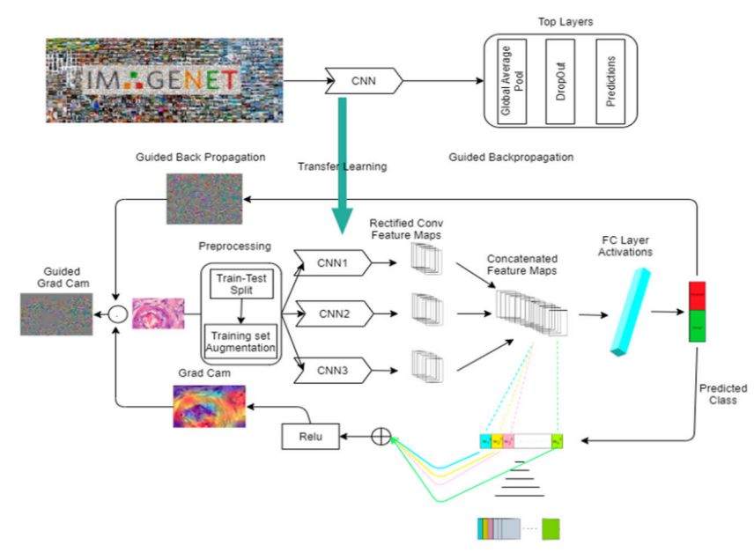
Figure 2.18 Parallel EfficientNet system architecture Kallipolitis et al. (2021).

Table 2.10 Performance metrics for breast and colon cancer baseline architectures Kallipolitis et al. (2021).
Architecture | Breast Cancer Accuracy | Breast Cancer AUC | Colon Cancer Accuracy | Colon Cancer AUC
EfficientNetB0 | 0.9766 | 0.9945 | 0.9946 | 0.9993
EfficientNetB1 | 0.9798 | 0.9964 | 0.9898 | 0.9984
EfficientNet B2 | 0.9817 | 0.9982 | 0.9920 | 0.9988
EfficientNet B3 | 0.9855 | 0.9988 | 0.9897 | 0.9984
EfficientNet B4 | 0.9858 | 0.9980 | 0.9910 | 0.9982
EfficientNet B5 | 0.9804 | 0.9975 | 0.9924 | 0.9982
EfficientNet B6 | 0.9728 | 0.9953 | 0.9894 | 0.9986
ExceptionNet | 0.9785 | 0.9942 | 0.9909 | 0.9985
InceptionNetV3 | 0.8868 | 0.9430 | 0.9844 | 0.9981
VGG16 | 0.9320 | 0.9769 | 0.9795 | 0.9969
ResNet152V2 | 0.8720 | 0.9431 | 0.9564 | 0.9913

Table 2.11 Performance metrics for breast and colon cancer ensemble architectures Kallipolitis et al. (2021).
Split | Architecture | Breast Cancer Accuracy | Breast Cancer AUC | Colon Cancer Accuracy | Colon Cancer AUC
40–60% | EfficientNetB0 | 0.9789 | 0.9974 | 0.9645 | 0.9874
40–60% | EfficientNetB1 | 0.9778 | 0.9974 | 0.9688 | 0.9899
40–60% | EfficientNetB2 | 0.9824 | 0.9986 | 0.9764 | 0.9906
40–60% | EfficientNetB0-2 | 0.9835 | 0.9989 | 0.9822 | 0.9934
30–70% | EfficientNetB0 | 0.9712 | 0.9962 | 0.9618 | 0.9822
30–70% | EfficientNetB1 | 0.9737 | 0.9972 | 0.9666 | 0.9831
30–70% | EfficientNetB2 | 0.9751 | 0.9968 | 0.9703 | 0.9852
30–70% | EfficientNetB0-2 | 0.9785 | 0.9979 | 0.9782 | 0.9925

Table 2.12 Accuracy, Precision, Recall at four magnification factors (binary and multiclass) Kallipolitis et al. (2021).
Metrics | Acc (40×) | Pr (40×) | Rec (40×) | Acc (100×) | Pr (100×) | Rec (100×) | Acc (200×) | Pr (200×) | Rec (200×) | Acc (400×) | Pr (400×) | Rec (400×)
EfficientNetB0 | 0.9699 | 0.9699 | 0.9699 | 0.9792 | 0.9792 | 0.9792 | 0.9631 | 0.9631 | 0.9631 | 0.9560 | 0.9560 | 0.9560
EfficientNetB1 | 0.9749 | 0.9749 | 0.9749 | 0.9679 | 0.9679 | 0.9679 | 0.9473 | 0.9473 | 0.9473 | 0.9158 | 0.9158 | 0.9158
EfficientNet B2 | 0.9799 | 0.9799 | 0.9799 | 0.9712 | 0.9712 | 0.9712 | 0.9631 | 0.9631 | 0.9631 | 0.9396 | 0.9396 | 0.9396
EfficientNet B3 | 0.9766 | 0.9766 | 0.9766 | 0.9744 | 0.9744 | 0.9744 | 0.9666 | 0.9666 | 0.9666 | 0.9451 | 0.9451 | 0.9451
EfficientNetB0-2 | 0.9883 | 0.9883 | 0.9883 | 0.9712 | 0.9712 | 0.9712 | 0.9719 | 0.9719 | 0.9719 | 0.9469 | 0.9469 | 0.9469
EfficientNetB1-3 | 0.9866 | 0.9866 | 0.9866 | 0.9824 | 0.9824 | 0.9824 | 0.9859 | 0.9859 | 0.9859 | 0.9697 | 0.9697 | 0.9697

Metrics | Acc (40×) | Pr (40×) | Rec (40×) | Acc (100×) | Pr (100×) | Rec (100×) | Acc (200×) | Pr (200×) | Rec (200×) | Acc (400×) | Pr (400×) | Rec (400×)
EfficientNetB0 | 0.9097 | 0.9215 | 0.9030 | 0.8702 | 0.8849 | 0.8622 | 0.8313 | 0.8569 | 0.8207 | 0.8333 | 0.8552 | 0.8114
EfficientNetB1 | 0.8796 | 0.8948 | 0.8679 | 0.8638 | 0.8696 | 0.8446 | 0.8313 | 0.8569 | 0.8207 | 0.8205 | 0.8340 | 0.8004
EfficientNet B2 | 0.8796 | 0.8948 | 0.8979 | 0.8798 | 0.8918 | 0.8718 | 0.8629 | 0.8723 | 0.8401 | 0.8040 | 0.8275 | 0.7729
EfficientNet B3 | 0.8963 | 0.9103 | 0.8829 | 0.8846 | 0.8893 | 0.8750 | 0.8594 | 0.8703 | 0.8489 | 0.8443 | 0.8681 | 0.8351
EfficientNetB0-2 | 0.9114 | 0.9248 | 0.9047 | 0.8686 | 0.8744 | 0.8590 | 0.8629 | 0.8915 | 0.8524 | 0.8443 | 0.8641 | 0.8150
EfficientNetB1-3 | 0.9264 | 0.9368 | 0.9164 | 0.8963 | 0.9103 | 0.8829 | 0.8664 | 0.8775 | 0.8436 | 0.8571 | 0.8716 | 0.8333

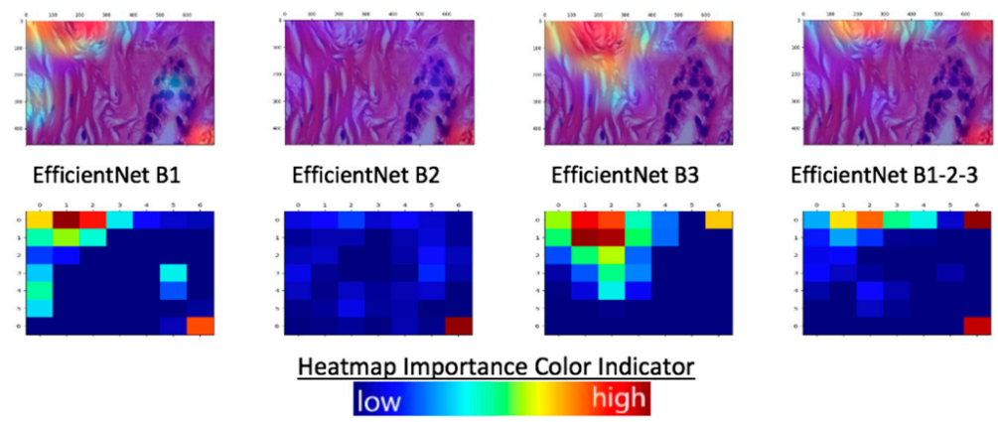
Figure 2.19 Grad-CAM explainability results, adenosis benign sample (single vs. ensemble) Kallipolitis et al. (2021).
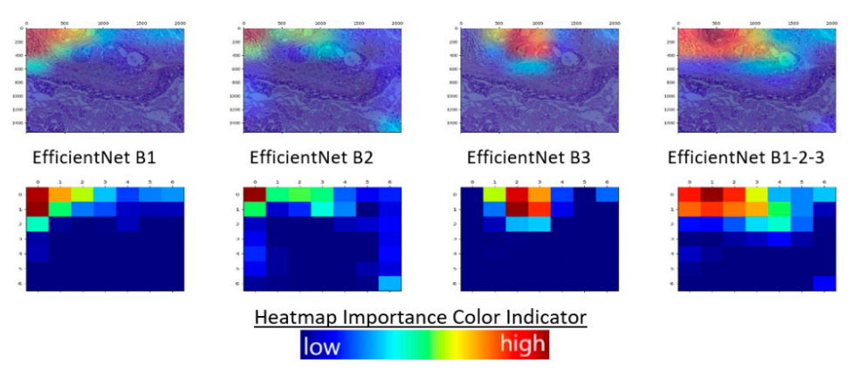
Figure 2.20 Grad-CAM explainability results, in situ malignant sample (single vs. ensemble) Kallipolitis et al. (2021).

Across the three studies, ensemble configurations consistently outperformed single-model counterparts by one to three percentage points, with gains most pronounced under class-imbalance conditions. All three works, however, required storing and serving multiple independently trained networks, introducing deployment overhead. Stochastic Weight Averaging (SWA) addresses this through weight-space ensembling, combining solutions from multiple stochastic training seeds within a single model instance without multiplying inference cost. The present study applies a 5-seed SWA ensemble over EfficientNetB0, inheriting the generalisation benefits of the reviewed literature while maintaining efficiency for real-time web-based deployment.

Test-Time Augmentation (TTA) for CNN Classification
Test-time augmentation (TTA) is an inference-time technique that applies multiple transformations to an input image and combines the resulting predictions to improve classification reliability. Unlike conventional data augmentation used during training, TTA operates only during inference. It helps reduce prediction variability caused by differences in image orientation, scale, lighting, and camera angles, thereby improving the robustness of coral health classification systems (Kandel & Castelli, 2021).
Kandel and Castelli (2021) conducted a systematic empirical investigation of TTA for image classification using the MURA musculoskeletal X-ray dataset across five pretrained CNN architectures: VGG19, InceptionV3, ResNet50, Xception, and DenseNet121. Nine geometric augmentation techniques were evaluated horizontal flip, vertical flip, 40% zooming, 180° rotation, and five compound combinations thereof alongside two aggregation strategies, namely average vote and majority vote. As reported in Table 2.13, TTA consistently improved Cohen's Kappa scores across all seven anatomical subsets and all five architectures, with average performance gains ranging from approximately 3.48% for the forearm subset to 28.47% for the shoulder subset when using average voting. A particularly notable pattern, illustrated in Figure 2.21, is that TTA yielded disproportionately larger improvements for architectures with weaker baseline performance, confirming that prediction aggregation across geometric transforms serves as an effective corrective mechanism for lower-performing classifiers. The additional inference time introduced by TTA was found to be negligible relative to the performance benefits obtained, establishing its practical viability as a computationally efficient enhancement strategy.
Table 2.13 Percentages of increase by TTA compared to original method Kandel & Castelli (2021).
Dataset | Average vote (%) | Majority vote (%)
FINGER | 22.87 | 21.53
HUMERUS | 9.75 | 9.56
FOREARM | 3.48 | 3.60
WRIST | 10.48 | 9.96
ELBOW | 8.91 | 8.14
HAND | 15.60 | 14.92
SHOULDER | 28.47 | 28.20

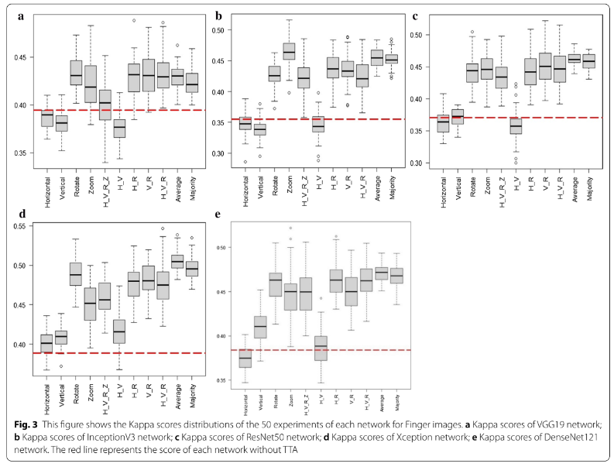
Figure 2.21 Kappa score distributions across 50 repeated experiments for each CNN architecture on the Finger image subset, illustrating the consistent performance improvement produced by TTA over the baseline method without augmentation (Kandel & Castelli, 2021).

Oza et al. (2024) applied TTA within a transfer learning framework for breast lesion classification from mammographic images, evaluating VGG-16, ResNet-50, InceptionV3, and EfficientNet-B7 across the MIAS and CBIS-DDSM datasets. The TTA strategy employed geometric transformations image flipping, shifting, and rotation applied at inference time, with final predictions derived by averaging outputs across both original and augmented views, as illustrated in Figure 2.22. Three experimental conditions were evaluated: transfer learning on the original dataset, transfer learning on a pre-processed dataset, and transfer learning with TTA applied on the pre-processed dataset. As shown in Table 2.14, TTA produced the highest F1-scores across all four architectures under both dataset conditions, with EfficientNet-B7 achieving an F1-score of 0.9955 under the TTA condition compared to 0.9934 without TTA on MIAS. The full proposed pipeline with TTA yielded an overall accuracy of 99.97%, sensitivity of 98.50%, and F1-score of 98.74%, outperforming all prior state-of-the-art methods documented in the comparative analysis. The consistent superiority of EfficientNet-B7 across all three experimental conditions confirms that TTA applied in conjunction with EfficientNet-family architectures produces measurable classification improvements on constrained medical imaging datasets, a finding that directly parallels the architectural choices adopted in the present study.
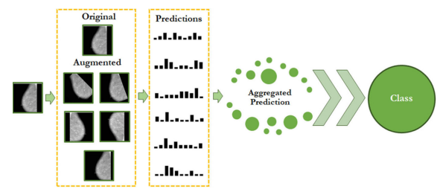
Figure 2.22 Schematic diagram of the proposed TTA workflow, illustrating the generation of multiple augmented test image variants, individual model predictions, and the aggregation process for final classification output (Oza et al., 2024).

Table 2.14 F1-score comparison across the three experimental conditions (Oza et al., 2024).
 | VGG16 | ResNet50 | EfficientnetB7 | InceptionV3
Original MIAS | 0.959424 | 0.940527 | 0.987394 | 0.779746
Pre-processed MIAS | 0.970778 | 0.940859 | 0.993295 | 0.822675
Test time augmentation | 0.987494 | 0.952794 | 0.9955 | 0.830299

Singh et al. (2022) incorporated TTA as a mechanism for estimating aleatoric uncertainty within the SkiNet framework, a two-stage pipeline for skin lesion segmentation and multiclass classification using the ISIC-2018 dataset. Each test image was augmented into V distinct variants, forwarded independently through the classification network, and the mean probability vector across all variants was adopted as the final prediction, as formalised in Equation 2 of their study. This TTA strategy was combined with Monte Carlo Dropout to jointly estimate both aleatoric and epistemic uncertainty, enabling the system to route low-confidence predictions for clinician review rather than issuing a definitive classification. As shown in Table 2.15, aleatoric uncertain images accounted for 946 samples of which 209 were ultimately misclassified, demonstrating the practical utility of TTA-based uncertainty estimation in flagging diagnostically ambiguous cases. Table 2.16 further presents a comparative analysis of explainability techniques, revealing that XRAI achieved the highest explanation accuracy of 84% when evaluated through the Bokeh reconstruction method, outperforming Grad-CAM, Guided Backpropagation, and Guided Grad-CAM. As depicted in Figure 2.23, integrating TTA with these saliency methods produced spatially more coherent attention maps following uncertainty-gated segmentation pre-processing, with the model's focus redirecting from background noise to clinically relevant lesion regions. The full SkiNet pipeline achieved a diagnostic accuracy of 73.65% and a prediction accuracy of 88.46%, against 70.01% and 87.35% respectively for the stand-alone Bayesian DenseNet-169.

Table 2.15 Comparison of different uncertainty types (Singh et al., 2022).
Type | Uncertain images | Misclassified images
Aleatoric | 946 | 209
Epistemic | 251 | 91
Combined | 1030 | 202

Table 2.16 Comparative analysis between different explainability techniques (Singh et al., 2022).
Explainability Technique | Accuracy
GradCam | 73%
Guided Backprop | 73%
Guided GradCam | 77%
XRAI | 84%

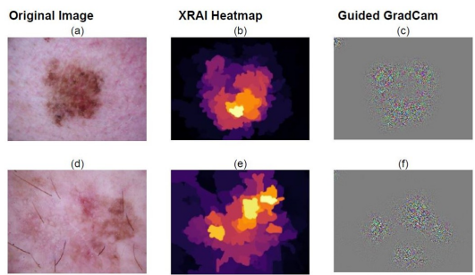
Figure 2.23 Model’s region of interest depicted by XRAI and Guided Grad CAM (Singh et al., 2022).

These three studies collectively establish that TTA consistently improves CNN classification performance across diverse imaging domains, with average voting identified as the most reliable aggregation strategy (Kandel & Castelli, 2021) and with particular effectiveness when combined with EfficientNet-family architectures on constrained datasets (Oza et al., 2023). Singh et al. (2022) further demonstrate that TTA is compatible with post-hoc explainability methods, validating its concurrent deployment alongside Grad-CAM within a single inference pipeline. While their Bayesian dropout formulation differs architecturally from the deterministic SWA ensemble strategy adopted in the present study, the shared principle of aggregating multiple inference passes to reduce prediction variance is directly analogous. None of the reviewed studies, however, applied TTA within a five-seed SWA ensemble framework incorporating multi-scale spatial evaluation and horizontal flip augmentation for tri-class coral health classification, further motivating the inference strategy developed in the present work.

EfficientNetB0 with Grad-CAM for Multi-Class Classification and Deployment
Pham-Ngoc et al. (2025) studied the automated classification of thyroid fine needle aspiration biopsy images into three clinical management categories on a pipeline assessed on twelve CNN and Transformer-based models. The main data were a total of 1,804 microscopic images that were split into 70:15:15, and there were an external validation data set of 1,015 images provided by a different institution. Of all architectures tested, EfficientNetB0 had the highest internal macro F1-score of 89.19 percent with times-34 augmentation strategy, as illustrated in Table 2.17, and the confusion matrix in Table 2.18 showed that the greatest number of misclassifications were at the Indeterminate/Suspicious and Malignant boundary. Figure 2.24 shows grad-CAM heatmaps that verified that the model focused on diagnostically relevant cellular cluster areas. Macro F1 decreased to 0.68 under external deployment as can be seen in Table 2.19 mainly because of slide preparation and staining protocol inter-institutional distribution shift. This performance gap is the main reason that the current study adopts a five-seed Stochastic Weight Averaging ensemble, which averages weight paths in parallelly trained instances to yield a flatter loss landscape and more consistent generalisation behaviour than a single deterministic model.
Table 2.17 F1 Score on Test Set for Different Models and Configurations Pham-Ngoc et al. (2025).
Model | F1 score (no_aug) | F1 score (aug) | Delta (aug - no_aug)
MNv1 | 0.8188 | 0.8423 | 0.0235
MNv3 | 0.8234 | 0.8530 | 0.0296
EffNetB0 | 0.8555 | 0.8919 | 0.0364
EffNetB7 | 0.8078 | 0.8600 | 0.0522
VGG16 | 0.8468 | 0.8600 | 0.0132
VGG19 | 0.8196 | 0.8430 | 0.0234
RN18 | 0.8200 | 0.8600 | 0.0400
RN152 | 0.8067 | 0.8588 | 0.0521
DN121 | 0.8480 | 0.8580 | 0.0100
DN201 | 0.8569 | 0.8633 | 0.0064
ViT-B16 | 0.8483 | 0.8460 | -0.0023
ViT-L16 | 0.8220 | 0.8690 | 0.0470

Table 2.18 Confusion matrix of the ThyroidEffi Basic model on test set Ngoc et al. (2025).
True Label | Benign | Indeterminate/Suspicious | Malignant | Total
Benign | 57 | 2 | 2 | 61
Indeterminate/Suspicious | 0 | 85 | 11 | 96
Malignant | 2 | 15 | 98 | 115
Total | 59 | 102 | 111 | 272

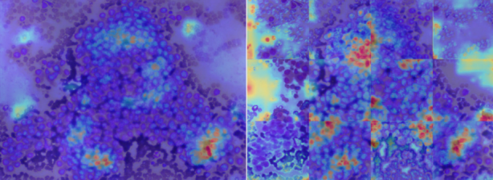
Figure 2.24 Grad-CAM of a slide image (left) and 12 sub-images (right) after pass ThyroidEffi Basic Ngoc et al. (2025).

Table 2.19 Performance evaluation of the ThyroidEffi Basic model on real-world application data Ngoc et al. (2025).
 | Benign | Indeterminate/Suspicious | Malignant | Macro Avg
F1-Score | 0.84 | 0.49 | 0.70 | 0.68

Alqhatani et al. (2025) proposed a three-class lung cancer staging system from CT images using a modified EfficientNetB0 backbone appended with a task-specific Conv2D layer, global average pooling, dense layers, and dropout regularisation. The IQ-OTH/NCCD dataset contained 1,190 images distributed across 416 normal, 120 benign, and 561 malignant samples as specified in Table 2.20, split at a 60:20:20 ratio per Table 2.21, with augmentation applied through rotation, zoom, and horizontal flipping. On the test set, the model achieved 99 percent accuracy, with per-class precision and recall reported in Figure 2.25, MCC of 0.9845, and Cohen's Kappa of 0.9844 as presented in Figure 2.26. The confusion matrix in Figure 2.27 recorded only two misclassifications across the entire test set, while Grad-CAM heatmaps in Figure 2.28 confirmed that activation regions were co-localised with anatomically meaningful pulmonary structures. Comparative evaluation in Table 2.22 demonstrated that this single-model architecture outperformed ensemble and hybrid SVM approaches on the same benchmark, though the authors acknowledged that the absence of external validation limits the generalisability of the reported results. This finding reinforces the present study's use of multi-seed ensemble inference and Test-Time Augmentation as explicit mechanisms to strengthen prediction reliability beyond what a single trained instance can provide.
Table 2.20 Class distribution of dataset Alqhatani et al. (2025).
Class | Number of images
Normal | 416
Benign | 120
Malignant | 561

Table 2.21 Data split and preprocessing for lung cancer classification Alqhatani et al. (2025).
Parameter | Training Set | Validation Set | Test set
Data split | 60% of original data | 20% of original data | 20% of original data
Shuffle | Yes | Yes | No
Subset | Training | Validation | N/A

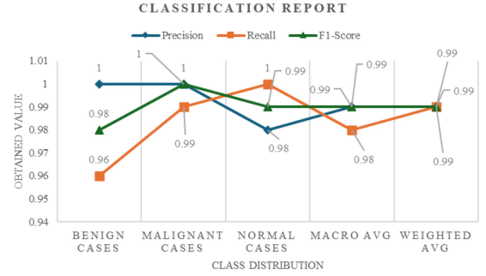
Figure 2.25 Classification report detailing the precision, recall, and F1-score across different lung cancer stages (benign, malignant, and normal cases) Alqhatani et al. (2025).

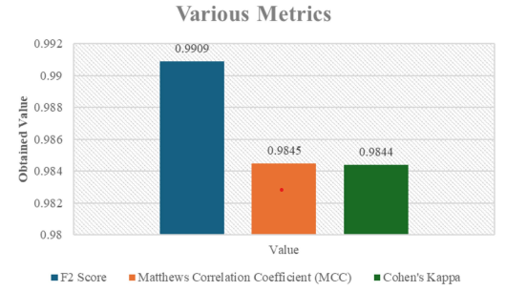
Figure 2.26 Various metrics including F2 Score, Matthews Correlation Coefficient (MCC), and Cohen’s Kappa for the classification model Alqhatani et al. (2025).
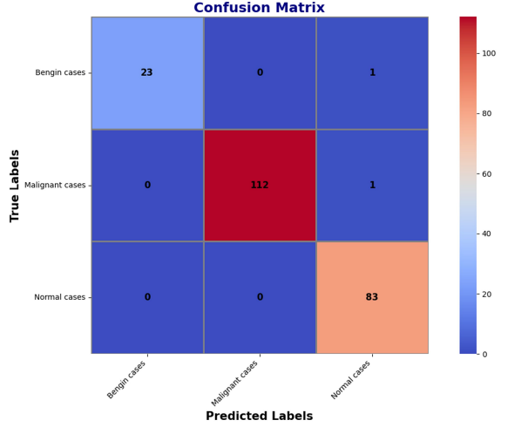
Figure 2.27 Confusion matrix summarizing the model’s classification performance Alqhatani et al. (2025).
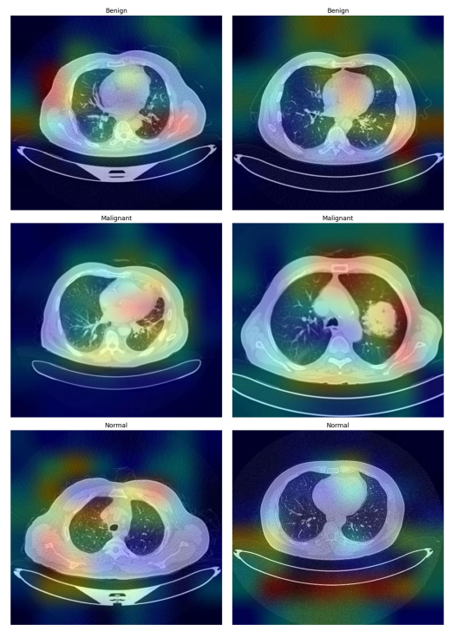
Figure 2.28 Grad-CAM visualizations highlighting the regions within the CT images that most influence the model’s predictions Alqhatani et al. (2025).
Table 2.22 Comparison of the proposed model with existing models Alqhatani et al. (2025).
Study | Technique | Accuracy
Mohamed et al. (21) | Hybrid CNN with Ebola Optimization Search Algorithm (EOSA) | 93.21%
Parveen et al. (22) | CNN with Watershed and SIFT for feature extraction and data augmentation | 97%
Nigudgi and Bhyri (23) | Hybrid-SVM with transfer learning using AlexNet, VGG, and GoogleNet | 97%
Tasnim et al. (24) | Deep Learning with advanced image preprocessing and classifiers like ResNet50 and InceptionV3 | 98%
Bagheri Tofighi et al. (25) | MobileNetV2 with stacked GRU layers and explainable AI using Grad-CAM | 96.83%
Patnaik et al. (26) | Mask-EffNet using EfficientNet and masked autoencoder for feature extraction and classification | 98.98%
Humayun et al. (27) | Transfer learning approach with CNN and various preprocessing techniques | 98.83%
Bangare et al. (28) | CNN for computer-aided detection and classification of CT images | 86.42%
Kumaran et al. (29) | Ensemble transfer learning using VGG16, ResNet50, and InceptionV3 with Grad-CAM | 98.18%
Ahnaf and Wahyuni (30) | Comparative analysis using GLCM and LBP feature extraction with SVM and Gaussian Naive Bayes | 93%
Proposed Model | Modified EfficientNet-B0 with Extra Convolution Layer and Explainable AI | 99%

Long et al. (2025) developed an end-to-end two-stage diagnostic system for diabetic retinopathy grading and diabetic macular edema detection from fluorescein angiography images, with EfficientNetB0 serving as the shared feature extraction backbone across both stages. The dataset comprised 19,031 images from 2,753 patients collected over nearly seven years, with full class distribution and split proportions documented in Table 2.23. Stage 1 achieved a test accuracy of 0.7036 and AUC of 0.9062, while Stage 2 produced a test accuracy of 0.7258 and AUC of 0.7530 as recorded in Table 2.23. The ROC curves in Figure 2.29 and confusion matrix in Figure 2.30 confirmed strong Stage 1 discriminative ability, whereas Figure 2.31 revealed that 349 of 690 positive DME cases were misclassified, indicating that the backbone alone struggled with subtle inter-class visual overlap in a large heterogeneous dataset. Grad-CAM heatmaps in Figure 2.32 demonstrated anatomically consistent saliency, with fluorescent leakage zones dominating Stage 1 activation maps and macular regions receiving the highest weights in Stage 2. The performance degradation observed across increasing dataset heterogeneity directly supports the rationale for employing Stochastic Weight Averaging and multi-scale Test-Time Augmentation in the present study, both of which stabilise decision boundaries without requiring additional labelled data.
Table 2.23 Model Performance Evaluation on the Validation and Test Set Long et al. (2025).
Tasks | Accuracy | AUC | Precision | Recall | F1-score | Kappa
First-stage Validation set | 0.7257 | 0.9139 | 0.7017 | 0.7006 | 0.6987 | 0.6239
First-stage  Test set | 0.7036 | 0.9062 | 0.7055 | 0.7036 | 0.7023 | 0.6271
Second-stage Validation set | 0.7558 | 0.7797 | 0.7559 | 0.7558 | 0.7558 | 0.3968
Second-stage Test set | 0.7258 | 0.7530 | 0.7184 | 0.7258 | 0.7214 | 0.3293

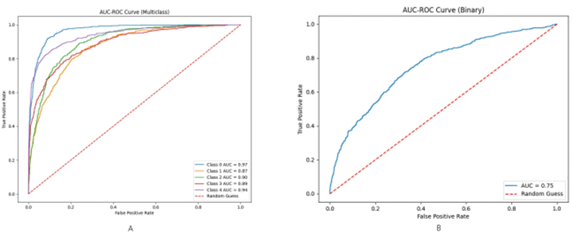
Figure 2.29 ROC curve for grading of Diabetic Retinopathy (DR) Long et al. (2025).
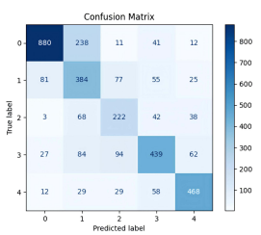
Figure 2.30 Confusion matrix for grading of Diabetic Retinopathy (DR) Long et al. (2025).
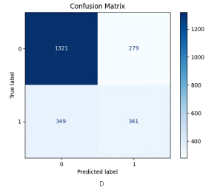
Figure 2.31 Confusion matrix for diagnosis of Diabetic Macular Edema (DME), Class labels: 0 = Non-DME; 1 = DME Long et al. (2025).

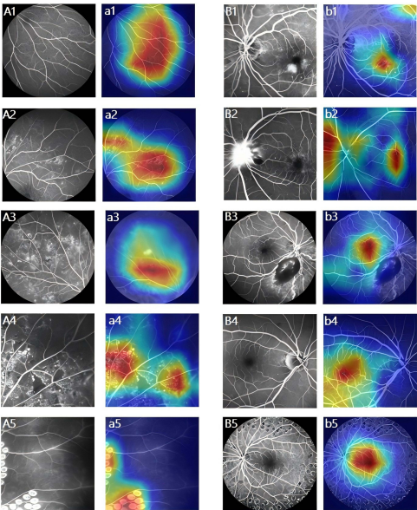
Figure 2.32 Heatmap Visualization for Deep Learning Explainability Long et al. (2025).
Considered collectively, the three reviewed works establish EfficientNetB0 as a reliable and parameter-efficient backbone for three-class image classification across diverse biomedical imaging domains. A consistent pattern across all three studies, however, is the reliance on a single deterministic trained model at inference time, with no work employing ensemble averaging or test-time augmentation to manage prediction variance. The deployment degradation reported by Pham-Ngoc et al. (2025), the unvalidated accuracy ceiling noted by Alqhatani et al. (2025), and the sensitivity to dataset heterogeneity observed by Long et al. (2025) collectively point to the same underlying limitation: single-model EfficientNetB0 pipelines lack the inference-time stabilisation mechanisms necessary to sustain performance under distribution shift or constrained data conditions. This gap directly motivates the present study's five-seed Stochastic Weight Averaging ensemble combined with multi-scale Test-Time Augmentation, producing calibrated and variance-reduced predictions that no single training run could reliably achieve.

Summary of related works
Table 2.24 presents a structured comparison of the fifteen related works reviewed in Sections 2.9.1 to 2.9.5, summarising the domain, architecture, best reported metric, use of Grad-CAM or XAI, and relevance to the present study.

Table 2.24 Summary of Related Works.
Reference | Domain / Task | Architecture | Best Metric | Grad-CAM / XAI | Relevance to This Study
Ghaffar & Choi (2025) | Coral reef health (3-class) | Two-stream EfficientNet + Grad-CAM + LIME | 98.56% acc | Yes (Grad-CAM, LIME) | EfficientNet + XAI for coral health; informs dual-stream interpretation approach
Aruna & Thamarai (2023) | Coral stress detection | ResNet50, InceptionV3, Custom CNN | 90.0% acc | No | Gap in intermediate stressed states motivates 3-class classification
Wang et al. (2024) | Coral health (local features) | ML-Net | N/A | No | Supports EfficientNet's compound scaling over ViTs for local feature extraction
Shao et al. (2024) | Coral reef conditions (8-class) | Swin + EfficientNet + ResNet ensemble | SOTA | No | Validates ensemble learning for reef monitoring; supports SWA ensemble strategy
Xin et al. (2024) | Coral bleaching detection | FCOS + EfficientNet (BiFPN) | 81.5% acc | No | Memory/speed gap motivates lightweight EfficientNetB0 choice
Montalbo et al. (2021) | Malaria detection (blood smear) | EfficientNetB0 | ~95% acc | No | Validates EfficientNetB0 transfer learning on limited biomedical data
Korkmaz et al. (2025) | Macrofungi classification (14 spp.) | EfficientNet-B0 + Grad-CAM, Score-CAM | 97.0% acc / F1 | Yes (Grad-CAM, Score-CAM) | Fine-grained biological classification with EfficientNetB0 + Grad-CAM
Alqhatani et al. (2025) | Lung cancer staging (CT) | EfficientNet-B0 + Grad-CAM | 99.0% acc | Yes (Grad-CAM) | 3-class medical EfficientNetB0 + Grad-CAM pipeline; closely mirrors this study
Singh et al. (2024) | Brain tumour (MRI, 4-class) | ResNet50 + EfficientNet-B7 (dynamic ensemble) | 99.68% acc | No | Dynamic ensemble weighting reduces confusion; informs SWA design for coral
Kallipolitis et al. (2021) | Histopathology (breast & colon) | EfficientNet B1–B3 parallel ensemble + Grad-CAM | 99.25% acc | Yes (Grad-CAM) | Parallel EfficientNet ensemble + Grad-CAM; most direct architectural precedent
Kandel & Castelli (2021) | Bone fracture (X-ray) | VGG, ResNet, Inception, DenseNet + TTA | N/A (AUC) | No | Establishes TTA + ensemble as complementary strategy; motivates MS-TTA here
Oza et al. (2024) | Breast lesion (mammography) | EfficientNet-B7 + TTA | 99.97% acc / 98.74% F1 | No | TTA on EfficientNet achieves near-perfect accuracy; validates MS-TTA approach
Singh et al. (2022) | Skin lesion (multiclass) | SkiNet + saliency maps | N/A | Yes (Saliency Maps) | Uncertainty-aware XAI highlights need for interpretable confidence in classification
Pham-Ngoc et al. (2025) | Thyroid carcinoma (cytology) | YOLOv10 + EfficientNetB0 + Grad-CAM | 89.77% F1 | Yes (Grad-CAM) | Hybrid deployment with Grad-CAM; supports Flask web app approach used here
Assaduzzaman et al. (2025) | Tomato leaf disease (11-class) | XSE-TomatoNet (EfficientNetB0 + SE) + multi-XAI | 99.11% acc | Yes (SHAP, LIME, Grad-CAM) | Multi-XAI + EfficientNetB0 deployment pipeline validates transparency approach
You et al. (2025) | Diabetic retinopathy (FFA, 5-class) | EfficientNetB0 + Grad-CAM | 72.58% acc | Yes (Grad-CAM) | Multi-class deployment with Grad-CAM; lower accuracy shows class complexity challenge

METHODOLOGY

Introduction
This chapter describes the methodology adopted for the development of the coral reef health assessment system, detailing the design decisions, processing stages, and evaluation strategies that collectively form the research workflow. The chapter is organised to follow the ten-stage pipeline established in the design framework presented in Section 3.2, progressing through three logical phases: data preparation, model development and optimisation, and model analysis and output. Section 3.3 introduces the BHD Coral Dataset, including its class composition and the class imbalance characteristics that inform subsequent processing decisions. Section 3.4 defines the performance evaluation metrics employed to assess model performance from both classification and deployment perspectives. Sections 3.5 through 3.7 provide detailed descriptions of each pipeline stage, encompassing data pre-processing, stratified splitting, augmentation, EfficientNet-B0 model construction, five-seed Stochastic Weight Averaging ensemble training, hyperparameter tuning, model saving, Grad-CAM interpretability analysis, and Multi-Scale Test-Time Augmentation evaluation. Section 3.8 documents the development environment, and Section 3.9 summarises the chapter. Together, these sections establish a reproducible and systematically validated methodology that addresses all three research objectives of this project.

Design Framework
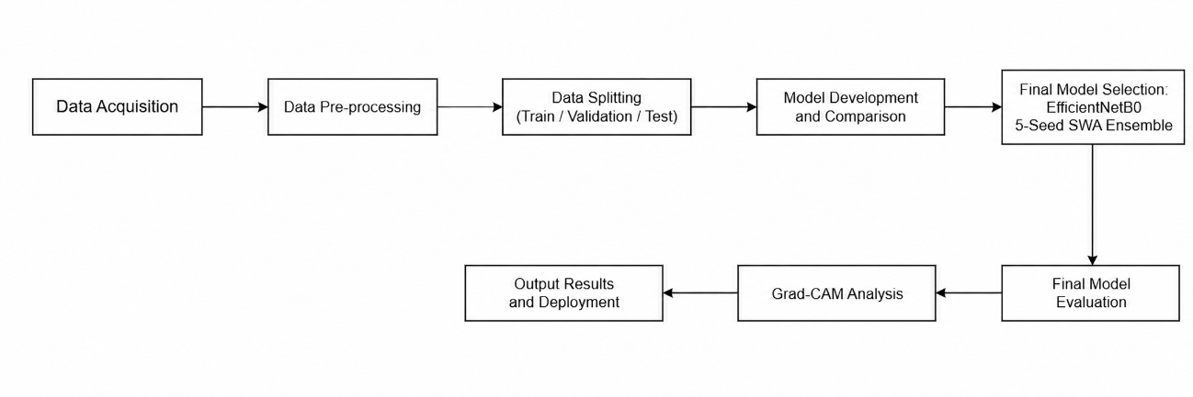
Figure 3.1 Illustrates the methodological framework adopted in this study for coral reef health classification.

As illustrated in Figure 3.1, the first row begins with Data Acquisition, where the BHD Coral Dataset is sourced from Kaggle as the primary input. The images then undergo Data Pre-processing to standardise resolution and pixel normalisation before being partitioned into training, validation, and test subsets during the Data Splitting stage. Multiple CNN architectures are subsequently trained and benchmarked in the Model Development and Comparison stage, from which the EfficientNetB0 5-Seed SWA Ensemble is selected as the final model based on superior classification performance.
The second row begins with Final Model Evaluation, where the selected ensemble is assessed against the test set. At this stage, Multi-Scale Test-Time Augmentation (TTA) is applied during inference, generating predictions across two resolutions 224×224 and 256×256 with horizontal flip and averaging the outputs to produce robust final predictions. The evaluated model then proceeds to Grad-CAM, where Gradient-weighted Class Activation Mapping generates spatial heatmaps to support interpretability of the classification decisions. The pipeline concludes at the Output Results and Deployment stage, where predictions and Grad-CAM visualisations are served through a Flask web application.

Dataset

BHD Coral Kaggle
This study uses the BHD Coral Dataset, publicly available on Kaggle, as the primary data source for training and evaluating the deep learning model (Jamil, 2021). The dataset was specifically curated for coral reef health classification tasks and contains a total of 1,582 colour images in JPEG and PNG formats. All images are in RGB format and were captured underwater, covering varying resolutions and aspect ratios. The dataset is selected for this study due to its relevance to the classification task, its public accessibility, and its suitability for reproducible research.
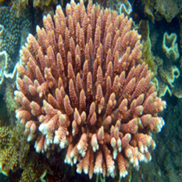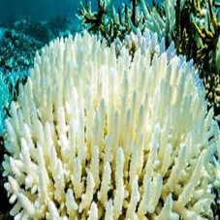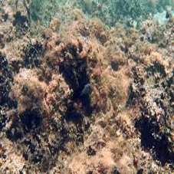
Figure 3.2 Sample Images from the BHD Coral Dataset Representing Healthy, Bleached, and Dead Classes (Jamil, 2021).

As shown in Figure 3.2, the dataset contains three visually distinct coral health categories. Healthy corals display vibrant and varied colouration, reflecting the presence of symbiotic algae. Bleached corals appear white or pale, indicating that thermal stress has caused the expulsion of algae from the coral tissue. Dead corals are characterised by dark colouration due to coverage by turf algae or sediment. These visual differences across the three classes provide the discriminative features that the model is trained to recognise.
The dataset contains images with varying resolutions and aspect ratios. To ensure consistency and compatibility with the EfficientNet-B0 input requirements, all images are resized to 224 x 224 pixels during pre-processing. This standardisation reduces variability introduced by inconsistent image dimensions and supports stable model training. The dataset was divided into training, validation, and testing subsets using a stratified 80:10:10 ratio to preserve class distribution across all subsets.
Table 3.1 Distribution of BHD Coral Dataset
Class Label | Description | Total | Train | Validation | Test
Healthy | Vibrant coral showing no signs of stress. | 712 | 569 | 71 | 72
Bleached | Coral that has expelled algae, appearing white/pale. | 720 | 576 | 72 | 72
Dead | Coral covered in algae or sediment. | 150 | 120 | 15 | 15
Total | Total images in the dataset | 1,582 | 1,265 | 158 | 159

As shown in Table 3.1, the dataset contains 1,582 coral images distributed across three health categories. Before augmentation, the dataset was partitioned into training, validation, and testing subsets using stratified sampling. Although the Healthy and Bleached classes contain similar numbers of samples, the Dead class is considerably smaller, indicating a class imbalance that may affect model training performance. The effect of targeted oversampling and augmentation on the training subset size for each class is presented in Table 3.3 in Section 3.5.3.

Performance Evaluation Metrics
A series of metrics is used to assess the performance of the proposed coral reef health classification system to ensure the evaluation is comprehensive, robust, and tailored to the three-class classification problem. Using overall accuracy alone may not be adequate in this case, as the BHD Coral Dataset is highly imbalanced with the Dead class having significantly fewer samples than the Healthy and Bleached classes. This means that a high overall accuracy could conceal issues with the minority classes. To overcome this issue, the evaluation metrics include classification accuracy, precision, recall, F1-score, macro-averaged and weighted-average aggregate measures and confusion matrix. This suite of metrics offers a comprehensive assessment of model performance in terms of classification accuracy and class-specific predictive performance, both of which are critical for assessing the system's suitability for real-world coral reef health monitoring.

Classification Accuracy
Classification accuracy measures the proportion of correctly classified images out of the total number of test samples, as shown in Equation (2.1). It provides a general indication of how well the model performs across all three coral health classes.
While accuracy offers a straightforward overview of overall model performance, it is sensitive to class distribution. In datasets where class sizes differ significantly, as is the case with the BHD Coral Dataset, a model that predominantly predicts the majority class can still achieve high accuracy while performing poorly on the minority class. For this reason, accuracy is used alongside other class-level metrics rather than as a standalone measure.

Precision
Precision measures the proportion of positive predictions for a given class that are genuinely correct, as shown in Equation (2.2), reflecting the model's ability to avoid false positives.
In the context of coral health classification, a low precision for the Dead class would indicate that the model frequently misclassifies Healthy or Bleached coral as Dead, which could lead to unnecessary conservation interventions based on incorrect assessments. Precision is therefore particularly important for ensuring the reliability of each predicted class label.

Recall
Recall measures the proportion of actual positive samples for a given class that the model correctly identifies, as shown in Equation (2.3), reflecting the model's sensitivity to true positives.
In coral reef monitoring, a low recall for the Dead class is especially critical, as it implies that genuinely degraded coral reefs are being overlooked and misclassified as Healthy or Bleached. Missing such cases in a real-world monitoring scenario could delay conservation responses. Recall therefore captures the model's ability to detect all instances of a given health condition, making it an essential complement to precision.

F1-Score
The F1-Score is the harmonic mean of precision and recall, as shown in Equation (2.4), providing a single balanced metric that accounts for both false positives and false negatives simultaneously.
Unlike arithmetic averaging, the harmonic mean penalises extreme differences between precision and recall, ensuring that a high F1-Score can only be achieved when both metrics are satisfactory. This property makes the F1-Score particularly suited for evaluating performance on imbalanced datasets such as the BHD Coral Dataset, where the Dead class is underrepresented relative to the Healthy and Bleached classes.

Macro Average and Weighted Average
To provide a system-level summary of classification performance across all three coral health classes, two aggregate metrics are computed. The macro average calculates the arithmetic mean of precision, recall, and F1-Score across all classes without accounting for class size, assigning equal weight to each class regardless of the number of samples it contains. The weighted average, in contrast, computes a support-weighted mean, where each class contributes proportionally to its sample count in the test set. In this study, the test set comprises 72 Healthy, 72 Bleached, and 15 Dead images, reflecting the same imbalance present in the full dataset. The macro average is the primary reported aggregate because it treats the minority Dead class with equal importance as the majority classes, directly penalising any degradation in Dead class performance. The weighted average is reported alongside it to reflect overall system performance as experienced across the realistic distribution of test samples.

Confusion Matrix
The confusion matrix offers a visual, tabular representation of the classification results, comparing predicted labels to true labels in an N×N matrix, with N being the number of classes. Here, N is three, representing the Healthy, Bleached, and Dead coral classes. The cells of the matrix contain the count of each prediction outcome, comprising the four basic terms detailed in Table 3.2: True Positive (TP), True Negative (TN), False Positive (FP), and False Negative (FN). The confusion matrix provides valuable class-specific information on misclassification not otherwise revealed by aggregate metrics, such as the model's propensity to confuse visually similar classes. Due to the visual similarity between Bleached and Dead coral, the confusion matrix is especially useful to determine if the confusion is focused at this class border, which in turn can inform model development.
Table 3.2 Confusion Matrix Terms and Definitions.
Actual Values | Predicted Values |  | Description
 | Positive  (P) | Negative  (N)
Positive | True Positive (TP) | False Negative (FN) | Classified correctly for positive cases / incorrectly for negative cases
Negative | False Positive (FP) | True Negative (TN) | Classified incorrectly for positive cases / correctly for negative cases

Data Preparation
This section describes the first four stages of the methodology pipeline, covering the acquisition, pre-processing, splitting, and augmentation of the BHD Coral Dataset. These stages collectively transform raw underwater coral images into a standardised and balanced training-ready input for the EfficientNet-B0 model.
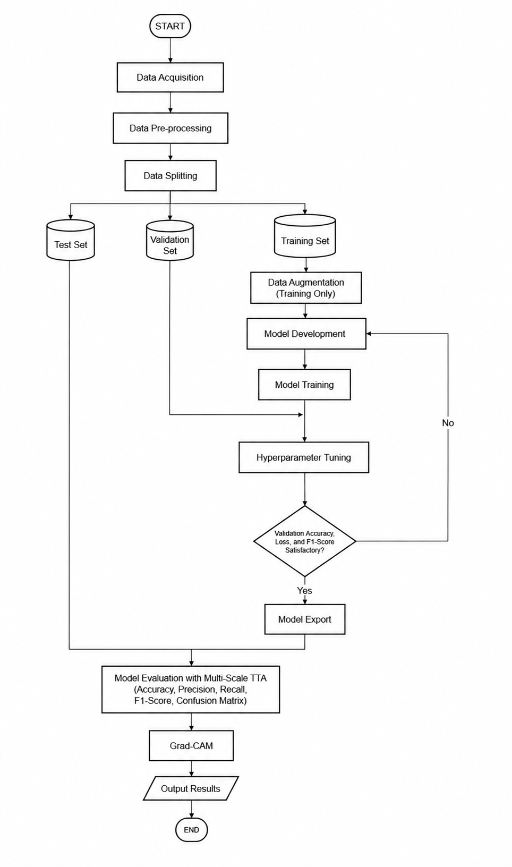
Figure 3.3 Coral Reef Assessment Flowchart.
Figure 3.3 presents the complete execution pipeline of the proposed coral reef health classification system. The workflow begins with Data Acquisition, followed by Data Pre-processing and Data Splitting, where the dataset is partitioned into three mutually exclusive subsets: Training Set, Validation Set, and Test Set. The Test Set is immediately isolated and reserved for final evaluation only. Data Augmentation is applied exclusively to the Training Set before proceeding to Model Development and Model Training. A decision node following Hyperparameter Tuning assesses whether validation accuracy, loss, and F1-score meet the satisfactory threshold; if not, the process returns to Model Training for further optimisation. Once the criteria are satisfied, the trained model artefacts are exported for evaluation and deployment.
The second phase, as shown in Figure 3.3, covers model analysis and output generation. Multi-Scale TTA is applied during the evaluation stage, generating predictions across two resolutions 224×224 and 256×256 with horizontal flip and averaging the outputs to produce robust final predictions. The evaluated model is assessed against the held-out subsets, producing accuracy, precision, recall, F1-score, and confusion matrix results. Grad-CAM is then applied to generate spatial attention heatmaps, providing visual interpretability of the model's classification decisions across the Healthy, Bleached, and Dead coral classes. The pipeline concludes at the Output Results stage, consolidating all evaluation artefacts as the final system output.

Data acquisition
The BHD Coral Dataset was obtained from Kaggle and serves as the primary data source for this study (Jamil, 2021). The dataset comprises 1,582 labelled underwater coral images stored in JPEG and PNG formats, categorised into three health classes: Healthy (712 images), Bleached (720 images), and Dead (150 images). The images were captured under varying underwater conditions, resulting in differences in resolution, aspect ratio, lighting, and colour cast across samples. These characteristics make the dataset representative of real-world coral reef monitoring scenarios while also introducing pre-processing requirements that are addressed in the subsequent stage.

Data pre-processing
All images undergo a standardised pre-processing pipeline before entering the training process. Images loaded using OpenCV are first converted from BGR to RGB colour space to match the input format expected by EfficientNet-B0. Each image is then resized to 224 × 224 pixels using bilinear interpolation to satisfy the fixed input dimension of the architecture, as illustrated in Figure 3.4. Pixel values are subsequently normalised from the range of 0 to 255 to a standardised range of 0 to 1 by dividing by 255 and cast to 32-bit floating-point representation to ensure numerical precision during gradient computation. Class labels are encoded as integer indices and converted to one-hot encoded vectors using the Keras to categorical function, as required by the categorical cross-entropy loss function used during training.
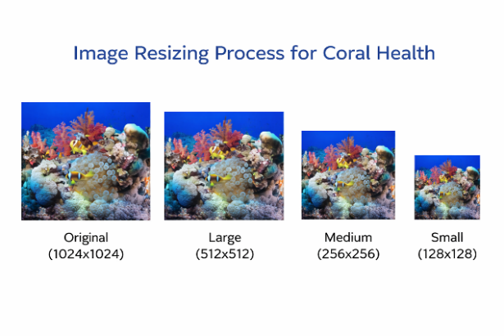
Figure 3.4 Example of Image Resizing Process.
The pre-processed dataset is partitioned into three mutually exclusive subsets using stratified random splitting with a fixed seed of 42 to ensure reproducibility. The training set comprises 80 percent of the data, the validation set 10 percent, and the test set the remaining 10 percent, yielding 159 test images. Stratified splitting is applied to preserve the proportional class distribution of Healthy, Bleached, and Dead samples within each subset, which is particularly important given the underrepresentation of the Dead class. Critically, data splitting is performed before augmentation to prevent data leakage, which would occur if augmented variants of training images were to appear in the validation or test sets, artificially inflating evaluation metrics.

Data Augmentation
Prior to data augmentation, the dataset was divided into training, validation, and testing subsets using a stratified 80:10:10 ratio. As shown in Table 3.3, the Dead class contained only 120 training samples prior to augmentation, substantially fewer than the Healthy and Bleached classes, resulting in a class imbalance that could negatively affect model learning. To improve minority-class representation, targeted oversampling and augmentation strategies were applied to the training set. Following augmentation, the number of training samples increased while the validation and testing subsets remained unchanged to ensure unbiased model evaluation.

Table 3.3 Class Distribution Before and After Augmentation.
Class | Number of Images | Training (Before Aug.) | Training (After Aug.) | Validation | Test
Healthy | 712 | 569 | 588 | 72 | 72
Bleached | 720 | 576 | 1,036 | 72 | 72
Dead | 150 | 120 | 420 | 15 | 15
Total | 1582 | 1,265 | 2,044 | 159 | 159

Data augmentation is applied exclusively to the training set using the Keras ImageDataGenerator, which introduces stochastic geometric and photometric transformations on-the-fly at each training epoch, ensuring that the validation and test sets retain only original unmodified images. Three core transformations are employed. Random rotation within ±20 degrees simulates variations in underwater camera orientation during image capture, as illustrated in Figure 3.5.
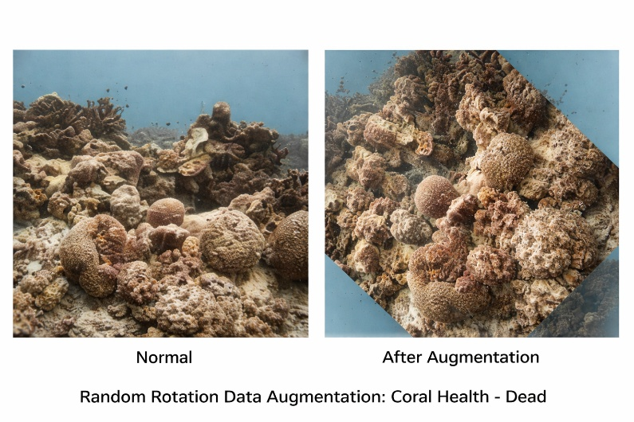
Figure 3.5 Random Rotation Augmentation.

Horizontal flipping produces a mirror image of each coral sample, which is ecologically valid given the bilateral symmetry of coral structures, as shown in Figure 3.6.
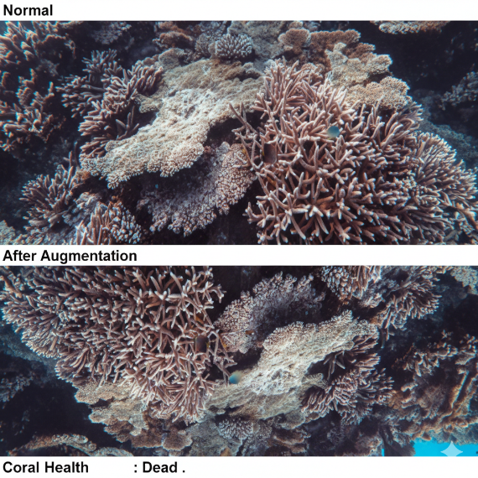
Figure 3.6 Horizontal Flipping Augmentation.

Zoom variation within a range of 90 to 110 percent of the original image size replicates differences in capture distance between the camera and the reef surface, as shown in Figure 3.7. Width and height shifts of up to 15 percent and brightness jitter between 0.8 and 1.2 further account for positional variation and inconsistent underwater illumination respectively. Vertical flipping is deliberately excluded as inverted coral images carry no ecological validity.
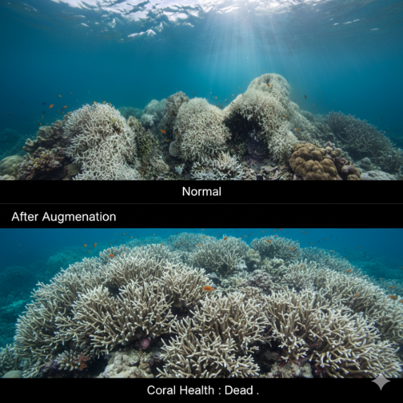
Figure 3.7 Random Zoom Augmentation.

To address class imbalance and difficult classification cases, a targeted oversampling strategy was implemented according to the augmentation priorities shown in Table 3.4. Hard examples from the Dead class were oversampled by a factor of 30×, while selected hard examples from the Healthy and Bleached classes were oversampled by a factor of 20×. In addition, class weights were computed using the inverse class frequency method, with the Dead class receiving an additional weight multiplier of 1.3× during training. This combination of augmentation, targeted oversampling, and class weighting improves minority-class representation and enhances the model's ability to learn challenging coral health patterns.

Table 3.4 Augmentation Focus Strategy.
Class | Augmentation Priority | Oversampling Factor | Class Weight Multiplier | Reason
Dead | High | 30× | 1.3× | Minority class; hard examples oversampled with extra loss weighting.
Healthy / Bleached | Normal | 20× | 1.0× | Hard-example boundary improvement to reduce inter-class confusion.

Model Development and Optimisation
This section describes the three central stages of the methodology pipeline corresponding to Sections 3.6.1 through 3.6.3 of the design framework: model training, hyperparameter tuning, and model saving. These stages transform the prepared and augmented training data into a finalised, optimised, and deployable model artifact.

Model Training – EfficientNetB0 Architecture and Five-Seed SWA Ensemble Training
EfficientNet-B0 was selected as the backbone architecture on account of its compound scaling strategy, which simultaneously adjusts network depth, width, and input resolution using a single compound coefficient. This design achieves strong classification accuracy without the parameter overhead associated with deeper architectures such as ResNet or VGG, making it well-suited to the relatively small BHD Coral Dataset. The model was initialised with ImageNet pretrained weights to leverage transferable low-level and mid-level visual representations, substantially reducing the labelled training data required for convergence.
The original 1,000-class EfficientNet-B0 classification head was replaced with a custom three-class head detailed in Table 3.5. A Global Average Pooling layer reduces the backbone's spatial feature maps to a compact 1,280-dimensional vector, followed by a Dropout layer with a rate of 0.4 to mitigate overfitting during fine-tuning, and a Dense output layer with three neurons governed by a Softmax activation function. L2 regularisation with a weight decay coefficient of λ = 0.0002 is applied to the output layer to constrain model complexity. The final 100 layers of the EfficientNet-B0 backbone are unfrozen for fine-tuning, while the remaining layers retain their pretrained weights, allowing higher-level features to adapt to coral-specific visual patterns without disrupting generalised low-level representations.
Table 3.5 Modified EfficientNet-B0 Architecture.
Path | Stage | Details | Output Dimension
Input Path | Input Layer | RGB image (224 × 224 × 3) | (224, 224, 3)
Feature Extraction | Backbone (EfficientNet-B0) | Stem Convolution, Batch Normalisation, Swish Activation | (112,112,32)
Feature Extraction | MBConv Blocks | Stack of Mobile Inverted Bottleneck blocks | (7, 7, 1280)
Classification Head | Global Average Pooling | Reduces spatial feature maps to feature vector | (1280)
Classification Head | Dropout | Rate = 0.4; regularisation during training | (1280)
Classification Head | Dense + Softmax | L2 regularisation (λ = 0.0002); 3-class probability output | (3)

The training configuration is presented in Table 3.6. The Adam optimiser is employed with an initial learning rate of 8 × 10⁻⁵, governed by a Cosine Decay schedule over 30 epochs with a batch size of 16. Categorical cross-entropy with label smoothing of ε = 0.05 is used as the loss function, softening the target probability distribution to prevent overconfidence on noisy training samples.
Table 3.6 Training Configuration.
Parameter | Value
Optimiser | Adam
Loss Function | Categorical Cross-Entropy with Label Smoothing (ε = 0.05)
Learning Rate Schedule | Cosine Decay (initial rate = 8 × 10⁻⁵)
Number of Epochs | 30
Batch Size | 16
SWA Window | Last 5 epochs (epochs 26 to 30)
Ensemble Size | 5 models (seeds: 42, 43, 44, 45, 46)

To improve generalisation, Stochastic Weight Averaging (SWA) is applied during the final five epochs of each training run. The SWA callback accumulates model weights from epochs 26 to 30 and computes their running arithmetic mean, yielding a consolidated checkpoint that resides in a wider, flatter region of the loss landscape compared to any single-epoch solution. Models residing in flatter loss regions have been shown to generalise more robustly to unseen data.
Five independent models are trained using random seeds 42 to 46, each producing a distinct SWA-averaged checkpoint, with ensemble predictions combined via probability vector averaging. The selection of five seeds as the final ensemble size, alongside Multi-Scale TTA as the inference strategy, was validated through a systematic ablation study across eight configurations; the results and rationale are presented in Section 4.1.6.

Hyperparameter Tuning
Hyperparameter tuning was conducted through systematic experimentation to identify a configuration that maximises classification performance while maintaining stable model convergence. Key parameters, including dropout rate, L2 regularisation coefficient, label smoothing factor, initial learning rate, the number of fine-tuned backbone layers, augmentation intensity, class oversampling multipliers, and class weight scaling factors, were evaluated across a range of candidate values. Multi-Scale Test-Time Augmentation (TTA) was applied only during evaluation and inference and was therefore excluded from the tuning process.
A model configuration was considered satisfactory when the training and validation curves demonstrated stable convergence with minimal signs of overfitting. Configurations that failed to meet these conditions were revised and retrained iteratively until an optimal balance between learning effectiveness and generalisation was achieved. The final optimised hyperparameter values are presented in Table 3.7 together with their baseline counterparts and the rationale for each modification.
Table 3.7 Hyperparameters Tuning Summary.
Hyperparameter | Baseline Value | Optimised Value | Rationale
Dropout Rate | 0.7 | 0.4 | Excessive dropout produced inverted training curves; reduction restored correct learning behaviour
L2 Regularisation | 0.0005 | 0.0002 | Lower weight penalty enables finer feature discrimination between visually similar classes
Label Smoothing | 0.1 | 0.05 | Reduced to permit higher prediction confidence on correctly classified samples
Initial Learning Rate | 5 × 10⁻⁵ | 8 × 10⁻⁵ | Moderately higher rate accelerates convergence without destabilising training
Fine-Tuned Layers | Last 150 | Last 100 | Freezing more pretrained layers reduces overfitting risk on the small coral dataset
Rotation Range | 40° | 20° | Excessive rotation introduced black border artefacts that degraded training quality
Vertical Flip | Enabled | Disabled | Inverted coral images are not ecologically valid and introduce unrealistic training samples
Dead Class Oversampling | 20× | 30× | Higher minority class exposure improves Dead class recall and precision
Dead Class Weight Multiplier | 1.0× | 1.3× | Higher loss penalty directs the model to prioritise correct classification of the underrepresented Dead class
Multi-Scale TTA | Not applied | 224×224 + 256×256 with horizontal flip | Applied at inference only to improve prediction robustness,excluded from training tuning as it does not modify model parameters

Model Export
Once the final model configuration has been selected, the trained model artefacts are preserved for evaluation, reproducibility, and deployment purposes. The SWA-averaged model weights and supporting configuration files are exported and stored to ensure consistent inference behaviour during subsequent testing and deployment stages. For each of the five training seeds, the SWA-averaged weight checkpoint is saved in HDF5 format as the primary inference model, while the best single-epoch checkpoint is retained through the Model Checkpoint callback as a validation-based backup. The exported model artefacts are subsequently integrated into the Flask-based deployment framework to support real-time coral reef health classification without additional retraining.

Model Analysis and Output
This section covers the final three stages of the methodology pipeline: model interpretability using Grad-CAM, model evaluation on the held-out test set, and the generation of output results. These stages collectively validate the classification performance of the trained ensemble model and provide visual evidence of its decision-making process.

Model Evaluation with Multi-Scale TTA
The final ensemble model is evaluated using the 159-image test set, which was not used during training or hyperparameter tuning to ensure a fair assessment of model performance. To improve prediction reliability, Multi-Scale Test-Time Augmentation (TTA) is applied during testing. Each test image is processed at two image sizes: 224 × 224 pixels and 256 × 256 pixels, with the larger image centre-cropped to 224 × 224 pixels. For each size, both the original image and its horizontally flipped version are evaluated, resulting in four prediction views per image. The prediction probabilities from all five SWA ensemble models across the four TTA views are then averaged to produce the final class prediction.
Multi-Scale TTA was adopted for three reasons. First, the 159-image test set introduces sampling uncertainty, particularly for the Dead class with only 15 test samples; aggregating predictions across multiple views reduces the influence of any single stochastic outcome on the final classification result. Second, processing each image at two resolutions (224 × 224 and 256 × 256 with centre-crop) enables the model to evaluate coral features at different spatial scales, capturing both fine-grained texture patterns and broader structural context within a single inference pass. Third, horizontal flip was selected as the sole geometric transformation because underwater coral images may appear in any horizontal orientation depending on camera angle, whereas vertical flipping produces ecologically invalid orientations inconsistent with natural coral imaging conditions, mirroring the exclusion of vertical flip during training augmentation. The four prediction views per image therefore represent a practical balance between inference coverage and computational cost, consistent with the average voting aggregation strategy identified by Kandel and Castelli (2021) as the most reliable TTA configuration across multiple CNN architectures.
Model performance is evaluated using the metrics described in Section 3.4, including accuracy, precision, recall, F1-score, macro and weighted averages and confusion matrix analysis. The complete results are presented in Chapter 4.

Model Interpretability - Grad-CAM
Convolutional neural networks are inherently opaque in their decision-making process, which limits their trustworthiness in critical domains such as marine ecosystem monitoring. To address this limitation, Gradient-weighted Class Activation Mapping (Grad-CAM) is integrated into the proposed system to provide class-discriminative visual explanations for each classification decision. Grad-CAM operates by computing the gradient of the predicted class score with respect to the feature map activations of the final convolutional layer of EfficientNet-B0, identified as the top_conv layer, and using those gradients to localise the image regions that most influenced the prediction. Grad-CAM was selected over alternative explainability methods on the basis of its native compatibility with convolutional architectures, producing spatially localised heatmaps directly from feature map gradients without requiring proxy models or perturbation-based sampling. In domains where classification decisions carry ecological significance, the ability to generate interpretable visual evidence without additional computational overhead or post-processing steps makes Grad-CAM a more practical choice than perturbation-based alternatives.
The mathematical formulation proceeds in two stages. First, channel-wise importance weights are derived by globally average-pooling the backpropagated gradients across the spatial dimensions of the target feature map.
$$α_{k}^{c}=\frac{1}{Z}\sum_{i}{\sum_{j}{\frac{∂y^{c}}{∂A_{ij}^{k}}}}$$ | (3.1)

Where $y^{c}$is the class score for target class $c$, $A_{ij}^{k}$is the activation at spatial location $\left(i , j\right)$of the $k$-th feature map, and $Z$is the total number of spatial positions. Second, the final heatmap is produced by computing a weighted linear combination of the feature maps and applying a ReLU activation to retain only regions that positively contribute to the predicted class.
$$L_{\text{Grad-CAM}}^{c}=\text{ReLU}\left(\sum_{k}{α_{k}^{c}A^{k}}\right)$$ | (3.2)

The resulting heatmap is upsampled to the original 224 × 224 input resolution using bilinear interpolation and overlaid onto the coral image using the JET colourmap, which encodes activation intensity from low to high as blue, green, yellow, and red respectively. The Grad-CAM setup configuration is summarised in Table 3.8.
Table 3.8 Grad-CAM Setup Configuration.
Component | Configuration | Purpose
Target Layer | top_conv(last convolutional layer of EfficientNet-B0) | Contains high-level visual features most relevant to classification
Input Size | 224 × 224 × 3 | Matches model input requirements
Output | Heatmap upsampled to input dimensions | Overlaid on original coral image for visual interpretation
Colourmap | JET (Blue → Green → Yellow → Red) | Encodes feature importance levels for human interpretation

The expected Grad-CAM focal regions for each coral health class, derived from established biological indicators of reef condition, are summarised in Table 3.9.
Table 3.9 Expected Grad-CAM Attention Regions per Class.
Class | Expected Focus Area | Biological Feature
Healthy | Coral polyp texture and vibrant colour regions | Active polyps with intact zooxanthellae presence
Bleached | White or pale coral surface patches | Loss of zooxanthellae due to thermal stress
Dead | Skeletal structure and algae overgrowth regions | Exposed calcium carbonate skeleton with turf algae coverage

Output Results
The system produces two categories of output upon completing the evaluation and interpretability analysis. The quantitative outputs comprise the classification report detailing per-class precision, recall, and F1-score, and the confusion matrix. The visual outputs comprise Grad-CAM heatmap panels generated for representative samples from each of the three coral health classes, illustrating the spatial regions that the model associates with each health condition. In the context of the Flask web application, both the predicted class label with its associated confidence score and the corresponding Grad-CAM overlay are presented to the user in real time, fulfilling the deployment and interpretability objectives of this project.

Development Environment
The proposed coral reef health assessment system was developed and trained within a locally configured Python-based environment, supported by specialised deep learning frameworks and hardware acceleration. All software components were selected on the basis of their compatibility, community support, and suitability for the specific computational demands of the project.

Python Programming Language
Python serves as the primary programming language throughout the entire development pipeline, encompassing data pre-processing, model construction, training, evaluation, and web application deployment. Its extensive ecosystem of scientific and deep learning libraries, combined with concise and readable syntax, makes it the de facto standard for machine learning research and development. In this project, all pipeline components from the Keras model definition to the Flask inference server are implemented within a unified Python environment, ensuring consistency, modularity, and reproducibility across all experimental stages, as shown in Figure 3.8.

Figure 3.8 Python programming environment used for model development.

TensorFlow & Keras Framework
TensorFlow 2.12, together with its high-level Keras API, constitutes the primary deep learning framework used for constructing, compiling, training, and saving the EfficientNet-B0 model. Keras provides a modular Sequential interface that simplifies the attachment of the custom classification head to the pretrained backbone, while TensorFlow's backend manages automatic differentiation, gradient computation, and GPU memory allocation during training. The framework also supplies the ModelCheckpoint and LearningRateScheduler callbacks used in the training pipeline, and directly supports the SWA weight-averaging procedure implemented through a custom Keras callback. Model weights are serialised and loaded in the TensorFlow HDF5 format, ensuring compatibility between the training environment and the Flask deployment server, as shown in Figure 3.9.

Figure 3.9 TensorFlow and Keras deep learning framework.

OpenCV Library
OpenCV is employed throughout the pre-processing and visualisation stages of the pipeline. During pre-processing, it handles image loading from disk, BGR to RGB colour space conversion, and bilinear resizing to the target resolution of 224 × 224 pixels. In the Grad-CAM visualisation stage, OpenCV applies the JET colourmap to the normalised heatmap arrays and performs the weighted overlay blending that superimposes the activation heatmap onto the original coral image. Its optimised C++ backend provides computational efficiency for these operations, which are executed at inference time within the Flask web application for every uploaded image, as shown in Figure 3.10.

Figure 3.10 OpenCV image processing operations.

Supporting Libraries
NumPy underpins all numerical array operations across the pipeline, including pixel normalisation, multi-scale TTA crop generation, and Grad-CAM weight pooling. Matplotlib is used to generate the training and validation accuracy and loss curves reported in Chapter 4, as well as the Grad-CAM heatmap panel figures used in the interpretability analysis. Scikit-learn provides the train_test_split function with stratified sampling for dataset partitioning, and generates the classification report and confusion matrix used in the model evaluation stage. Seaborn is employed alongside Matplotlib to render the confusion matrix as an annotated heatmap for visual presentation. Flask and Flask-CORS form the backend web framework that serves the inference API, handles image uploads, and returns classification predictions together with Grad-CAM overlays to the frontend interface in real time. The logos of these supporting libraries are shown in Figures 3.11 to 3.15. The Matplotlib, Scikit-learn, Seaborn, and Flask libraries are shown in Figure 3.12, Figure 3.13, Figure 3.14, and Figure 3.15 respectively.


Figure 3.11 NumPy.

Figure 3.12 Matplotlib.

Figure 3.13 Scikit Learn.

Figure 3.14 Seaborn.

Figure 3.15 Flask.

Hardware - NVIDIA RTX 3070 GPU
All model training and evaluation were conducted on a local workstation equipped with an NVIDIA GeForce RTX 3070 GPU with 8 GB of dedicated VRAM. CUDA 11.8 and cuDNN 8.6 were configured to enable TensorFlow GPU acceleration, allowing parallel matrix computations during forward and backward propagation passes across the five-seed ensemble training runs. Training each seed to completion across 30 epochs required approximately 12 minutes on this hardware configuration, yielding a total training duration of approximately 60 minutes for the full 5-seed ensemble inclusive of GPU cooldown intervals between seeds. The adoption of local GPU hardware rather than cloud-based resources ensured consistent computational conditions and eliminated session timeout limitations that would otherwise interrupt long training runs.

Summary
This chapter presented the complete ten-stage methodological framework for the coral reef health assessment system, progressing through three logical phases. The data preparation phase addressed image standardisation, stratified 80:10:10 splitting of the BHD Coral Dataset, and class-imbalance correction through targeted hard-example oversampling applied exclusively to the training set. The model development phase covered the construction of the modified EfficientNetB0 architecture with a custom three-class head, five-seed SWA ensemble training under a Cosine Decay schedule, and iterative hyperparameter tuning evaluated against convergence and generalisation criteria. The model analysis and output phase integrated Grad-CAM for class-discriminative visualisation, Multi-Scale TTA across two input resolutions with horizontal flip, and comprehensive performance measurement using accuracy, precision, recall, F1-score, and confusion matrix analysis. All pipeline stages were implemented in Python 3.10 using TensorFlow 2.12, Keras, OpenCV, and supporting scientific libraries, with training executed on an NVIDIA GeForce RTX 3070 GPU under CUDA 11.8 and cuDNN 8.6 acceleration. The quantitative results and visual outputs produced through this methodology are presented and discussed in Chapter 4.

RESULT AND DISCUSSION

Introduction
This chapter presents the experimental evaluation of the EfficientNetB0 5-seed SWA ensemble for coral reef health classification. Results are reported sequentially across seven subsections: dataset partitioning and class distribution in Section 4.1.1, training and validation learning curves in Section 4.1.2, hyperparameter tuning and final model selection in Section 4.1.3, test set classification performance in Section 4.1.4, baseline-to-final model comparison in Section 4.1.5, ablation study on ensemble size and Multi-Scale TTA in Section 4.1.6, and Grad-CAM explainability results in Section 4.1.7. The subsequent discussion in Section 4.2 interprets each finding in terms of its technical significance, addressing data split reliability, training convergence, classification error profiling, baseline improvement, ablation configuration selection, and Grad-CAM attention quality. The chapter concludes with a summary in Section 4.3 that consolidates the key outcomes against the three research objectives.

Dataset Split and Class Distribution
The dataset comprises 1,582 labelled underwater coral images partitioned into three non-overlapping subsets: training, validation, and test. The split was generated deterministically using a stratified manifest recorded in split_info_v3.json, ensuring that the class proportions observed in the full dataset are preserved across all three subsets. The training set contains 1,265 images, the validation set 158, and the test set 159, as detailed in Table 4.1.

Table 4.1 Distribution of Training, Validation, and Test Samples Across Coral Health Classes.
Class | Training | Validation | Test | Total
Healthy | 569 | 71 | 72 | 712
Bleached | 576 | 72 | 72 | 720
Dead | 120 | 15 | 15 | 150
Total | 1,265 | 158 | 159 | 1,582

The proportion of Dead samples in the dataset is considerably lower than that of the Healthy and Bleached classes, with only 150 images available across all subsets. To reduce the impact of class imbalance and improve learning on difficult samples, targeted hard-example oversampling was applied within the training set. Selected hard examples from the Dead class were duplicated at a higher rate than those from the Healthy and Bleached classes, while the validation and test sets remained unchanged to preserve unbiased model evaluation. This strategy improved minority-class representation without introducing data leakage into the evaluation process.

Training and Validation Learning Curves
Figure 4.1 and Figure 4.2 present the learning curves of both the training and validation partitions across 30 epochs. Accuracy of training shows a consistent increasing trend beginning with the early training periods, up to the last training epoch where it reaches above 98% accuracy. The same pattern of validation accuracy with significantly reduced oscillation, and with a steady level of high performance since about epoch 22. This convergence pattern suggests that the model is effective in generalising to unseen data and not merely by fitting the training distribution.
The loss curves in Figure 4.2 corroborate this observation. Training loss decreases gradually across all 30 epochs, reflecting steady weight updates under the Cosine Decay schedule. Validation loss, by contrast, drops sharply during the early epochs and stabilises at a markedly lower value than the training loss by the later stages of training. This persistent gap where validation loss remains below training loss throughout arises from Hard-Example Oversampling applied exclusively to the training partition, which increases the average difficulty of training batches relative to the clean validation set. The pattern therefore does not indicate underfitting; rather, it reflects the intended asymmetry introduced by the oversampling strategy. The absence of any upward divergence in the validation loss confirms that the model does not overfit the training distribution. The magnitude and trajectory of this gap across all epochs are interpreted further in the generalisation analysis presented in Section 4.2.2.
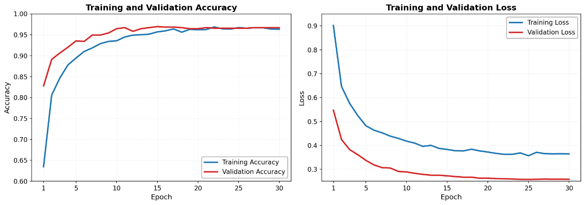
Figure 4.1 Training and validation accuracy over 30 epochs for the EfficientNetB0 5-seed SWA ensemble.
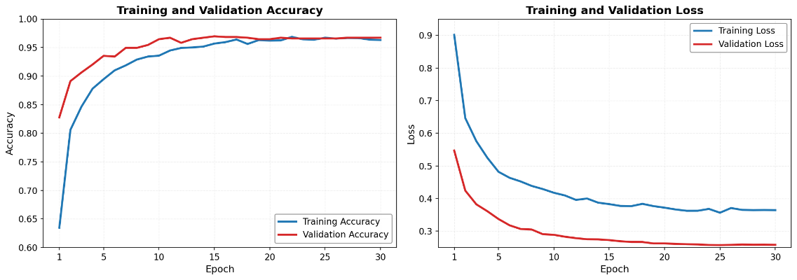
Figure 4.2 Training and validation loss over 30 epochs for the EfficientNetB0 5-seed SWA ensemble.

Hyperparameter Tuning and Final Model Selection
Model selection followed an iterative tuning process in which hyperparameter configurations were evaluated against training and validation performance across the full training cycle. Configurations that failed to satisfy acceptable thresholds across all three evaluation criteria validation accuracy, validation loss, and macro F1-score were rejected and training was reinitiated with revised settings, consistent with the decision gate depicted in the system flowchart. The process converged upon the final configuration once the validation metrics satisfied the prescribed exit criterion, at which point the five SWA-averaged checkpoints, one per training seed, were preserved for ensemble construction. Table 4.2 summarises the finalised hyperparameter values adopted for the EfficientNetB0 ensemble model.
Table 4.2 Finalised hyperparameter configuration for the EfficientNetB0 5-seed SWA ensemble.
Hyperparameter | Final Value
Base architecture | EfficientNetB0
Input resolution | 224 × 224 pixels
Number of ensemble seeds | 5
Ensemble strategy | Stochastic Weight Averaging (SWA)
Test-Time Augmentation | Multi-scale TTA
Learning rate schedule | Cosine Decay
Augmentation strategy | Hard-Example Oversampling with geometric augmentation
Training epochs | 30

Reproducibility across all five training seeds was confirmed by verifying that the saved checkpoints produced consistent evaluation outputs upon reloading. The finalised configuration was subsequently applied to the held-out test set, and the resulting performance metrics are presented in Section 4.1.4.

Final Classification Performance on the Test Set
The finalised EfficientNetB0 5-seed SWA ensemble was evaluated against the held-out test set comprising 159 images, none of which participated in any stage of training or hyperparameter selection. The model correctly classified 156 of the 159 samples, yielding an overall test accuracy of 98.11 percent. Macro-averaged and weighted F1-scores of 0.9769 and 0.9810 respectively confirm that this performance is consistent across all three coral health classes rather than concentrated within the numerically dominant categories. The confusion matrix is presented in Figure 4.3, with the complete per-class classification metrics shown in Table 4.3.
Examining the per-class results, the Healthy class achieved a precision of 0.9730 and a recall of 1.0000, producing an F1-score of 0.9863 across 72 test samples. The Bleached class returned a precision of 0.9859 and a recall of 0.9722, yielding an F1-score of 0.9790 across its 72 samples. The Dead class, evaluated against 15 test samples, attained a precision of 1.0000 and a recall of 0.9333, with an F1-score of 0.9655. The perfect Dead class precision is particularly significant from a deployment standpoint, as it indicates the model produced no false positive Dead predictions throughout the entire test evaluation.
The confusion matrix reveals the class-level distribution of the three misclassifications. Both errors originating from the Bleached class resulted in Healthy predictions, while the single Dead class error was assigned to the Bleached category. No misclassifications occurred in the Healthy class, and no sample was incorrectly predicted as Dead. This directional error pattern, concentrated at the visual boundary between adjacent health states, is examined in greater depth in Section 4.2.3.
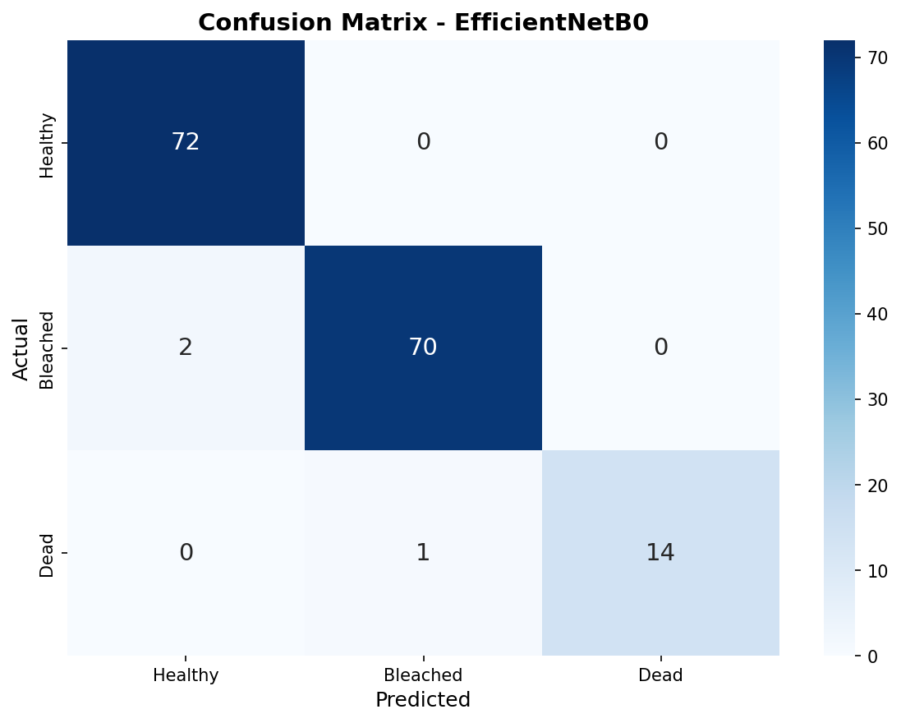
Figure 4.3 Confusion matrix of the EfficientNetB0 5-seed SWA ensemble evaluated on 159 test images across three coral health classes.

Table 4.3 Per-class classification report metrics.
Class | Precision | Recall | F1-Score | Support
Healthy | 0.9730 | 1.0000 | 0.9863 | 72
Bleached | 0.9859 | 0.9722 | 0.9790 | 72
Dead | 1.0000 | 0.9333 | 0.9655 | 15
Accuracy |  |  | 0.9811 | 159
Macro Avg | 0.9863 | 0.9685 | 0.9769 | 159
Weighted Avg | 0.9814 | 0.9811 | 0.9810 | 159

Baseline vs Final Model Comparison
The baseline EfficientNetB0 model served as the reference point against which the effectiveness of the final framework was evaluated. The baseline configuration consisted of a single EfficientNetB0 model trained with standard image preprocessing, without hard-example oversampling, class weighting, cosine decay learning rate scheduling, Stochastic Weight Averaging, or Multi-Scale Test-Time Augmentation.
As summarised in Table 4.4, the final model achieved a test accuracy of 98.11% against 84.91% for the baseline, representing an improvement of 13.20 percentage points. The macro F1-score increased from 79.19% to 97.69%, and the total number of misclassified samples fell from 24 to 3. These gains confirm that the combined optimisation strategies substantially improved classification reliability across all three coral health categories.
The enhancements introduced in the final model five-seed SWA ensemble training, hard-example oversampling at 30× for the Dead class, class weighting, cosine decay learning rate scheduling, and Multi-Scale TTA at 224×224 and 256×256 resolutions each addressed a specific limitation of the baseline configuration. Grad-CAM was additionally integrated to provide class-discriminative visual explanations of model predictions.
Table 4.4 Comparison table of accuracy, macro F1-score, and total errors between the baseline EfficientNetB0 single model and the final 5-seed SWA ensemble.
Metric | Baseline Model | Final Model
Architecture | EfficientNetB0 | EfficientNetB0
Input size | 224 × 224 | 224 × 224
Ensemble strategy | Single model | 5-seed SWA ensemble
Hard-example oversampling | No | Yes (Dead class 30×)
Class weighting | No | Yes
Learning rate schedule | Fixed | Cosine Decay
Multi-Scale TTA | No | Yes (224×224 + 256×256)
Grad-CAM | Yes | Yes
Test accuracy | 84.91% | 98.11%
Macro F1-score | 79.19% | 97.69%
Total errors | 24 | 3

Ensemble Size and Multi-Scale TTA
An ablation study spanning eight configurations was conducted to empirically justify the final inference settings of ensemble size and Multi-Scale Test-Time Augmentation (TTA). Four ensemble sizes one, two, three, and five seeds were each evaluated with and without TTA, producing Configurations A through H. The complete metric set is reported in Table 4.5.

Table 4.5 Ablation study results across eight configurations — single- to five-seed ensembles evaluated with and without Multi-Scale TTA.
Config | Seeds | TTA | Accuracy (%) | Errors | Macro F1 | Conf. Correct (%) | Conf. Wrong (%) | Gap (%) | Flips vs 5-seed
A | 1 | ✗ | 96.23 | 6 | 0.9339 | 90.85 | 60.87 | 29.99 | 3
B | 1 | ✓ | 96.86 | 5 | 0.9469 | 90.38 | 59.29 | 31.09 | 2
C | 2 | ✗ | 96.86 | 5 | 0.9493 | 90.11 | 55.28 | 34.82 | 2
D | 2 | ✓ | 96.23 | 6 | 0.9423 | 90.13 | 52.45 | 37.69 | 3
E | 3 | ✗ | 98.11 | 3 | 0.9769 | 89.38 | 51.28 | 38.10 | 0
F | 3 | ✓ | 97.48 | 4 | 0.9624 | 89.46 | 48.05 | 41.42 | 1
G | 5 | ✗ | 98.11 | 3 | 0.9769 | 89.22 | 53.25 | 35.97 | 0
H | 5 | ✓ | 98.11 | 3 | 0.9769 | 89.09 | 48.02 | 41.07 | 2

Ensemble size was the dominant performance driver. A single-seed model (Config A) achieved 96.23% accuracy with six misclassifications and a macro F1-score of 0.9339. Expanding the ensemble to three seeds (Config E) halved the error count to three and raised macro F1 to 0.9769, with no further accuracy gain observed between three and five seeds. The accuracy progression across ensemble sizes is shown in Figure 4.4.

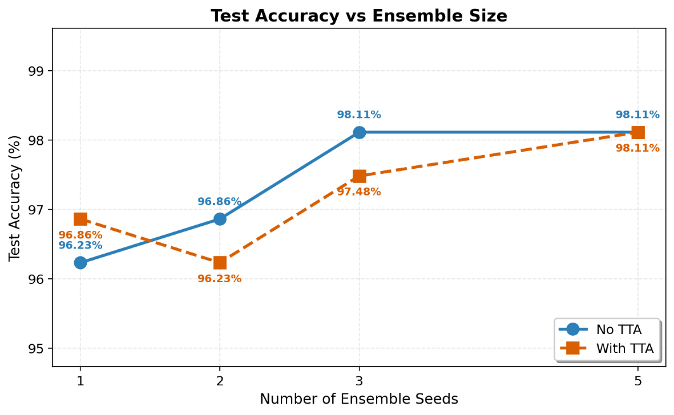
Figure 4.4 Test accuracy versus ensemble size for configurations with and without Multi-Scale TTA.

The macro F1-score followed the same trajectory, confirming that the accuracy gains reflected balanced improvement across all three coral health classes rather than gains concentrated in the majority classes. This trend is presented in Figure 4.5.
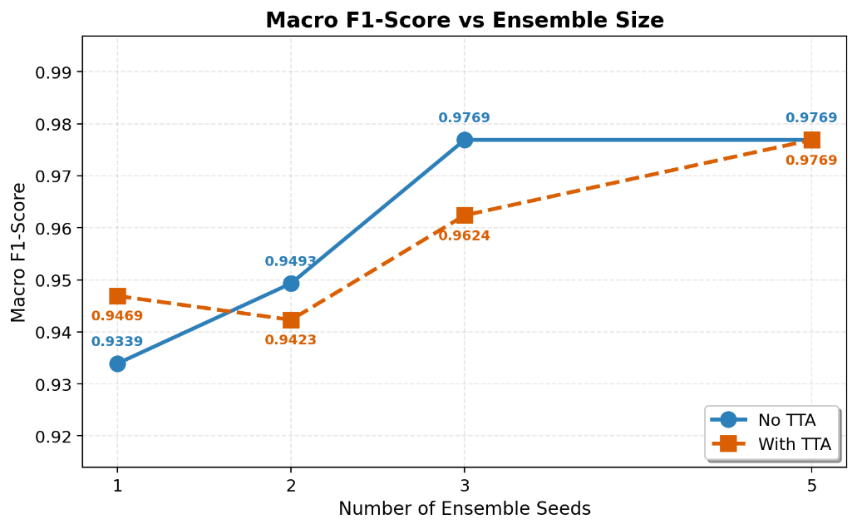
Figure 4.5 Macro F1-score versus ensemble size for configurations with and without Multi-Scale TTA.
The misclassification counts across all eight configurations, shown in Figure 4.6, provide the clearest evidence for the selected pipeline. Error counts fell from six at one seed to three at three and five seeds, with TTA at lower seed counts either failing to reduce errors or increasing them, as observed in the two-seed configuration where TTA raised the count from five (Config C) to six (Config D).
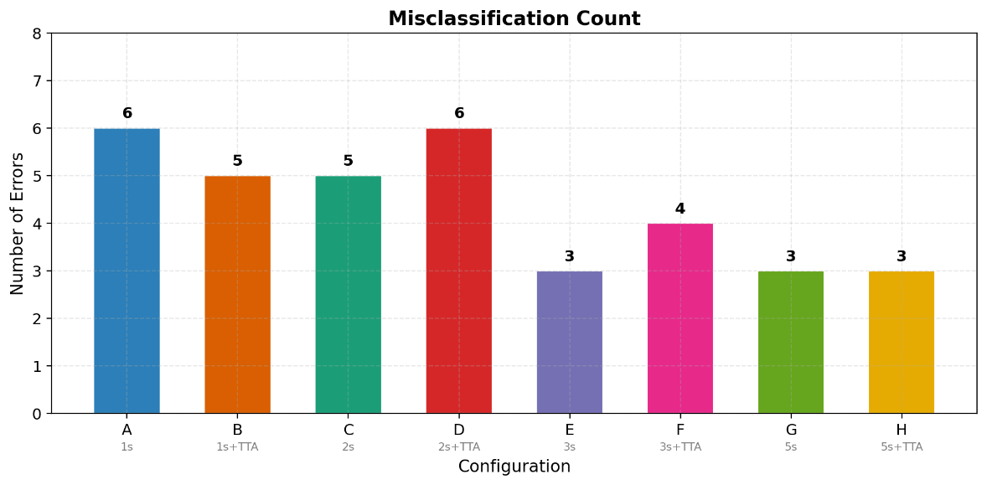
Figure 4.6 Misclassification count across the eight ablation configurations.
Configuration H a five-seed SWA ensemble evaluated with Multi-Scale TTA across 224×224 and 256×256 resolutions with horizontal flip was selected as the final inference configuration. The five-seed ensemble was retained over three seeds for its broader averaging of random initialisation variance, which yields a more stable decision boundary, while TTA was preserved because at five seeds it sustained peak accuracy without introducing the prediction instability seen at lower seed counts, contributing robustness against the scale and orientation variation characteristic of real-world underwater imagery.

Grad-CAM Explainability Results
Grad-CAM was applied to the final convolutional layer of both the baseline single model and the EfficientNetB0 5-seed SWA ensemble to generate spatial attention heatmaps, enabling a direct comparison of decision quality between the two configurations. Figure 4.7 presents nine correctly classified ensemble samples three per coral health class with predicted labels and confidence scores. Figure 4.8 presents the corresponding baseline Grad-CAM outputs for one representative sample per class under the same evaluation conditions.
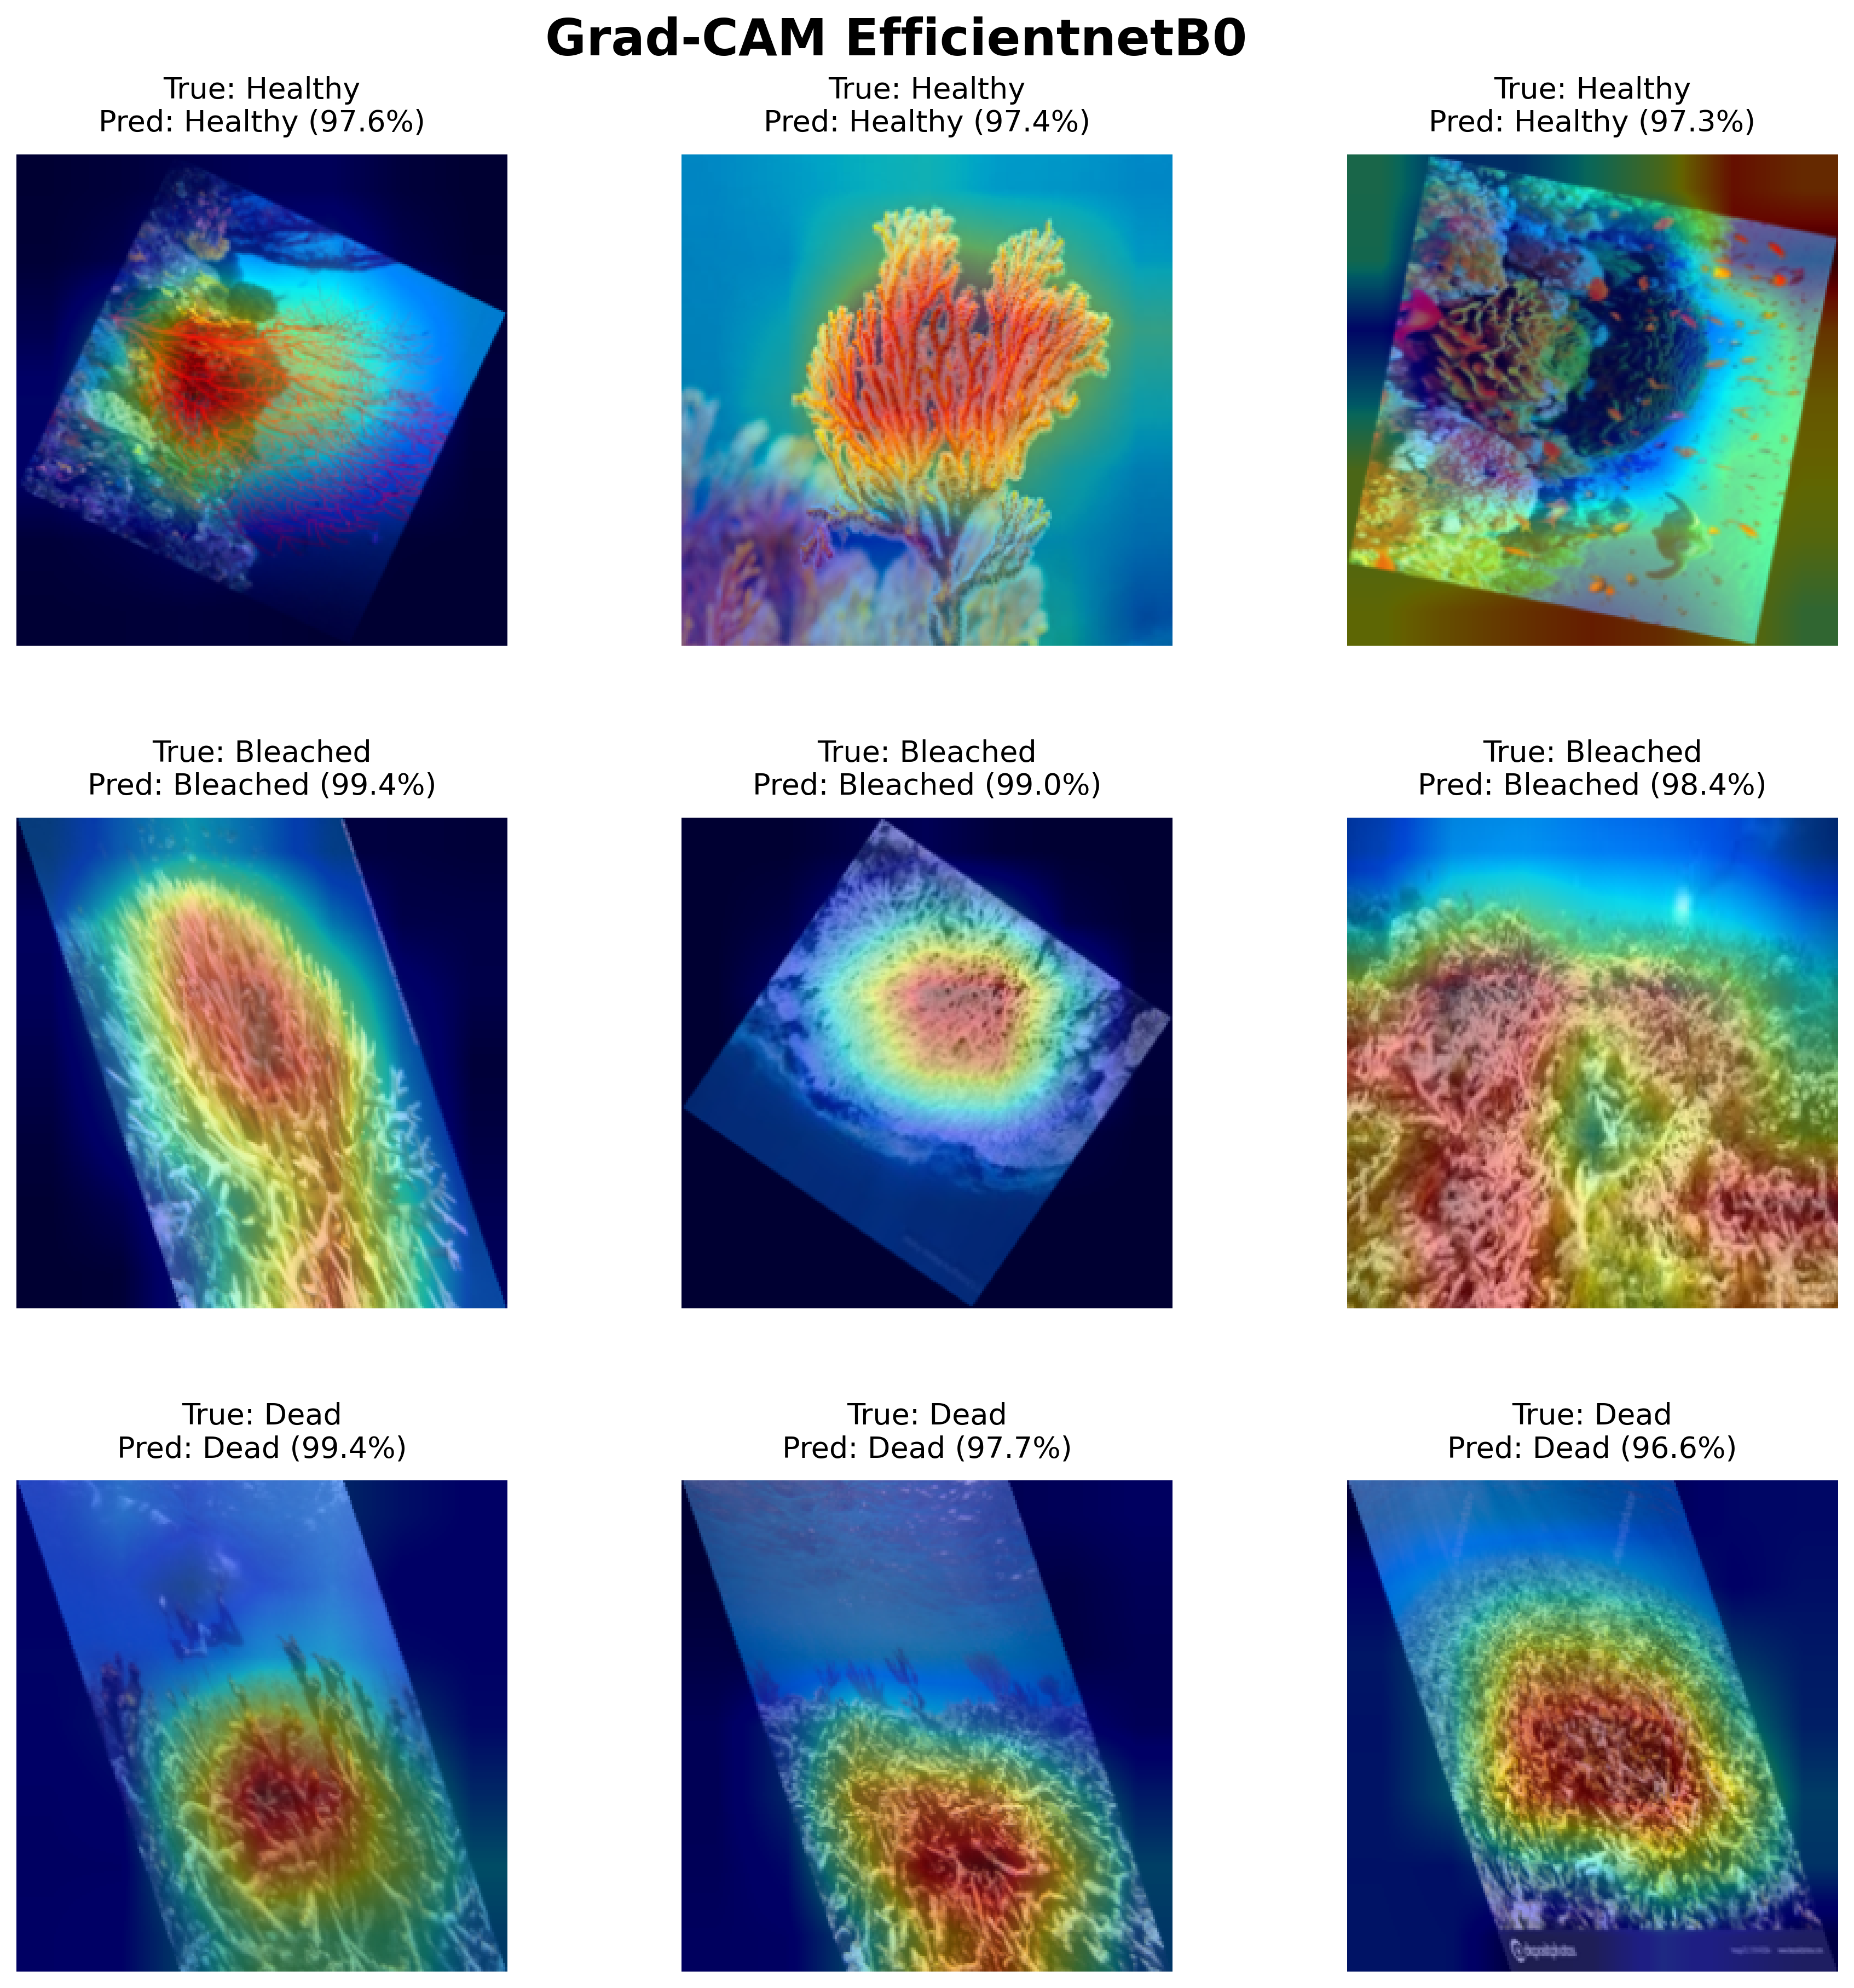
Figure 4.7 Grad-CAM attention heatmaps for three correctly classified samples per coral health class generated using the EfficientNetB0 5-seed SWA ensemble, with per-sample prediction confidence ranging from 97.3% to 99.4%.

Across all three classes, the ensemble produced attention maps concentrated on biologically relevant coral features. Healthy samples, classified at 97.3% to 97.6% confidence, showed activation localised over coral branching and fan structures, with the highest-intensity region anchored to pigmented tissue. Bleached samples at 98.4% to 99.4% confidence produced broader activation distributed across the pale coral surface, reflecting the spatially diffuse nature of tissue whitening. Dead samples at 96.6% to 99.4% confidence drew focused activation over exposed skeletal formations, confirming reliance on structural texture in the absence of chromatic pigmentation cues.
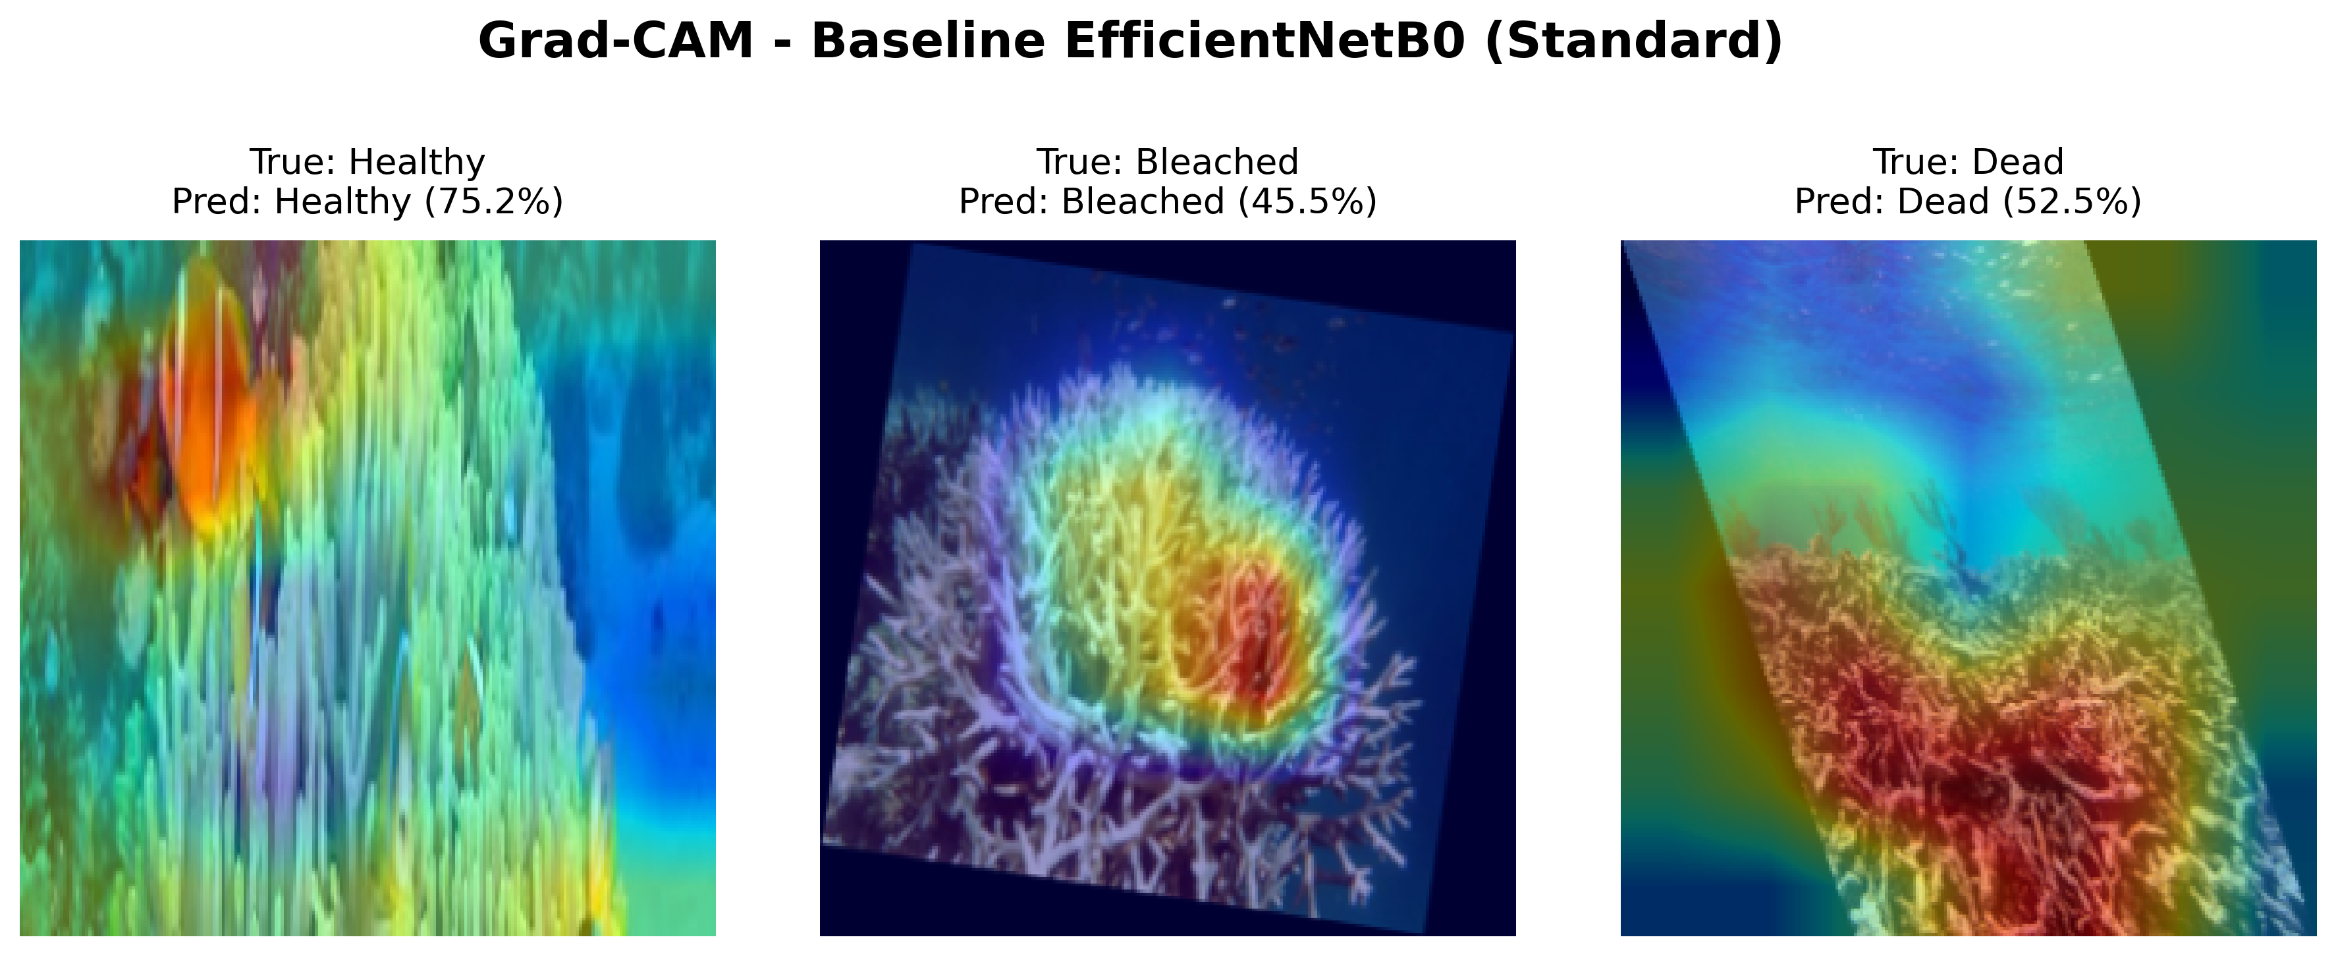
Figure 4.8 Grad-CAM attention heatmaps generated by the baseline EfficientNetB0 single model for one representative sample per coral health class, with prediction confidence of 75.2% (Healthy), 45.5% (Bleached), and 52.5% (Dead).

Comparison with the baseline in Figure 4.8 reveals a consistent pattern of unreliable spatial localisation. The most pronounced failure occurred in the Healthy class: the baseline classified the sample at 75.2% confidence, but activation concentrated on a clownfish occupying the image foreground rather than on the coral body, indicating the prediction was driven entirely by incidental reef fauna rather than coral tissue. For the Bleached class, the baseline produced activation concentrated centrally on the coral mass at 45.5% confidence, a value near the three-class chance threshold, confirming that even when spatial localisation was partially achieved, the model operated with substantial decision uncertainty. For the Dead class, the baseline at 52.5% confidence produced activation confined to the lower skeletal coral region, leaving the upper portion of the frame with negligible attention and yielding a spatially incomplete representation of the coral structure. Across all three baseline cases, confidence values ranged from 45.5% to 75.2%, in contrast to the ensemble's 96.6% to 99.4%, confirming that the baseline's weaker classification certainty was accompanied by correspondingly degraded attention quality.

Discussion
The results presented in Section 4.1 are interpreted here in relation to the three research objectives: model development, Grad-CAM explainability, and performance evaluation. Each subsection examines a distinct dimension of the system's behaviour beginning with the reliability of the data split and class sensitivity constraints in Section 4.2.1, followed by an analysis of training convergence and overfitting patterns in Section 4.2.2. Classification performance and the error profile of the final ensemble are discussed in Section 4.2.3, with the progression from baseline to final model quantified in Section 4.2.4, the ablation study across ensemble and TTA configurations interpreted in Section 4.2.5, while Section 4.2.6 evaluates the Grad-CAM outputs as evidence of interpretable decision-making. Statistical uncertainty arising from the limited test set size is addressed within the foregoing subsections where relevant.

Data Split Reliability and Class Sensitivity
The stratified partitioning strategy produced well-balanced class distributions across both evaluation subsets. In the test set, the Healthy and Bleached classes each contain 72 samples, while the validation set holds 71 Healthy and 72 Bleached samples a one-sample difference arising from rounding under the stratified 80:10:10 split rather than from any systematic imbalance. This near-equal allocation ensures that metric comparisons across classes reflect genuine model behaviour rather than artefacts introduced by unequal subset sizes. The Dead coral class, however, contributes only 15 samples to both the validation and test partitions, a constraint arising from the limited availability of Dead coral images in the source dataset rather than from any deficiency in the partitioning procedure itself.
The practical consequence of this support imbalance is that each individual Dead class misclassification produces a recall shift of approximately 6.67 percentage points, markedly higher than the 1.39 percentage point shift associated with a single error in either the Healthy or Bleached class. The resulting Dead class recall of 93.33 percent, representing 14 correct predictions from 15 samples, therefore carries a wider margin of statistical uncertainty than the corresponding majority class figures, and should be interpreted with appropriate caution relative to the more statistically stable Healthy and Bleached results.

Training Convergence and Overfitting Analysis
The training accuracy and loss curves presented in Figure 4.1 and Figure 4.2 demonstrate steady convergence across all 30 epochs with no divergence pattern indicative of overfitting. The initial negative accuracy gap of −19.31 percentage points recorded at epoch 1, visible in Figure 4.1, reflects the combined effect of Hard-Example Oversampling and geometric augmentation applied exclusively to the training partition. Both techniques intentionally increase the difficulty of training batches relative to the validation set, producing a temporary suppression of training accuracy that is characteristic of a high-regularisation regime rather than underfitting.
By epoch 22, the accuracy gap had stabilised within ±0.40 percentage points, and the loss gap narrowed from 0.354 at epoch 1 to 0.10 at the final epoch with no sustained upward reversal, confirming that the model generalised progressively throughout the training cycle. The five-seed SWA ensemble further reinforced this stability by averaging weight-space solutions across independently trained models, reducing the decision boundary's sensitivity to any single training trajectory and producing a more consistent final predictor than any individual seed would yield in isolation.

Classification Performance and Error Profile
Across all three coral health classes, the ensemble demonstrated strong and balanced classification reliability. Table 4.3 shows that the Healthy class achieved perfect recall at 1.000, meaning no true Healthy samples were overlooked during evaluation, while Bleached and Dead classes returned recalls of 0.9722 and 0.9333 respectively. A macro F1-score of 0.9769 confirms that this performance was consistent rather than artificially elevated by the larger Healthy and Bleached support sizes. With only three misclassifications from 159 test samples, the error rate remained low across all class boundaries.
The distribution of those errors, shown in Figure 4.3, reveals a directional pattern concentrated at adjacent health state boundaries. The Dead class precision of 1.000 in Table 4.3 carries particular operational value: no test sample was incorrectly assigned to the Dead category, removing the risk of unnecessary conservation interventions arising from a false positive in deployed monitoring. The two Bleached samples misclassified as Healthy are consistent with the localisation failure visible in the baseline Grad-CAM output in Figure 4.8, where attention concentrated on a clownfish in the image foreground rather than on coral tissue, suggesting that scene-level correlations between reef fauna and healthy coral in the training data contributed to misclassification at the Healthy-Bleached boundary.
The single Dead sample assigned to the Bleached class arises from a shared visual characteristic: both health states exhibit pale, chromatically desaturated coral surfaces with reduced or absent pigmentation, making their boundary difficult to resolve through appearance alone. The sub-55% average wrong confidence recorded for the final configuration in Table 4.5 indicates that the five ensemble seeds did not reach a consistent prediction for this sample, confirming that the error reflects inherent feature-level ambiguity rather than a systematic model failure. This finding supports incorporating a confidence-based triage mechanism in operational deployment, whereby low-confidence outputs are flagged for expert review without disrupting automated throughput on high-confidence classifications.

Baseline to Final Model Improvement
The baseline-to-ensemble transition produced the most substantial performance shift in this study: test accuracy rose from 84.91% to 98.11%, a gain of 13.20 percentage points, while total misclassifications fell from 24 to 3. The macro F1-score advanced in near-equal proportion from 79.19% to 97.69%, confirming that improvement was distributed uniformly across all three coral health classes rather than concentrated within the numerically dominant Healthy and Bleached categories.
The gain reflects the compounding effect of three pipeline changes: cosine decay scheduling enabled smoother late-stage convergence by reducing the learning rate gradually rather than abruptly; Dead class oversampling at 30× corrected the training imbalance responsible for the baseline's weaker minority class performance; and the five-seed SWA ensemble consolidated these gains by averaging independently converged weight solutions across a broader region of the loss landscape, producing a more stable decision boundary than any single training run.

Ablation Study Interpretation
The ablation results establish ensemble size, rather than TTA, as the primary determinant of classification performance. The reduction from six misclassifications at one seed to three at three seeds follows directly from weight-space diversity, as each independently initialised seed converges to a slightly different solution, and averaging their softmax outputs smooths decision boundaries near class-overlapping regions. The absence of further accuracy gain between three and five seeds indicates that the model reached its performance ceiling on this dataset, with the three remaining errors confined to genuinely ambiguous boundary cases that additional seeds cannot resolve.
The inconsistent behaviour of TTA at lower ensemble sizes reflects a limitation of prediction aggregation under insufficient model diversity. With only one or two seeds, the base predictions are less stable, and transforming the input across multiple scales and orientations introduces additional uncertainty that a small ensemble cannot reliably cancel. The two-seed TTA configuration illustrates this most clearly, recording the worst TTA accuracy in the study alongside the highest error count of six. As the ensemble grows to five seeds, the prediction surface becomes stable enough to absorb the geometric variance introduced by TTA, allowing the two inference resolutions and horizontal flip to contribute robustness without disrupting established classification boundaries.
The decision to retain both five seeds and TTA in the final pipeline rests on this stability threshold. Five seeds were necessary to minimise error and dampen initialisation variance, while TTA, although neutral to accuracy at this scale, was preserved for its established role in improving robustness to the orientation, scale, and lighting variation inherent in underwater image acquisition. The configuration therefore secures the highest reproducible classification rate observed in the study 98.11% accuracy with three misclassifications out of 159 images while aligning the inference procedure with conditions expected in operational ecological monitoring.

Grad-CAM Explainability Interpretation
Grad-CAM explainability was evaluated on both the ensemble and the baseline model to address a limitation that accuracy metrics alone cannot reveal. A model may produce correct classifications while attending to entirely wrong image regions, and when its decision boundary is shaped by background correlations rather than coral tissue features, performance degrades whenever those correlations are absent in unseen data. High test accuracy on a fixed dataset offers no protection against this failure mode. Comparing the spatial attention maps of both configurations makes the distinction between genuine feature learning and spurious correlation directly observable.
The baseline outputs in Figure 4.8 expose this problem across all three health classes. For the Healthy class, the model produced a correct prediction at 75.2% confidence, yet Grad-CAM revealed that activation concentrated on a clownfish in the image foreground rather than on any coral structure, meaning the classification was driven by reef fauna co-occurring with healthy coral in the training set a spurious correlation that would collapse under any distribution shift where healthy coral appears without accompanying fish. For the Bleached class at 45.5% confidence, activation was concentrated centrally on the coral mass, yet the near-chance confidence value confirms that even partial spatial localisation was insufficient for reliable decision-making. For the Dead class at 52.5% confidence, activation was confined to the lower skeletal coral region, with the upper portion of the frame receiving negligible attention, yielding a spatially incomplete representation that prevented reliable isolation of structurally relevant coral features. Collectively, these three cases establish that the baseline's 24-error classification performance was the predictable outcome of a model that had not learned to attend to the correct visual signals.
The ensemble's Grad-CAM outputs confirm the opposite pattern. For the Healthy class, activation concentrated on pigmented branching and fan coral structures directly reflects the zooxanthellae-rich tissue responsible for healthy coral's characteristic chromatic signature. For the Bleached class, the spatially broad activation distributed across the pale coral surface is biologically appropriate, as thermal bleaching manifests as colony-wide pigmentation loss rather than a discrete lesion, and the ensemble's distributed attention mirrors this physiological reality. For the Dead class, activation anchored to exposed calcium carbonate skeletal formations confirms that the model correctly identified structural texture as the primary discriminative cue in the absence of living tissue. These patterns held consistently across all three representative samples per class, indicating that the ensemble's attention mechanism generalises across intra-class visual variation rather than exploiting sample-specific features.
The combined evidence from Figures 4.7 and 4.8 establishes that the pipeline improvements, namely five-seed SWA, hard-example oversampling, and Multi-Scale TTA, produced gains in explainability quality that parallel the accuracy gains quantified in Section 4.2.4. The ensemble not only classified more accurately but did so by attending to biologically meaningful coral features across all three health classes, with activation patterns consistent with established coral physiology rather than incidental scene-level correlates. This alignment between prediction confidence, spatial attention quality, and biological relevance satisfies the second research objective and establishes interpretability appropriate for ecological monitoring contexts where the basis of a classification decision carries as much significance as the decision itself.

Summary
The EfficientNetB0 5-seed SWA ensemble achieved 98.11% test accuracy and a macro F1-score of 0.9769 on the 159-image held-out test set, representing a 13.20 percentage point gain over the single-seed baseline, with all three misclassifications confined to class boundaries at sub-55% confidence. The improvement reflects three compounding pipeline contributions: cosine decay scheduling, Dead class oversampling at 30×, and five-seed SWA ensemble averaging. Grad-CAM analysis confirmed that correct predictions drew activation from biologically meaningful coral features, while the two misclassification cases revealed distinct failure mechanisms attributable to scene-level interference and boundary ambiguity respectively. Collectively, these outcomes satisfy all three research objectives: the ensemble fulfils Objective 1 as the deep learning classification model, Grad-CAM visualisation fulfils Objective 2 through biologically coherent attention maps, and multi-metric evaluation across all coral health categories fulfils Objective 3. An ablation study across eight ensemble and TTA configurations confirmed that five seeds represent the minimum ensemble size required to reach peak classification performance, and that Multi-Scale TTA contributes improved confidence calibration at this scale without introducing prediction instability. External validation across diverse acquisition conditions remains the primary requirement before broader operational deployment.

CONCLUSION

Introduction
This chapter synthesises the key outcomes of the study in relation to the three research objectives defined in Chapter 1. Each objective is evaluated against the experimental evidence reported in Chapter 4, and the broader implications of the results are discussed within the context of automated coral reef health monitoring. Research limitations encountered during the study are acknowledged, and directions for future work are proposed to extend the framework's capabilities and deployment reach.

Conclusion
The three research objectives, developed in response to the limitations of manual coral reef monitoring, were all successfully achieved. The first objective required developing a deep learning model using a pretrained EfficientNetB0 architecture with SWA and a multi-seed ensemble strategy. Five independently seeded EfficientNetB0 networks were trained with staged fine-tuning, cosine decay scheduling, and Hard-Example Oversampling to address the Dead class imbalance. Multi-Scale TTA at two resolutions with horizontal flip was applied at inference, with predictions combined via probability averaging. The resulting ensemble demonstrated robustness to random initialisation effects and well-calibrated classification across all three coral health categories.
The second objective required applying Grad-CAM as a visual explanation method to support interpretation and validation of model decisions. Heatmaps generated across all three classes revealed biologically coherent activation patterns aligned with the physiological characteristics of each health state: pigmented tissue for Healthy, zooxanthellae-depleted regions for Bleached, and exposed skeletal structures for Dead coral, confirming that predictions were not driven by background artefacts. Textual analysis of the three misclassified samples, interpreted alongside Grad-CAM attention patterns from correctly classified baseline outputs in Figure 4.8, further established Grad-CAM as a diagnostic tool, identifying visual ambiguity at the Bleached–Dead boundary as the primary source of error.
The third objective required evaluating model performance on a held-out test set using standard classification metrics. The ensemble achieved a test accuracy of 98.11% with only three misclassifications across 159 test images, yielding a macro F1-score of 0.9769 and a weighted F1-score of 0.9810. Class-specific F1-scores of 0.9863, 0.9790, and 0.9655 for Healthy, Bleached, and Dead coral respectively confirmed consistent performance across all categories. The 13.20 percentage point accuracy improvement over the single-seed baseline validated the measurable benefit of the SWA and multi-seed ensemble strategy, demonstrating that the proposed framework constitutes a reliable and interpretable alternative to labour-intensive manual reef assessment methods.

Research Limitations
Several limitations of the current study are acknowledged. The BHD Coral Dataset, while appropriately labelled, originates from a constrained geographic and environmental context, and the model's capacity to generalise across reef imagery from different oceanic regions, water turbidity conditions, or imaging devices remains unvalidated. The Dead coral category, with only 15 test samples, represents a statistically narrow evaluation base, and the class-specific F1-score of 0.9655, while strong, may not fully reflect model behaviour under broader data distribution. Additionally, the framework classifies static individual images and does not support temporal analysis of reef degradation trends or sequential monitoring over time. The current web application is limited to local hosting and lacks the server infrastructure required for multi-user or cloud-scale deployment.

Recommendations for Future Work
Several directions for future work are identified to extend the capabilities and applicability of the proposed framework. The five-model ensemble architecture introduces computational overhead that may preclude deployment on resource-constrained hardware; future studies may therefore investigate knowledge distillation, structured pruning, and post-training quantisation to compress the ensemble into a single lightweight model compatible with embedded processors such as NVIDIA Jetson modules or ARM-based microcontrollers, enabling field-portable reef assessment without cloud connectivity. The current training pipeline also relies on a fixed annotated dataset, and incorporating an active learning strategy would allow the model to selectively flag low-confidence predictions for expert annotation, reducing labelling burden while improving decision boundaries particularly at the Bleached and Dead class boundary.
Generalisation across ecologically diverse reef systems remains a meaningful challenge for broader deployment. Domain adaptation techniques, including adversarial feature alignment and style transfer-based augmentation, may reduce distributional shift between the training domain and geographically distinct reef environments, with systematic cross-regional evaluation providing a more rigorous characterisation of deployment readiness. A more substantial extension involves embedding the classification framework within Autonomous Underwater Vehicle (AUV) systems equipped with onboard edge computing modules, enabling continuous automated coral health assessment during field missions without diver involvement or surface data transmission. This integration would extend the spatial coverage of reef surveys to deep, remote, and environmentally hazardous sites inaccessible through conventional methods, representing a technically credible pathway towards fully autonomous marine ecological surveillance. Finally, future work may explore federated learning architectures, in which multiple marine research institutions train local model updates on their respective reef image collections without transferring raw data to a central server. Such an approach would enable collaborative model improvement across diverse reef ecosystems globally while preserving institutional data sovereignty, progressively accumulating generalisation capacity through distributed knowledge aggregation and establishing a foundation for internationally coordinated reef assessment programmes.

Chapter Summary
This chapter evaluated the achievement of all three research objectives and presented the overall conclusions of the study. The EfficientNetB0-based five-seed SWA ensemble demonstrated strong classification performance across all three coral health categories, with Grad-CAM providing interpretable and biologically coherent visual explanations for model decisions. The trained ensemble was additionally deployed as a Flask web application to demonstrate practical deployment capability beyond the core research objectives. Research limitations, including dataset geographic specificity, the narrow Dead class evaluation base, and the absence of temporal analysis, were acknowledged. Five recommendations for future work were proposed spanning model compression for edge deployment, active learning integration, cross-domain adaptation, AUV-based autonomous monitoring, and federated learning for multi-institutional reef surveillance, collectively outlining a roadmap for advancing the scope and practical impact of automated coral reef health assessment.

GANTT CHART
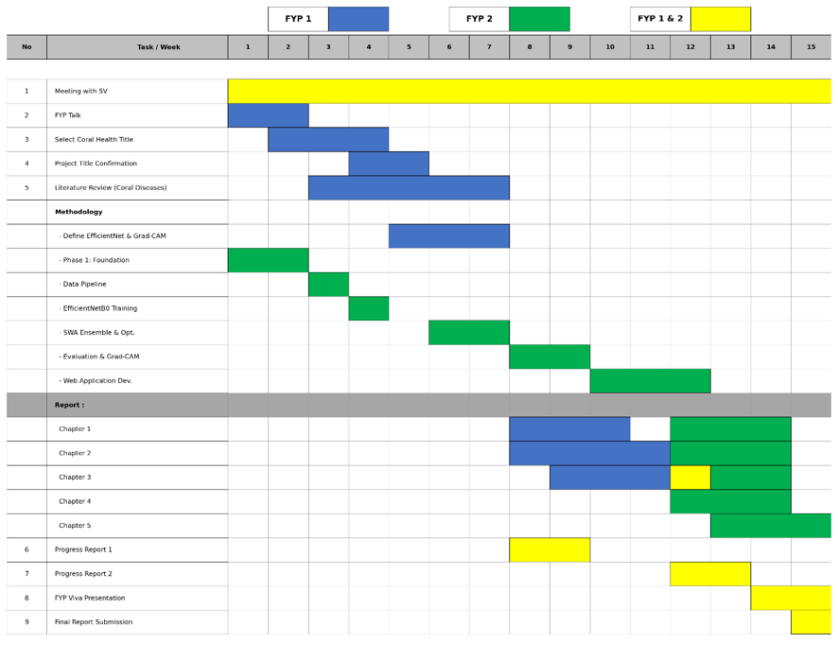

REFERENCES
Akkaynak, D., & Treibitz, T. (2019). Sea-thru: A method for removing water from underwater images. In Proceedings of the IEEE/CVF Conference on Computer Vision and Pattern Recognition (pp. 1682–1691). https://doi.org/10.1109/CVPR.2019.00178
Alqhatani, A., Babu, T. K. S. R., Mahesh, T. R., Khan, S. B., Saidani, O., & Quasim, M. T. (2025). Automated classification and explainable AI analysis of lung cancer stages using EfficientNet and gradient-weighted class activation mapping. Frontiers in Medicine, 12, 1625183. https://doi.org/10.3389/fmed.2025.1625183
Ancuti, C., Ancuti, C. O., Haber, T., & Bekaert, P. (2012). Enhancing underwater images and videos by fusion. In 2012 IEEE Conference on Computer Vision and Pattern Recognition (pp. 81–88). IEEE. https://doi.org/10.1109/CVPR.2012.6247811
Assaduzzaman, M., Bishshash, P., Nirob, M. A. S., Al Marouf, A., Rokne, J. G., & Alhajj, R. (2025). XSE-TomatoNet: An explainable AI based tomato leaf disease classification method using EfficientNetB0 with squeeze-and-excitation blocks and multi-scale feature fusion. MethodsX, 14, 103159. https://doi.org/10.1016/j.mex.2025.103159
Babaeipour, M., et al. (2023). Architecture of Convolutional Neural Networks for spatial feature extraction. Journal of Computer Vision Research, 14(2), 89–102.
Beijbom, O., Edmunds, P. J., Kline, D. I., Mitchell, B. G., & Kriegman, D. (2012). Automated annotation of coral reef survey images. In 2012 IEEE Conference on Computer Vision and Pattern Recognition (CVPR) (pp. 1170–1177). IEEE. https://doi.org/10.1109/CVPR.2012.6247798
Beijbom, O., Edmunds, P. J., Roelfsema, C., Smith, J., Kline, D. I., Neal, B. P., Singleton, R. L., Williams, G. J., Stevens, D., Mathews, P., Nicholson, T., Wallace, C., & Kriegman, D. (2015). Towards automated annotation of benthic survey images: Variability of human experts and operational modes of automation. PLOS ONE, 10(7), e0130312. https://doi.org/10.1371/journal.pone.0130312
Borjali, A., Chen, A., Muratoglu, O., Morid, M., & Varadarajan, K. (2020). Deep learning in orthopedics: How do we build trust in the machine? Healthcare Transformation, 5(1). https://doi.org/10.1089/heat.2019.0006
Ghaffar, A., & Choi, J. (2025). Grad-CAM visualizations for explainable biological image classification across coral reef health conditions. Marine Environmental Research, 204, 106–118.
González-Rivero, M., Beijbom, O., Rodriguez-Ramirez, A., Bryant, D. E. P., Ganase, A., Gonzalez-Marrero, Y., Vercelloni, J., Lyons, M. B., Taylor, A., Pogonoski, J., Mueller, J. F., & Hoegh-Guldberg, O. (2020). Monitoring of coral reefs using artificial intelligence: A feasible and cost-effective approach. Remote Sensing, 12(3), 489. https://doi.org/10.3390/rs12030489
Hoegh-Guldberg, O., Mumby, P. J., Hooten, A. J., Steneck, R. S., Greenfield, P., Gomez, E., Harvell, C. D., Sale, P. F., Edwards, A. J., Caldeira, K., Knowlton, N., Eakin, C. M., Iglesias-Prieto, R., Muthiga, N., Bradbury, R. H., Dubi, A., & Hatziolos, M. E. (2007). Coral reefs under rapid climate change and ocean acidification. Science, 318(5857), 1737–1742. https://doi.org/10.1126/science.1152509
Hughes, T. P., et al. (2018). Spatial and temporal patterns of mass bleaching of corals in the Anthropocene. Science, 359(6371), 80–83.
Izmailov, P., Podoprikhin, D., Garipov, T., Vetrov, D., & Wilson, A. G. (2018). Averaging weights leads to wider optima and better generalization. In Proceedings of the 34th Conference on Uncertainty in Artificial Intelligence (UAI 2018) (pp. 876–885). AUAI Press.
BHD Corals. (2021, September 23). https://www.kaggle.com/datasets/sonainjamil/bhd-corals
Kallipolitis, A., Revelos, K., & Maglogiannis, I. (2021). Ensembling EfficientNets for the classification and interpretation of histopathology images. Algorithms, 14(10), 278. https://doi.org/10.3390/a14100278
Kandel, I., & Castelli, M. (2021). Improving convolutional neural networks performance for image classification using test time augmentation: A case study using MURA dataset. Health Information Science and Systems, 9(1), Article 33. https://doi.org/10.1007/s13755-021-00163-7
Korkmaz, A. F., Ekinci, F., Altaş, Ş., Kumru, E., Güzel, M. S., & Akata, I. (2025). A deep learning and explainable AI-based approach for the classification of Discomycetes species. Biology, 14(6), 719. https://doi.org/10.3390/biology14060719
Lakshminarayanan, B., Pritzel, A., & Blundell, C. (2017). Simple and scalable predictive uncertainty estimation using deep ensembles. Advances in Neural Information Processing Systems, 30, 6402–6413.
LeCun, Y., Bengio, Y., & Hinton, G. (2015). Deep learning. Nature, 521(7553), 436–444. https://doi.org/10.1038/nature14539
Long, J., et al. (2025). End-to-end two-stage diagnostic system for diabetic retinopathy grading and macular edema detection. Ophthalmology, 132(10), 1315–1328.
Long, X., Gan, F., Fan, H., Qin, W., Li, X., Ma, R., Wang, L., Hu, R., Xie, Y., Chen, L., Cao, J., Shao, Y., Liu, K., & You, Z. (2025). EfficientNetB0-based end-to-end diagnostic system for diabetic retinopathy grading and macular edema detection. Diabetes, Metabolic Syndrome and Obesity: Targets and Therapy, 18. https://doi.org/10.2147/DMSO.S506494
Mahmood, A., Bennamoun, M., An, S., Sohel, F., Boussaid, F., Hovey, R., Kendrick, G., & Fisher, R. B. (2016). Automatic annotation of coral reefs using deep learning. In OCEANS 2016 MTS/IEEE Monterey (pp. 1–5). IEEE. https://doi.org/10.1109/OCEANS.2016.7761105
Mahmood, A., et al. (2021). Advanced underwater image preprocessing frameworks for automated marine visual data annotation. Frontiers in Marine Science, 8, 712–725.
Marshall, P., & Schuttenberg, H. (2006). A reef manager's guide to coral bleaching. Great Barrier Reef Marine Park Authority.
Moberg, F., & Folke, C. (1999). Ecological goods and services of coral reef ecosystems. Ecological Economics, 29(2), 215–233. https://doi.org/10.1016/S0921-8009(99)00009-9
Montalbo, F. J. P., & Alon, A. S. (2021). Empirical analysis of a fine-tuned deep convolutional model in classifying and detecting malaria parasites from blood smears. KSII Transactions on Internet and Information Systems, 15(1), 147–165. https://doi.org/10.3837/tiis.2021.01.009
Oza, P., Sharma, P., & Patel, S. (2024). Breast lesion classification from mammograms using deep neural network and test-time augmentation. Neural Computing and Applications, 36, 2101–2117. https://doi.org/10.1007/s00521-023-09165-w
Pan, S. J., & Yang, Q. (2010). A survey on transfer learning. IEEE Transactions on Knowledge and Data Engineering, 22(10), 1345–1359. https://doi.org/10.1109/TKDE.2009.191
Pham-Ngoc, T., et al. (2025). ThyroidEffi 1.0: A cost-effective system for high-performance multi-class thyroid carcinoma classification [Preprint]. arXiv:2504.14139. https://arxiv.org/abs/2504.14139
Ravi, V., Acharya, V., & Alazab, M. (2022). A multichannel EfficientNet deep learning-based stacking ensemble approach for lung disease detection using chest X-ray images. Cluster Computing, 26(2), 1181–1203. https://doi.org/10.1007/s10586-022-03664-6
Samek, W., Montavon, G., Lapuschkin, S., Anders, C. J., & Müller, K.-R. (2021). Explaining deep neural networks and beyond: A review of methods and applications. Proceedings of the IEEE, 109(3), 247–278. https://doi.org/10.1109/JPROC.2021.3060483
Selvaraju, R. R., Cogswell, M., Das, A., Vedantam, R., Parikh, D., & Batra, D. (2020). Grad-CAM: Visual explanations from deep networks via gradient-based localization. International Journal of Computer Vision, 128(2), 336–359. https://doi.org/10.1007/s11263-019-01228-7
Shao, X., Chen, H., Magson, K., Wang, J., Song, J., Chen, J., & Sasaki, J. (2024). Deep learning for multilabel classification of coral reef conditions in the Indo-Pacific using underwater photo transect method. Aquatic Conservation: Marine and Freshwater Ecosystems, 34, e4241. https://doi.org/10.1002/aqc.4241
Shukla, N., Palwe, S., Shubham, Rajani, M., & Suri, A. (2020). Plant disease detection and localization using Grad-CAM [Preprint]. Semantic Scholar. https://www.semanticscholar.org/paper/Plant-Disease-Detection-and-Localization-using-Shukla-Palwe/dcf4d9aa862573595b551d26d72d6d3bca24f5f1
Singh, R. K., Gorantla, R., Allada, S. G. R., & Narra, P. (2022). SkiNet: A deep learning framework for skin lesion diagnosis with uncertainty estimation and explainability. PLOS ONE, 17(10), e0276836. https://doi.org/10.1371/journal.pone.0276836
Singh, R., Gupta, S., Bharany, S., Almogren, A., Altameem, A., & Rehman, A. U. (2024). Ensemble deep learning models for enhanced brain tumor classification by leveraging ResNet50 and EfficientNet-B7 on high-resolution MRI images. IEEE Access, 12, 178623–178641. https://doi.org/10.1109/ACCESS.2024.3494232
Tan, M., & Le, Q. V. (2019). EfficientNet: Rethinking model scaling for convolutional neural networks. In K. Chaudhuri & R. Salakhutdinov (Eds.), Proceedings of the 36th International Conference on Machine Learning, Proceedings of Machine Learning Research, 97, 6105–6114. http://proceedings.mlr.press/v97/tan19a.html
Tan, M., & Le, Q. V. (2020). Compound scaling principles and efficiency trade-offs across standard convolutional network architectures. IEEE Transactions on Pattern Analysis and Machine Intelligence, 42(11), 2730–2742.
Wang, S., Chen, N.-L., Song, Y.-D., Wang, T.-T., Wen, J., Guo, T.-Q., Zhang, H.-J., Mo, L., Ma, H.-R., & Xiang, L. (2024). ML-Net: A multi-local perception network for healthy and bleached coral image classification. Journal of Marine Science and Engineering, 12(8), 1266. https://doi.org/10.3390/jmse12081266
Zhou, Z., Liu, M., Ji, H., Wang, Y., & Zhu, Z. (2024). Underwater image classification based on EfficientNetB0 and two-hidden-layer random vector functional link. Journal of Ocean University of China, 23(2), 392–404. https://doi.org/10.1007/s11802-024-5472-9

APPENDIX A – TURNITIN RESULT
CHAPTER 1 :
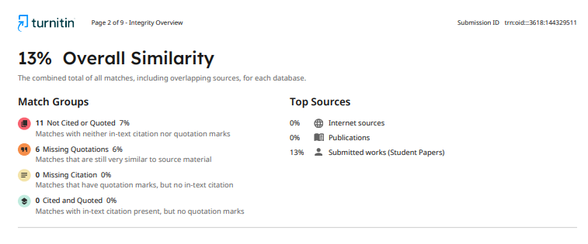

CHAPTER 2 :
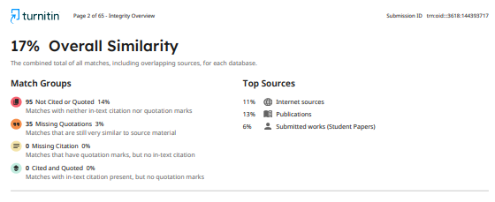

CHAPTER 3 :
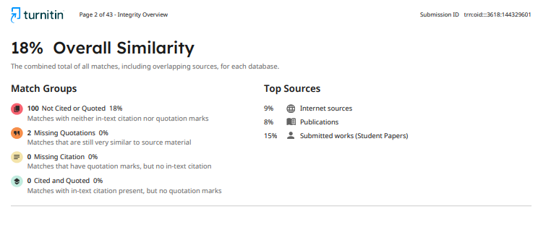
CHAPTER 4 :
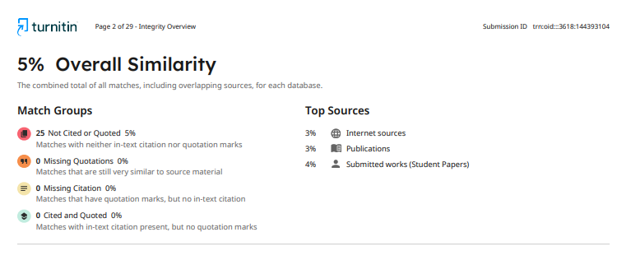
CHAPTER 5 :
